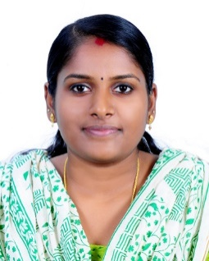
PRABHA

Email: prabha-393524@2freemail.com

PROFILE

As an experienced teacher, I would like to devise captivating, fascinating, and unique practices of teaching that creates interest in the students. With the help of my cordial nature, I would like to build good rapport with students as well as teachers around me.

EDUCATIONAL QUALIFICATION

Qualification | Academic Year | Specialisation /Stream | University / Board | Marks (%)
M.Com | 2012 - 2014 | Finance | Mahatma Gandhi University | 74.25 %
B.Com | 2009 - 2012 | Finance & Taxation | Mahatma Gandhi University | 82.75 %
XII | 2007-2009 | Commerce | Kerala state board examination | 89 %

TEACHING EXPERIENCE

- Worked as a Guest Lecturer in commerce in Kerala, India. For the Academic year 2018-2019
- Worked as a Guest Lecturer in Thiruvalla, Kerala, India. For the academic year 2016 Aug – March 2017.
- Worked as a Guest Lecturer in commerce in Kerala, India. For the academic year 2015-2016.

KEY SKILLS AND COMPETENCIES
- Willingness to go above and beyond the call of duty to ensure that all pupils that achieve.
- Establishing good relationship between Students, patents and with Staffs
- Using speech and body movement to communicate with class
- Communicate to maintain and improving own personal competence
- Committed to eliminating any discriminatory practice towards pupils based on origin, race, and gender.

COMPUTER PROFICIENCY
- Good working knowledge of MS Office (MS Word, MS Excel and MS PowerPoint).
- Working knowledge of Accounting Package – Tally. ERP9.

EXTRA-CURRICULAR ACTIVITIES AND ACHIEVEMENTS

- First prize in story writing competition conducted by DB Pampa College Parumala, for the academic year 2011-2012.
- Second prize in Travelogue writing competition in the academic year 2006-2007 conducted by SKV High School, Kuttemperoor.

PROJECTS UNDERTAKEN

- Project with a sample size of 50 on the topic “Consumer’s satisfaction towards Kissan Credit Card” was completed as per academic requirement. [Team Size :1]
- Market Research Project completed as part of academic requirement with a sample size of 50 on the topic “Effectiveness of two wheeler Advertisement among college students”. [Team Size :3]

PERSONAL DETAILS

Educational Qualification : M.Com
Gender : Female
Age & Date of birth : 26, (May 22nd 1992)
Marital Status : Married
Nationality : Indian
Religion & Cast : Hinduism, Viswakarma
Languages Known : Malayalam, English & Tamil
Permanent Address : Kerala, India.

DECLARATION

I hereby declare that the above written particulars are true to the best of my knowledge and belief. I bear the responsibilities for the correctness of the above-mentioned particulars.

PRABHA

