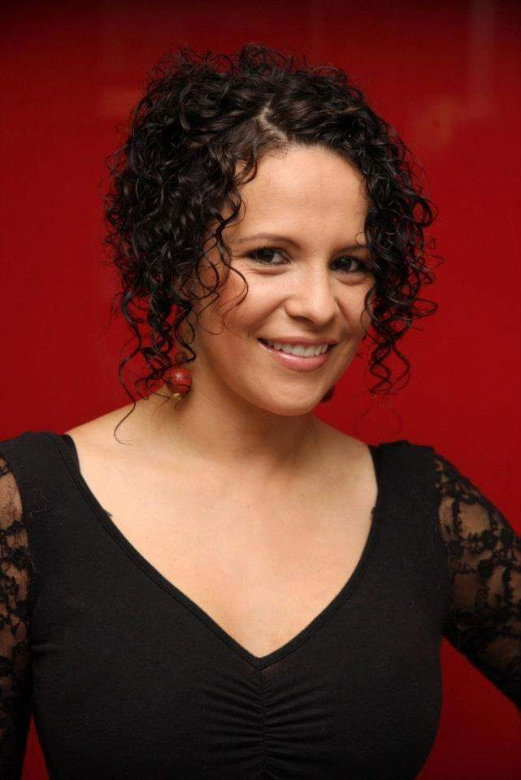 |  |  |  | SHIRLEY

Experience
Jan 2019–Feb 2019
Hairdresser•Senior Hairdresser•Just Cuts Casuarina Darwin Australia
Nov 2018–Jan 2019
Hairdresser• Senior Hairdresser • Just Cuts Roseland Sydney Australia

Dec 2017–Nov 2018
Hairdresser• Senior Hairdresser • Just Cuts Warriewood Sydney Australia
Apr 2015–Nov 2017
Hairdresser• Manager • Peppa Hair and Beauty Spa Brisbane AustraliaBEAUTY Massage for the body,warn stone massage,facial massage,Swedish massage, reflexology massage popular beauty treatment operate galvanic machine high frequency with various techniques offering benefits to the skin (including the application of beauty products) and for increasing mental well-being.
Sep 2014–Jan 2015
Hairdresser• Senior Hairdresser • XpressCuts Brisbane Australia
I am professional in Haircuts for men & women, Foils, Highlights, Full Colour, Brazilian Blowout KERATINE, Waxing, Make Up, Eye Brow & Lash Tint, Customer Service, Chemical Straightening, Ombre, Keratin Treatments, Perform Scalp & Re-touch Bleach, General Salon Duties, Customer Service with Consultation all duties manager also I am qualified Beauty therapy with friendly and welcoming manner, ability to make clients feel relaxed, ability to explain procedures clearly to clients, tact and diplomacy and my best skill ability to sell products and earn commission.

Education
2014 - 2014 Diploma in Advance Management at HETC - Brisbane
2013 - 2014: Diploma in Business at HETC - Brisbane
2012 - 2013: Diploma in Beauty Therapy - Endeavour College of Natural Beauty
2011 - 2012: Diploma in Marketing at HETC - Brisbane.
2008 - 2011: Diploma of Hairdressing Salon Management - Australian Institute of Applied Sciences. 2008 - 2011: Certificate III and IV in Hairdressing - Australian Institute of Applied Sciences
(This course has included 900 hours of practical training at CPS Hair Design and Imagine Hair)
2006 - 2007: English General - TAFE Southbank

Languages
English Upper Intermediate
Spanish Native

Leadership
- Honesty and Integrity. ...
- Inspire Others. ...
- Commitment and Passion. ...
- Good Communicator. ...
- Decision-Making Capabilities. ...
- Delegation and Empowerment. ...
- Creativity and Innovation

References
Peter Vergotis (Owner / Manager Just Cuts)
Phone. 0408405084
peter.vergotis@gmail.com

Nikki Irwin (Owner / Manager Just Cuts) Roseland
Phone. 0400033934

Kathy Robinson (Owner / Manager Just Cuts).
Email: kathylc@live.com
Phone: 0423771061

 |  | Shirley-393563@2freemail.com

