CURRICULUM VITAE

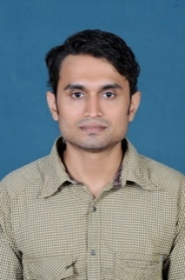

JIJIN
EMAIL: jijin-393574@datachampion.com

OBJECTIVE :

Pursuing a career, which make sure safety on all man machine and environment are the top priority, and which requires motivated, dedicated, above average person and where individual performance and achievements will be recognized, thereby allowing opportunities for growth and development within a successful company

WORK EXPERIENCE:

Worked as fire alarm technician in a Fire Alarm supplier in Banglore
Worked in L&T for 1 year
Worked in computer service centre for 3 years
Worked in studio as Graphic Designer for 2 years
Worked as Front desk officer for 3 years

QUALIFICATION:

- S.S.L.C from PMGHSS Palakkad, 2002
- Plus Two from Madras University, 2005
- Diploma, NIFE,
- Advanced MS office, Personal computing and Digital Lifestylefrom NIIT.

SKILLS:

- Hardware and Networking
- Photoshop, Graphic design , Premiere Pro video editing
- Good verbal and written communication skills.

PERSONAL INFORMATION:

Date of birth : 28th December 1983
Gender : Male
Nationality : Indian
Languages known : English, Hindi, Malayalam, Tamil

DECLERATION

I declare that the particulars furnished above are true and accurate to the best of my knowledge.

Date:
Place: JIJIN

