CURRICULAM VITAE
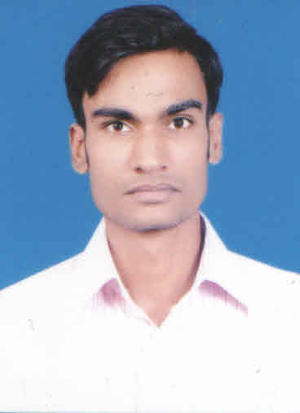
Dilip
E-Mail : dilip-393619@2freemail.com

OBJECTIVE :
To work in a professional environment that enhances, widens the skills,
Knowledge and enables to cope up with challenges in emerging technology.

Education:
S.S.C | Century School | Mumbai | 63.38% | 2007
H.S.C | R.K.T College | Mumbai | 64.23% | 2009
T.Y.B.Com | R.K.T College | Mumbai University | 72.33% | 2012

Other educational qualification
Diploma in Financial Accounting

Experience:
Dubai
(Jan 2018 to present)
As a Accounts Assistants
- Preparing Receipt & Payments Entries.
- Preparing Outstanding Statement.
- Preparing Commission Statement.
- Preparing Bank Reconciliation.
- Preparing daily expenses entries.
- Handling petty cash.
- Calculating Vat& Return Filing.

(June 2012-July 2013)
SAMIR GANDHI & CO.
Chartered Accountant
Prepare Trial Balance, Profit & Loss account, Balance Sheet

Tax Audit
Advance Tax, TDS - Salary & Other than Salary, Vat, Service, Tax, Debtors &Creditor Scrutiny More than six month & Less than six month.

Aaronica Global Exim Pvt.Ltd. (Jan 2015 to Dec.2017)
As a Accounts assistants
Responsibilities:
• Sales & Purchase entries
• Bank Reconciliation
• Petty Cash Handling
• Preparing Invoice & Challan
• Accounts Payable & Receivable
• Preparing Report of Vat & CST Return
• Filling Online Return of Income Tax, Vat, Service Tax
• Gst Registration & Online Return.

Key Competencies & Skills:
Computer Skills: Excel, MS Office, Tally Erp9

Personal Information
Gender : Male
Nationality : Indian
Date of birth : 13th APRIL, 1991
Marital Status : Single
Languages Known : English, Hindi, Marathi

About Me :

I am basically from Mumbai. I am self motivated person who loves challenges. I am team member with excellent communication and analytical skill. I don’t let my work pile up, I am a good strong attitude towards work
I have co-operative nature, and have ability to work with team as well as individual.

Declaration
I hereby declare that above mentioned particulars are true the best of my knowledge.

Date: (DILIP)

