Curriculum vitae 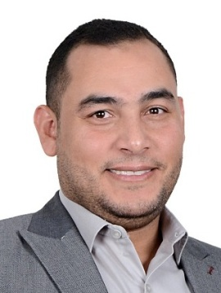
Name : METWALLY
E mail:- metwally-393632@2freemail.com

CAREER OBJECTIVE
Looking for ACCOUNTANT position to develop my career in a reputable company where I can utilize my skills to increase productivity and sales goal.

WORK EMPLOYMENTS
- ACCOUNTANT Under Training ALLAMS SONS COMPANY(2007 to 2008)
- ACCOUNTANT at ORASCOM TELECOM in ALGERIA (2008 to 2010)
- ACCOUNTANT at Magic Tulip Hotel Marsa Alam (2010 to 2011)
- ACCOUNTANT in Saudi Arabia (2011 to 2015)
- ACCOUNTING MANAGER in Saudi Arabia
JOB Description

Dealing with Microsoft, Word, Excel and Power Point Programs.
Control and Self Confidence
Providing high level of customer service
Receiving cash payment from the clients
Doing the daily cash reports.

EDUCATIONAL QUALIFICATION

- Faculty of Commerce ZagazIg University 2006 .

PERSONAL DETAILS
Nationality : Egypt
Civil Status : Married
DOB : 14/02/1985
Religion : Islam

LANGUAGES KNOWNS
ARABIC -BASIC
ENGLISH - VERY GOOD
TURKISH -GOOD
ITALIAN - NORMAL
FRENCH - GOOD

HOBBIES

INTERNET
TRAVEL
READING
SPORTING

DECLARATION
I hereby declare that all above –mentioned information is in accordance
with fact or truth up to my knowledge and I bear the responsibilities
for the correctness of the above mentioned particulars.

