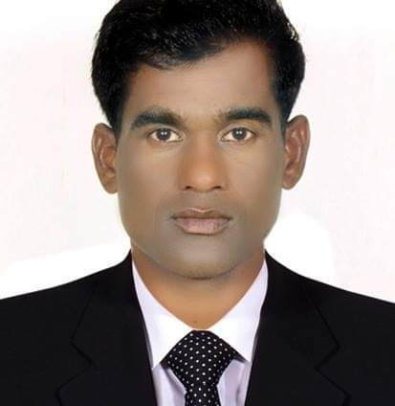
RESUME

MUNNA
CIVIL ENGINEER
E-mail : munna-393761@2freemail.com

_____________________________________________________________________________________
PERSONAL PROFILE:
I am a very organized person who enjoy making sure that jobs get done in a timely and efficient manner. I enjoy working in a busy office environment making sure that the office runs effectively and the work gets completed on time.
EMPLOYMENT HISTORY IN GULF:
- Civil Engineer, November 2009 to April 2012 Abu Dhabi, DUBAI.

- Project HLG Site No 275, Capita Gate Abu Dhabi National Exhibition centre, 35 Floor Stories, & Height 160 Metter, one of the tallest Building in the city and inclines 18 degree to the west.
Client: Abu Dhabi National Exhibition Centre (ADNEC).
- Project HLG Site No 278, Dusti Hotel, Residential and Commercial Complex {P9} Abu Dhabi, U.A.E.
The Structure includes a 40 storey hotel tower, a 22 – storey serviced apartment building, a 17 – storey office building, and three levels of common basements.
Client: East West International Group.

Site Engineer, 27 January 2013, to 20 October 2016, working in Riyadh, Saudi Arabia {KSA}.

- King Abdullah Project for Development of Security Headquarters - Phase 2, Package A
Client: Ministry of Interior {MOI}

- King Abdullah Bin Abdul-Aziz Project for Development of the Security Facilities for MOI KAP 2C1. Al-Baha Project {Special Emergency Force Camp – Type C}
Client: Ministry of Interior {MOI}

Responsibilities:
- Execution of all Construction Works as per Approved Drawings.
- To check changes in site and prepare as built Drawing.
- Study and Review Construction Drawings and specifications.
- Assign various team to site activities, Direct and Supervise all Teams for Proper and Timely Execution of site works.
- Expediting of Material, Manpower, Tools and Equipment Requirements for proper execution of works.
- Checking sub-contractors requirement and making arrangement for their proper works.
- Make sure to follow all safety rules.
- Auto Cad {Computer aided design} Drawings.
- Checking Concrete cubes for site & Dubai Municipality.
- Taking follow up to material our project.
- Making a judgment on whether certain projects are feasible by looking at costs, time and labour requirements of the project
- Fully handling the site, Preparing and Providing purchase Order with Delivery Schedule, Maintaining the work progress at site with ensuring Quality and safety, Controlling and Monitoring the wastage of manpower and materials, Preparing and Checking client bill and Sub-contractor bill, Maintaining Daily work done report and labour report and Continuous communication with Main office for work progress.

- Civil Engineer, October 2017 to April 2019, Fujairah.

Ground Floor + 4, Housing.
Responsibilities:

- Planning & scheduling of work progress.
- Assisting in the supervision of civil, Building works or services contracts.
- Surveillance and review of structures, design plans and drawings.
- Preparing and reviewing documentation for regulatory approvals, Municipality works and contract issues.
- Preparation of Drawings, reports and specifications.
- Ensuring compliance with all project QA procedures and requirements.
- Liaising with clients and sub-consultants.

Trainings:

- British Safety Council Engineering Training March 2010, {HEETS, Habtoor Leighton Group}.
- Fire Fighting & Fire Marshal Training {HEETS April 2011}.

DRIVING LICENSE:

- ( Valid 2037)

QUALIFICATIONS:

- 10Th High School Nimez ,Buxar, First Division, in 2003
- +2 MAHARAJ COLLEGE, ARA, BHOJPUR, First Division during the year 2003-2005.
- Bachelor Civil Engineering, 2005 to 2009 from Institute of Management and Engineering New Delhi.

TECHNICAL SKILLS:

MS Project 2007, MS Office 2007, Auto CAD Civil 2D, modeling 2009, (Word, Excel, Power Point) Microsoft WINDOWS XP, Web Internet

LANGUAGES KNOWN:

- Hindi – Mother Languages, 2. English – Excellent, 3. Arabic-Average,

PASPORT INFORMATION:
- Passport Valid
- Date of Issue. 06 / 10 / 2015
- Date of Expiry . 05 / 10 / 2025

PERSONAL DETAILS:
Gender----------------------------------------Male
Religion---------------------------------------Hindu
Marital status--------------------------------Marriage
Date of Birth---------------------------------24/08/1987
Nationality-----------------------------------Indian
Height----------------------------------------5’6”

Munna
Civil Engineer.

