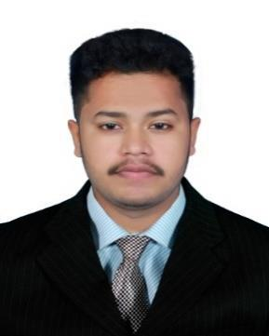
CURRICULUM VITAE

SHAFEEK
Email : shafeek-393773@2freemail.com
Visa Type: Visit Visa
Membership: IMA USA Since Jan 2017

CAREER OBJECTIVE

To pursue highly challenging and creative career where I can apply my knowledge and creativity, acquire new skills and effectively contribute to the Organization.

EDUCATION

QUALIFICATIONS | UNIVERSITY / | YEAR OF PASSING
 | INSTITUTION
CMA PART I | INSTITUTE OF CERTIFIED | PURSUING
 | MANAGEMENT ACCOUNTS
CMA PART II | INSTITUTE OF CERTIFIED | 2019
 | MANAGEMENT ACCOUNTS
MASTER OF COMMERCE | MKU UNIVERSITY | 2018
BACHELOR OF COMMERCE | UNIVERSITY OF CALICUT | 2015
12TH STANDARD ( COMMERCE ) | GVHSS KODUMUNDA | 2012
HIGH SCHOOL (10TH) | DR. KBMMHS SCHOOL | 2010

WORK EXPERIENCES

- Tax Consultants & Accountants, KERALA – INDIA.

(ACCOUNTANT CUM AUDITOR) 3 years, (October 2015 - November 2018)

JOB RESPONSIBILITIES
- Daily enter key data of financial transactions in database.

- Stock auditing & reconciliation of bank accounts monthly basis

- Helping to senior Accountant for MIS & other reports

- Evaluation of clients accounting and internal control system and compliance testing.

- Experienced in VAT calculation & return filing

- Concentrate on accounts receivables, payables & prepare ageing statements

- Sales and purchase management

- Preparation of the bank reconciliation statement

- Cash / Cheque deposit & withdrawals & other banking operations.

- Provide assistance and support to company personnel.

- Book keeping and maintain day book.

- Expenses analysis on a monthly basis to determine accuracy and reasonability

- Accounting works and preparation of financial reports and financial statements.

TECHNICAL SKILL
- Diploma in Foreign Financial Accounting

- MS Office, Applications & Tools

- Tally ERP 9, Quick Books

- Windows (XP – 10)

PERSONAL SKILL
- Good interpersonal skill

- Willingness to learn and determined

- Highly trustworthy, discreet and ethical

- Quick learn and work well with others

ACHIEVEMENTS
- Reduced monthly expenses of branches in 2016

- Detected fake sales in branches

PERSONAL DETAILS

• | Date of birth | : | 04/04/1995
• | Sex | : | Male
• | Nationality | : | Indian
• | Marital status | : | Single
• | Language | : | English, Hindi, Arabic, Malayalam,
• | Home address | : | KERALA, INDIA

EXTRA CURRICULAR ACTIVITIES
- I have participated intercollege cricket & volleyball tournament at college level

- I have also participated in cricket tournament in district level

DECLARATION

I hereby declare that above furnished details are true to the best of my knowledge.

SHAFEEK

