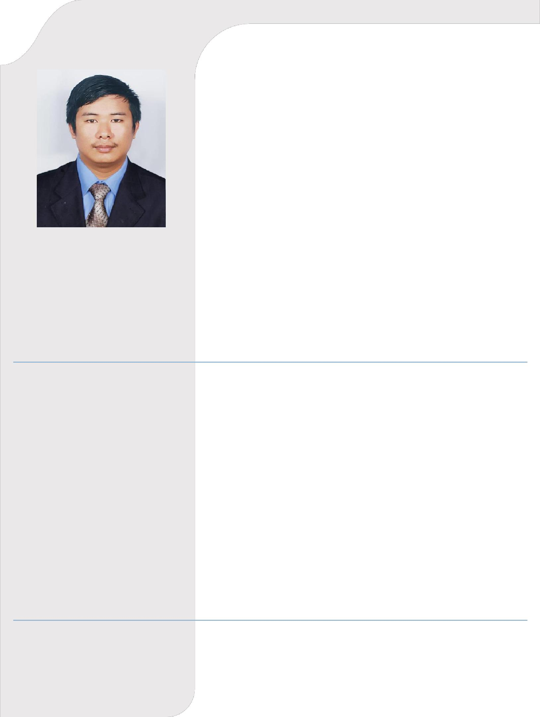

AMIT
Address: Dubai, UAE

EMAIL: amit-393814@2freemail.com

Visa Status : Currently on Visit Visa

PROFILE

I am a graduated mechanical engineer, with a background in mechanical engineering. I am qualified to perform component maintenance, modification and repair on a wide variety of mechanical field. A thorough and systematic worker with a great attention to detail, it is my goal to bring my skills to a respected company to continue developing my engineering expertise.

EDUCATION

High School: Prativa Higher Secondary School, Nadipur, Pokhara, Kaski, Nepal. Passed in First Division with distinction marks (Year 2011).

Intermediate (10+2): Sagarmatha Higher Secondary Collage, (HSEB Board), passed in First Division (Year 2013)

Bachelor of Technology (Mechanical Engineering): R.P Indraprastha Institute Technology (RPIIT) (Kurukshetra University, Kurushetra, Haryana, India). Department Mechanical Engineering, Graduation Year 2018, in First Division.

During my graduation, I had different major courses that helped in my career development.
Some of the major subjects in which I have an excellence knowledge are:

- Strength of materials

- Fluid mechanics

- Thermodynamics

- Machine drawing/ engineering drawing/ machine design

- Steam generation and power

WORK EXPERIENCE

- Worked as a Senior Mechanic in Kathmandu Nepal.

- Basic maintenance course for Mechanical Engineering (Structure/Engines) according to the requirements for the Automobiles on Vijay Motors, Kathmandu Nepal.

GRADUATIION PROJECT

Project on Fabricate lathe Machine
Project on Automat Garage Door Opener

SKILLS

AutoCAD

MS OFFICE

KEY COMPETENCIES:

- Leadership

- Teamwork

- Good communication skills

- Hard working

- Decision making

PERSONAL INFORMATION:

• | Sex: | Male
• | Marital status: | Unmarried
• | Date of Birth: | 3 December 1993 (26 Yrs.)
• | Nationality: | Nepali
• | Visa Status: | Visit Visa

PASSPORT DETAILS

Place of Issue: | Kathmandu Nepal
Date of Issue: | 21 Aug 2018
Date of Expiry: | 20 Aug 2028

REFERENCE: Available Upon request

I hereby declare that the above details furnished by me are true and correct to the best of my knowledge and behalf.

Amit

Dubai, UAE

