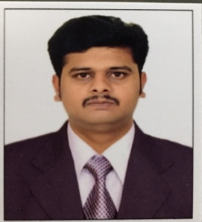
Nagarajan
Email id: nagarajan-393847@2freemail.com

Carrier Objective:

I am seeking a challenging and responsible position as a civil engineer in construction/maintenance project.
ACADEMIC CREDENTIALS
- Diploma in CIVIL ENGINEERING ​with Ist Class​– From DOTES, India – 2011.
- Higher Secondary Education with ​Ist Class​ From Tamil Nadu (India) State Education Board – 2008
- Secondary School with Ist Class​– From Tamil Nadu State Education Board – 2006.
PROJECTS HANDLED
Project 3 (GHANTOOT CONSTRUCTION in Abu Dhabi (2016 to Till now)
- REEM MALL in Reem Island, Abu Dhabi.
- SAADIYAT ISLAND RESORT DEVELOPMENT in Abu Dhabi
Project 2 (ETA- ASCON MARBLES & GRANITES) (2014 - 2016)
- Healthcare city “HYATT HOTEL & APARTMENT TOWER” in Dubai, UAE.
Project 1 (MK CONSTRUCTIONS in chennai)(2011 – 2014 )
- Construction of “MK GOKULAM” (G+5) Residential apartment in Chennai, India.
- Construction of G+2 individual houses in Chennai, India. .
. PROFESSIONAL PROFILE
- An accomplished professional with ​8 Years ​of experience in the arena of construction, commercial, residential buildings project.

Experience in Site supervision, Structural works, Finishing works etc.

Having good knowledge of Civil structural works and all type of finishing works.

Having sound knowledge of engineering software and well familiar with IRC and Indian standards.

Possess excellent organizational, communication, analytical and troubleshooting skills.

Carrier strength:
- Disciplined and positive attitude towards work
- Honest and sincere, good project management skills & technical competence
- Ability to work effectively under pressure and meet deadlines
- Support, develop, implement ideas and skills thereby contributing to the growth and add value to the Company’s team goal
- Knowledge of general work procedures and applications in the construction industry,
- Superb time management skills and ability to meet strict deadlines
- Initiative to learn skills that would benefit the position and operational objectives.

Personal Details:

Age : 29 years
Gender : Male
Status : Single
Religion : Hindu
Nationality : Indian
Languages Known : English, Hindi, Tamil and Malayalam

Declaration:

I hereby proclaim that the above particulars furnished by me are factual to the best of my knowledge. If I am getting a chance, I will execute my work much contented to my superiors.

Thanking you!

Respectfully yours,
NAGARAJAN

