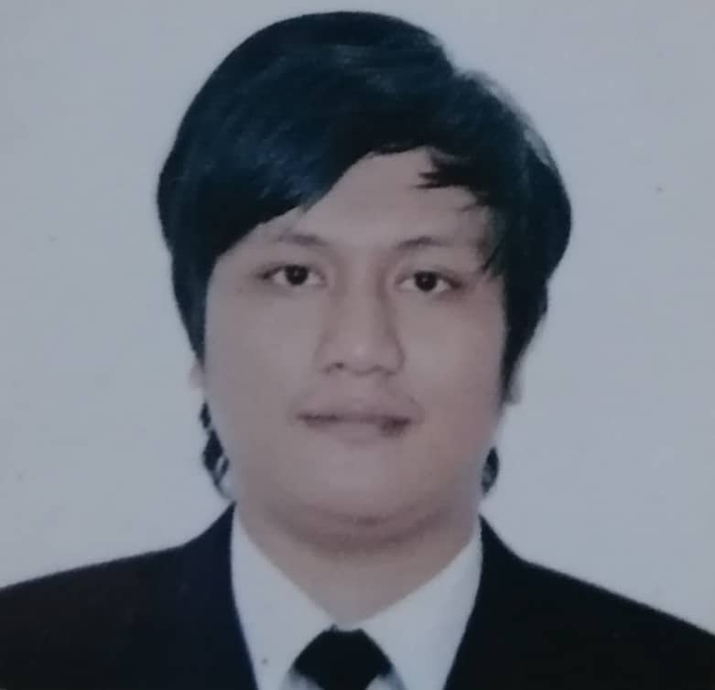 |  | EPHRAIM  ELECTRICIAN/ELECTRICAL/TECHNICIAN
OBJECTIVES To obtain a position that fits and suitable in my failed experience and willing to learn and accept whatever challenging responsibilities beyond my skilled with an opportunity for growth and career advancement as successful achievement. To prove that I can manage project properly. Contact EMAIL: Ephraim-393859@2freemail.com PERSONAL PROFILE Birth Date: March 09,1990 Age: 29 Civil Status: Single Religion: Seventh Day Adventist Gender: Male Nationality: Filipino Visa Status: Until October 2019 EDUCATIONAL BACKGROUND BACHELOR OF SCIENCE IN industrial technology Surigao State College of Technology, Philippines March 2007-2011 sPECIAL Skills Know About: - Residential and Commercial Building wiring. - Installation and Troubleshooting of Industrial Motor control - Transmission Line Electrical Lineman - Can read and interpret electrical drawing and diagram. - Maintaining Area safe and clean all times. - Hardworking and can work under pressure - To finish my job in the deadline schedule. - Quality service for the client satisfaction. - Can estimate materials to be used in a certain works schedule - A law-abiding worker to the company rules and regulation - Follow instruction and utilize initiatives - To protect company asset and liabilities. - Can work holiday and extended hours of duty. EDUCATION [School Name] [Dates From] - [To] [It’s okay to brag about your GPA, awards, and honors. Feel free to summarize your coursework too.] |  | WORK EXPERIENCE  electrician @ midfield terminal building project abu dhabi international airport-Anel emiRATES  march 20,2018 – JULY 14, 2019.  AWARD received:  RECEIVED THE APPRECIATION AWARD.  Awarded as exemplary work attitude, discipline and performance in compliance with HEALTH, SAFETY AND ENVIRONMENT POLICIES OF THE PROJECT. Granted on August 31,2018.  DUTIES AND RESPONSIBILITIES  *Layout and Piping, Box setting, slabbing  *Cable pulling of feeder line/Ducab wire and Elswedy wire.  *Performing of wiring  *Fire alarm system / Public ADDRESS  *Installation of module of fire alarm and relay  *Installation of electrical devices /lightning fixtures  *Termination of panel board /Isolated switches  *Termination of module of lighting control  *Snagging  *Installation of cable Tray and trunking.  TECHNICIAN / ELECTRICIAN – al-khobar, kingdom of Saudi Arabia  august 13, 2015 to august 13, 2017  (END OF CONTRACT)  DUTIES AND RESPONSIBILITIES  *Performing in commercial and residential electrical wiring, repair and maintenance  *Fixtures and lightning system  *Read and interpret electrical drawing and diagram.  *Piping and lay-out lighting and pener  *Wiring termination / Panel board / cable pulling  *Install safety system including emergency lighting in terms of fible power ang battery supply  *Trouble shoot electrical faults and fixtures problem installation  *Ability to perform jobsite risk assessments and maintain safe work  environment.  BUILDING ELECTRICIAN  January 2014 to January 201  DUTIES AND RESPONSIBILITIES  *Piping and layout  *Slabbing  *Box setting  *electrical wiring  *cable pulling  BUILDING ELECTRICIAN  January 08, 2015 to August 01, 2015  DUTIES AND RESPONSIBILITIES  *Box setting layout and piping /conduct bending  *Performing electrical wiring / fire alarm systems / public address  *Cable pulling of feeder line  *Installation of electrical devices and lighting fixtures.  ELECTRICIAN  May 2013 to January 2014  DUTIES AND RESPONSIBILITIES  *Installing of Electrical devices  *Terminating of Panel board  *Piping and layout  *Performing electrical wiring  *Testing and commissioning feeder line  ELECTRICIAN / TECHNICIAN  Electricia/Technician  January 2012 to April 2013  DUTIES AND RESPONSIBILITIES  *Power rehabilitation building wiring and lining electrical maintenance  *Comprehensive experience in the repair and maintenance of motors control panel and major mechanical and electrical system, including timers, ciremit, breaker, feeder coils and relays  *Testing and commissioning  *Transmission line and linemen

