Core Competencies

HR Policy Executive Induction

Training & Development

Recruitment

Payroll Management

Employee Relations/welfare

General Administration Performance management

Compensation & benefits

Organizational Development Team Management

HARITHA
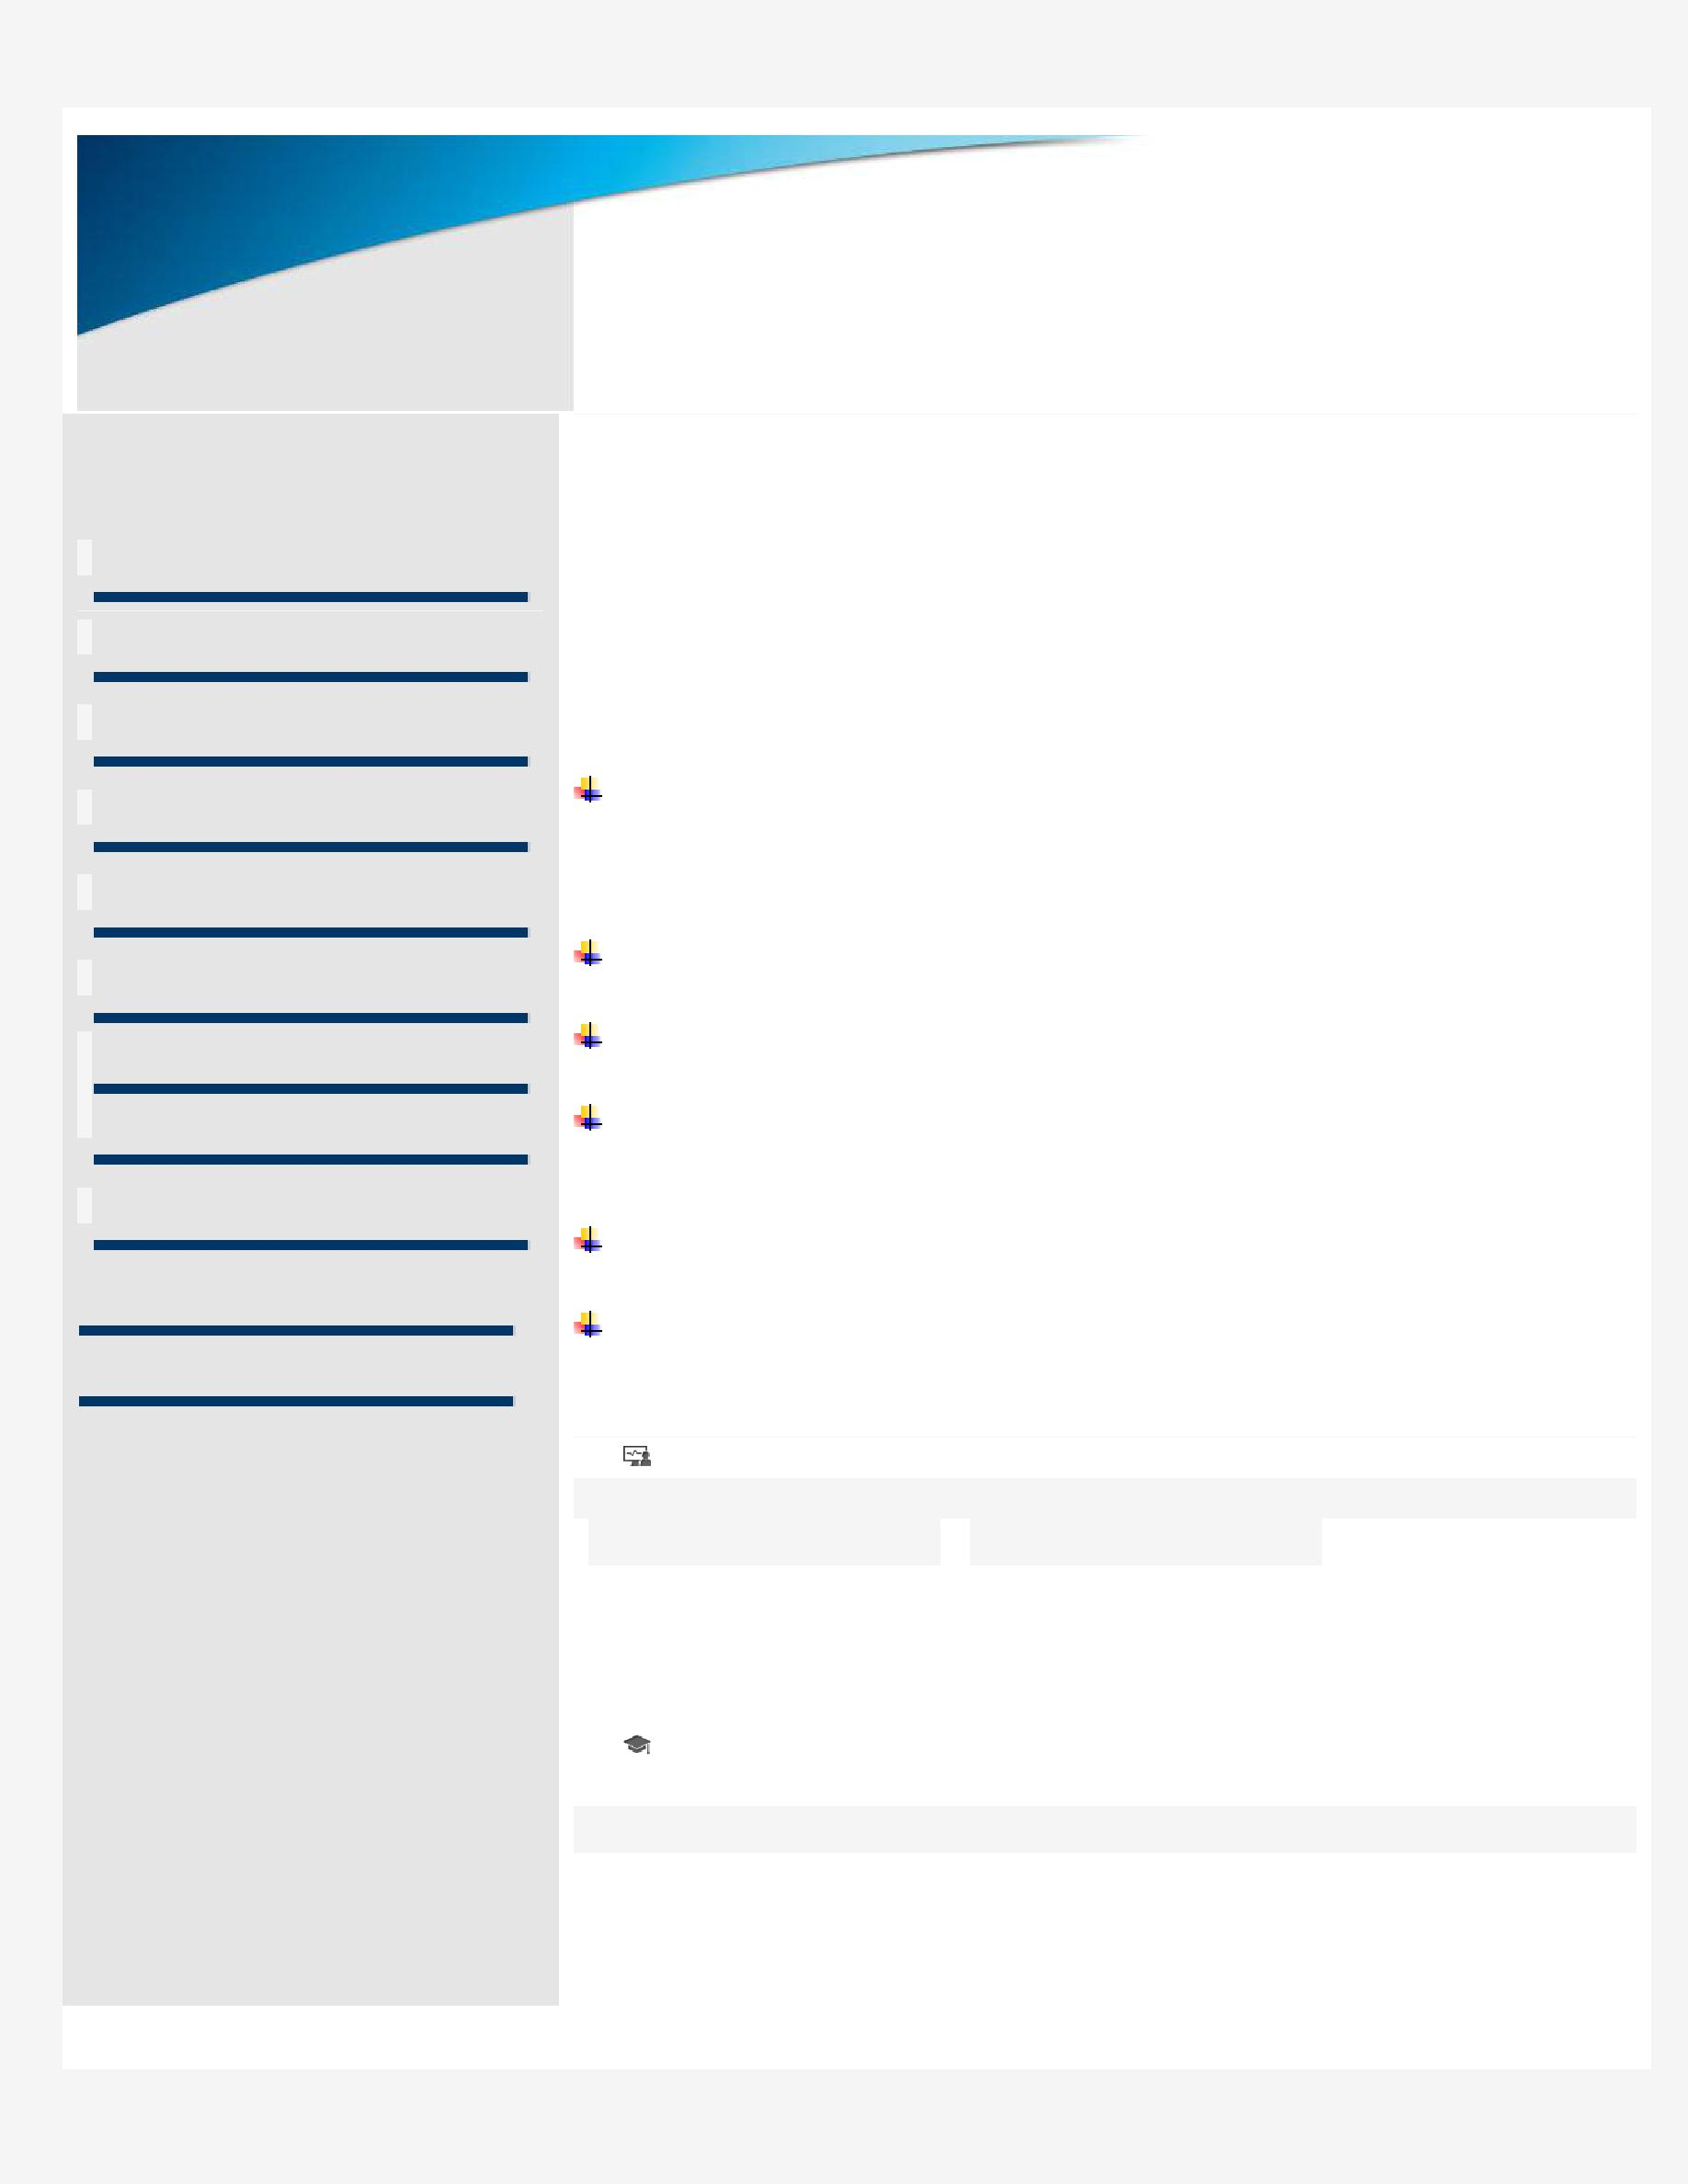

HR EXECUTIVE

Email: haritha-393871@2freemail.com

Visa type: Visit Visa

Scaling new heights of success with hard work & dedication and leaving a mark of excellence on

each step; targeting assignments as HR EXECUTIVE with a leading organization of repute

Profile Summary

Offering over 3 years of experience in working as a HR Executive in India

Graduate in Electrical Engineering with over 3yeras of experience in recruitment - sourcing to On-boarding; Performance management; Compensation & benefits; Payrolls, Welfare and General Administration including Vendor and Client Relationship management.

Presently associated as a HR Executive.

Experienced in manpower management, recruitment involving screening, short-listing and interviewing.

Adept at people management; maintaining healthy employee relations; handling employee grievances thus creating an amicable & transparent
environment.

Skilful in implementing HR policies, conducting training programs towards enhancing employee productivity and building committed teams.

Possess strong communication and inter personal skills. A dynamic go-getter & quick learner wit h ability to under pressure and meet deadlines.
.

IT Skills

 | ● Keka Software |  | ● Adobe Reader

- MS Excel, Word, PPT,Out look

Education

- B.Tech in Electrical Engineering from Sagar Institute of Technology/JNTUH, Hyderabad in 2013, India.

- 12th from Sri Chaitanya Junior College.
10th from Bhashyam Public School.

Career

Timeline

 | September |  | Present
 | 2016

HYDERABAD, INDIA.

Holds the distinction of handling recruitment approximately 15-25 on monthly basis viz.
- Functioned as Lead recruiter for the office of the managing partner.

- Achieved lowest offer declines with lowest terminations due to background verification. Instrumental in initiating the knowledge sharing sessions in the service lines handled. Accountable for streaming background verification Process.

Successful in recruiting the largest team-lockbox during the tenure.

Steered initiatives towards recruiting drives such as Campus placements, Walk-Ins and Job Fairs.

Pivotal in developing as well as launching new test papers for entry level hires.

Received “Shining Star Certificate” during Feb’2017.

H1 Immigration and preparation on RFE and dealing with US Consultants and daily Monitoring.
Personal Details

Date of Birth: 17/August/1991

Languages Known: Hindi, Telugu, English.

Marital status: Married

Visa type: Visit visa

Sex: Female

Nationality: Indian

Soft Skills

