ISMAIL

Ismail-393896@2freemail.com

Dubai , International City.
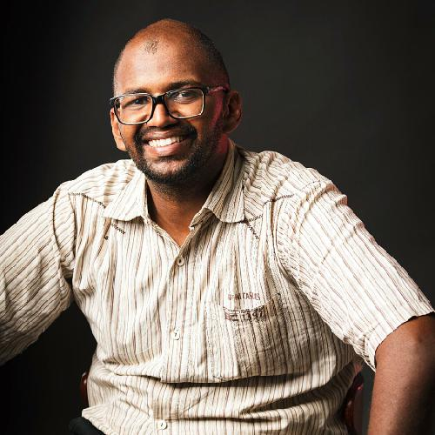

SKILLS

High Impact Presentation.

Effective Report Writing

MS Oﬃce

PERSONAL DETAILS

Date of Birth | : | 12/5/1990
Marital Status : |  | Single
Nationality | : | Sudanese

ACTIVITIES

Work in different Voluntary Works in Sudan to help community Such as TEDX , Nafeer ,...

Member in SPE (International society of petroleum Engineering ) .

References = Ayman Zohair HR Head of Function BAT ( British American Tobacco , Sudan Branch) Ayman_Zohair@batbncc.com

References= Bakri Mohamed Khider QHSE Manager CNLC (China National Logging Company ) beko5.max@gmail.com

OBJECTIVE

Iam a Professional HSE Engineer , B.Sc.,in Petroleum Engineering , NEBOSH Certified , With 5 years Exp, in Oil Fields ,Mining , Constructions ,Certified Trainer ,First Aid+Fire Fighting+Inspection Courses Done, I hope to fully use my skills for the success of your organization.

EXPERIENCE

International Leading Oil

Company. Nov 2014 - Oct 2017 HSE Engineer.

HSE Reports +Set ERP ( Emergency Response Plan ) +Experience to provide ( Safe place of work , Safe Access

- Safe Egress , Training , Supervision , Inspection and Audit.

Mining Company . Oct 2017 - Nov 2018

HSE Engineer.

-Set QHSE Plan ( weekly , monthly and Yearly ).

-Set( ERP , Risk Assessment , Work Permit,Reports).

-Set Training Programs .

-Set QHSE Policy for Company.

-Annual investigations , Internal and External Audit. -Apply ISO 14001 ( The Environmental Management Standards).
- Control all types of Wastes .

- Conduct mock Safety Drills.

Sudan Branch.

HSE Executive . Nov 2018 - Sep 2019 Set all QHSE strategies and System.( ERP , Training , Inspections , policy and system of work ).

EDUCATION
Sudan University of Science & Technology. |  | 2013
Bachelor of Science ( Honours ) in Petroleum Engineering
.

National Examination Board in Occupational Safety and Health.(

British ) 2017

NEBOSH ( International General Certificate In Occupational Health and Safety ).

Occupational Safety and Health Administration . ( USA) | 2014

OSHA ( Occupational Safety and Health Certificate) in General and Construction Industries.

References = Yousif Ibrahim EHS Maneger BAT ( British American Tobacco , Sudan Branch) Yousif_Ibrahim@batbncc.com

LANGUAGE

Arabic is a mother tongue.

English Fluent ( Read+ Write).

Institution of Occupational Safety and Health .( British ). | 2016
IOSH Managing Safely.
The Open University of Sudan. | 2014
Strategic Planning Diploma.
UNESCO - Center For International Relation 2010. | 2010
First Aid Certificate.
GGNPOC ( Greater Nile Operating Company ). | 2013
HSE Training
PDOC ( Petrodar Operating Company ) | 2012
Pathway to healty life Training.
PDOC ( Petrodar Operating Company ) | 2012
Pathway To Healthy Life Training .
GNPOC ( Greater Nile Operating Company ) | 2012
GNPOC Safety Passport
CNLC ( China National Logging Company ). | 2015
CNLC Safety Passport.
Sudanese Civil Defense Authority | 2013
General Safety and Fire Fighting.

Radiation Safety Institute ( RSI ), Sudan Atomic Energy Commission

( SAEC). 2015

Radiation Protection Against Exposure in Well Logging .

CNLC ( China National Logging Company ) | 2017

Safety Matrix

PROJECTS

BAT - Khartoum New WH Fire Alarm Project .

-Leading Negotiations with Civil Defence Authorities + Suppliers to provide ( heat and smoke detectors , alarm siren ,Beam detectors , Control panel , Fire Cables and installation).Also we set FM 200 Assembly to protect our servers.

Cyanide Basin Study for Sand Stone Mining Company . Fix more than 6 large Basin full of water mixed by Cyanide.by provide Engineering solutions to the problems by provide Fences + Micron Mish + Safety Sign.

QHSE System for RAK- Ceramics Factory Sudan .

-Set format for training , Investigation and Audit. Risk

Assessment for vehicles workshop belong to RAK .Working in factory Area to provide safe place by editing the lights and ventilation system.

