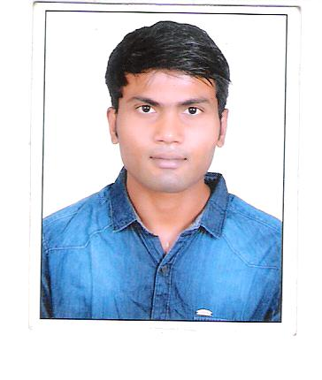
RESUME

AMANCHI
Email : amanchi-393897@gulfjobseeker.com

OBJECTIVE:

Seeking the position of receptionist at Royal Hotel to utilize my admirable welcoming attitude and friendly customer service skills in the delivery of high quality service.
Academic Qualifications:
Qualification | School / College | Board / University | Year of Passing | Percentage
Diploma | frankfinn institute of air hostess training. | Frankfinn | 2013 | 62%
Intermediate | Sri Chaitanya Junior College. | Board of Intermediate | 2012 | 59%
SSC | Nirmala English medium high school, Kadapa | Board of Secondary Education, A.P | 2010 | 81%

Work Experience:
- 2 years experience as Guest Relation Executive l in Tirupati.
- 8 months experience as Guest Relation Executive in TIRUPATHI.
- 1 year experience as Front Office in Kadapa.
Personal skills
- Hard work, sincere efficient in work.
- Quickly Grasp and Learn New Skills.

GRA DUTYS AND RESPONSIBLE:

- Welcome guest during check-in and giving a found farewell to guest while checkout.
- Handling guest complaints and concerns in an efficient and timely manner.
- Overseeing VIP guests, arrivals and departures.
- Coordinating and multi-tasking job duties in a busy environment.
- A passion for delivering an exceptional level of guest service.
- Commitment to delivering a high levels of coustmer service.
- Flexibility to respond to a variety of different work situations.
- Registers and rooms all arrivals according to established procedure.
- Maintain knowledge of departmental standards and procedures.
Achievement:

- Coustmer interaction program got a merit.

Personal Profile :

DOB : 08.01.1995
Gender : Male
Nationality : Indian
Languages : English, Telugu And Hindi .

DECLARATION:

I here by declare that all the above presented information is true to the best of my knowledge.
Place:
Date: Amanchi

