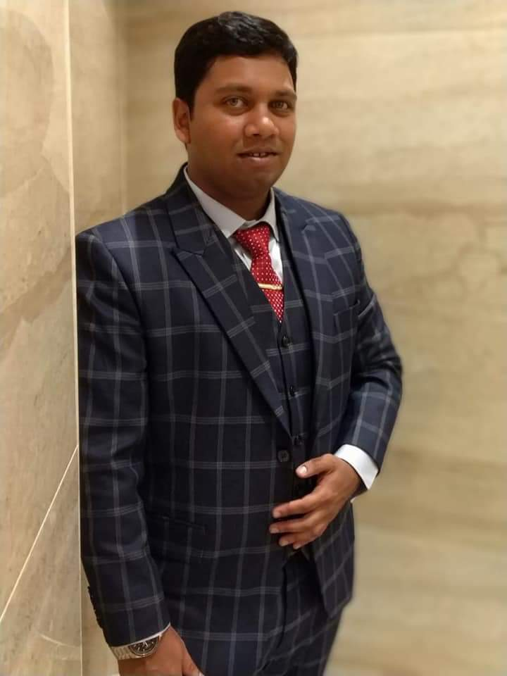

Adeeb

Email: adeeb-393910@2freemail.com
Driving Licences: Dubai, UAE

OBJECTIVE

Searching for employment in order for me to utilize my accounting and sales& marketing skills, sound communication ability, vast knowledge in customer caretaking and my productive organizational talent to improve and develop the core values of the company.

PROFILE

Possess record of excellent performance in matching customers with desired products, Ten years of both local and international accounting and sales & marketing experience, very productive in building long lasting relationship with client.

Extremely passionate in the area ofaccounting and sales& marketing, sound knowledge of computer software, and rich in experience on cold calling in sync with smooth closing abilities.

Professional Experience:

Credit Controller- (Industrial Gas), Dubai, United Arab Emirates.Jan 2016 to present
- Evaluate the credit status of clients to identify credit level.
- Assist customers in setting up a credit control system that allows for periodic debt repayment.
- Conduct negotiations with debtors to fix terms and conditions for payment of receivables
- Handle internal issues and ensure timely payment to creditors
- Contact debtors through calls, emails or letters to notify them of outstanding invoice
- Maintain regular contact with clients to ensure proper management of debt
- Conduct business operations in compliance with standard policies and regulations
- Maintain proper records of client accounts and purchasing activities
- Monitor payment history to identify changes in reparation and take necessary actions
- Conduct monthly reconciliation of debtor ledger accounts
- Proffer recommendations and advice on queries regarding accounts receivable
- Commence legal action against debtors in event of halted payment
- Propose irrecoverable debts to be written off or they may employ strategies to recover receivables in cases of debtor bankruptcy
- Oversee the forwarding of monthly statements to clients to keep them updated on debt collection activities
- Collaborate with legal attorneys to discuss appropriate terms and conditions for debt repayment.

Worked as a Gold Appraiser in Bangalore, India.
Mar 2012to Jan 2016
- Ensure 100% right valuation - capturing right cartage, proper stone deduction etc
- Adhere high ethical standards and comply with all the laid down processes / policies - KYC adherence, maintaining all important registers etc.
- Provide high quality customer service, prompt resolution of queries pre & post loan disbursal.
- Supporting branch staff in business development activities & helping to achieve branch targets.
- Customer Care Executive Handle walk-in customers.
- Adhere administrative process & policies of the organization is a must.
- Understand needs & interests of the customers and cater to the same.
- Guide & provide the customers with all the required information about loans & schemes.
- Able to solve the queries of the customers as well as handling the customers in a cooperative & efficient way.
- Should be able to acquire new customers through referencing.
- Keeping the existing customers up dated with their existing account details.

Achievements:
- Commended by management on numerous occasions for the quality and consistency of my performance.
- Created and presented an excellent image of the company and its services to customers, and coordinated and communicated well with clientele and management at all level.
- Ability to create and present an excellent image of the company and its service to customers, and to coordinate and communicate well with clientele and management at all levels.
- Expert organizer and an aggressive communicator with a proven ability to accomplish the most detailed, time sensitive activity while remaining within the committed timelines.
- High motivational level, excellence of leadership technique, and professional attention to detail supplemented by the ability to influence and stimulate others.

Skills:
- Good communication skills
- Good interpersonal skills
- Familiarity with computer systems and complex databases
- Good numeracy skills
- Confidence and the ability to place pressure tactfully on individuals and companies who owe money
- Organisational skills
- Problem solving skills
- A realistic approach to the world of finance
- Empathy for the situations of others who may be unable to make payments on time
- The ability to explain financial issues to others in a simple yet direct manner
- The ability to negotiate

Education:

Indian School of Business Management andAdministration, Bangalore, India
Completed Executive-MBA in International Finance Management 2014

Indian School of Business Management andAdministration, Bangalore, India
Completed Bachelor in Management Studies in International Marketing Management 2012

PresidencyPre-University College Bangalore, India
Completed Pre-University Education (12th) in Commerce 2008

Kaveera English Medium High School, Hassan (Dist), India Completed 10th (SSLC) 2006
LanguagesKnown:
English, Urdu, Hindi, and Kannada
PersonalDetails:

Sex | Male
Date ofBirth | 29-01-1988
Nationality | Indian
Caste &Religion | Sunni Muslim/Islam
Hobbies | Playingfootball, Cricket,Volleyball, PC games, watching Movie, readingnewspaper, Outingwith friends and family.

Declaration:
I,Adeeb UrRehmanH.J,herebydeclare thattheabovefurnishedinformationisauthentictothebestofmy knowledge.
Adeeb

