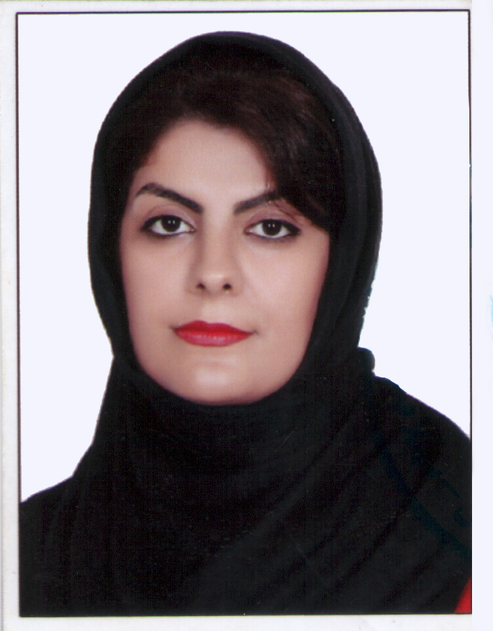

curriculum vitae

PERSONAL INFORMATION

Name |  | SARA
E-mail |  | Sara-393927@2freemail.com

Nationality |  | Iranian

Date of birth |  | [15, 07 , 1985 ]

Education and training |  | [Please describe the whole study path done]

• Date (from2003 – to2007) |  | Bachelor of Architecture
• Name and type of organisation providing education and training |  | Islamic Azad University of Kerman, Iran
Duration of the program of study |  | 4 years
• Principal subjects/occupational skills covered |  | Architectural design, Architectural and urban research, interior design
• Title of qualification awarded |  | Architectural Engineering
Final mark obtained |  | 16.81

graduation thesis

Title |  | The researching center of Faror island's Biosphere
Language |  | Persian/English
Supervisor |  | Mrs.Afsaneh Hekmat (phd) and Mr.Reza Afhami (phd)
Thesis Summary |  | Achieving a sustainable society is impossible without trying to protect the environment and Since the environmental issue in Iran is a matter of great concern, it is necessary to consider the basic research for environmental protection and planning for the future in the years to come. The Persian Gulf, as the most valuable national and cultural asset of Iran, has a long-standing connection with the life of the people and the history of our country. In recent years, the spread of environmental pollution in the Persian Gulf and increasing the excessive fishing of ornamental fish in the islands under international protection Alarm to respond to the challenges of the environment. Having a place to explore and gather international scholars can make a special look at this issue.  In this regard, a research center on the Faroe Island has been designed to protect this biosphere.  This huge building is set as a hard skin at the edge of the island so that the lower floors of the building are always underwater. This collection includes well-equipped research institutes, laboratory space, library, galleries and underwater museums, hotel, restaurant and administrative complex. The most important feature of this building is the full use of energy from the environment. In order to provide energy, the shell's surface is absorbed by the sun's energy and also the drinking water of the collection is provided through domestic sweeteners.

Education and training |  | [Please describe the whole study path done]

• Date (from2003 – to2007) |  | MS in Architecture
• Name and type of organisation providing education and training |  | Islamic Azad University, Science and Research Branch , Iran
Duration of the program of study |  | 2 years
• Principal subjects/occupational skills covered |  | Architectural design, Architectural and urban research
• Title of qualification awarded |  | Architectural Engineering
Final mark obtained |  | Due to personal problems and death of my father, despite passing all the units of the course and thesis design, I failed to hold my defence and finish my studies.

graduation thesis

Title |  | Design of « Posht e Shahr» Parish Coastal Edge in Bandar Abbas With The Approach of Crime Prevention Through Environmental Design (CPTED)
Language |  | Persian/English
Supervisor |  | Mr.Iraj Etesam (phd) and Mr.Reza Afhami(phd)
Thesis Summary |  | Crime is a complex event. A crime occurs when there are four simultaneous factors: the law, the offender, the purpose and place of the crime. The theory of crime prevention through environmental design rooted in the severe disappointment of Siri Jeffrey of the ineffectiveness of the criminal justice system in crime prevention. This theory began with his search for a new theory of crime prevention based on the relationship between humans and their environment. One of the most important concepts in these theories is Theories of the concept of an unprotected space.  In this plan a neighborhood in the southernmost part of Iran has been investigated in the coastal city of Bandar Abbas. It is the largest commercial port of Iran and one of the most important ports in the Middle East. The " Posht e Shahr " neighborhood, despite being in the center of city development, still retains its old texture. The immediate proximity of this neighborhood with the city's new commercial fabric and Qeshm passenger's pier is a phenomenon that is very difficult to find in port cities. On the other hand, the high crime rates in the neighborhood have raised the site as a security knot in the city. The traditional and worn-out texture of this neighborhood with narrow alleys and stiffness is another dilemma in the urbanization of this region.  This research seeks to provide solutions for architectural and urban planning of the region Based on the four fundamental principles of the CPTED theory: Namely, monitoring, controlling the way of entry, the importance of the relationship between the use of land and the places of activity and history; The dense and irregular texture of the neighborhood increases the crime conditions, with crowded streets and lacking adequate lighting and urban amenities. Therefore, creating a center for popular activities and attracting tourists can help to strengthen the economic dimension of the lives of residents. The coastline, given the potential capacity, has the potential to become such a place. Therefore, by presenting a proper plan, it can be used to reduce the physical conditions of the crime to strengthen economic conditions. (Such as lighting and the type of passageways or troughs and corners without body visibility). This research is done in two parts of the coastal design and provides crime prevention strategies

certifications

GRE |  | [indicate date and mark obtained]
GMAT |  | [indicate date and mark obtained]
Certifications of language knowledge |  | IELTS 6
Other Certifications |  | Certificate of merit: selected learner in architectural drawing in festival of visual arts of technical and vocational school in Hormozgan  Certificate for selected learner in architectural education in course of quantity surveying during 2012-2013 education year  Certificate for selected learner in architectural education in course of building installation-quantity surveying and estimating during 2013-2014 education year

Work experience, stages, studies abroad

• Date (from – to) |  | 2006-2008
• Type of business or sector |  | Building Consultancy Company
• Type of employment |  | contractual
• Main activities and responsibilities |  | Start as apprentice and after that work as Auto cad and 3DS MAX operator and cartographer.

• Date (from – to) |  | 2008-2018
• Type of business or sector |  | Engineering Design Office
• Type of employment |  | Part time contractual from 2008 t 2011, full time contractual from 2011 to 2018
• Main activities and responsibilities |  | Work as Architecture Design and head of the technical department

• Date (from – to) |  | 2013-2016
• Type of business or sector |  | School of Art and Architecture
• Type of employment |  | Part time teacher
• Main activities and responsibilities |  | Architecture and art teacher and provincial teacher for two consecutive years in the lessons: construction estimates,mechanical installation, architectural history

• Date (from – to) |  | 2016-2018
• Type of business or sector |  | Training for children in need and social injuries
• Type of employment |  | Managing director and founder
• Main activities and responsibilities |  | A school for teaching children's life skills. This social activity is listed without salary

Personal skills and competences
Acquired in the course of life and career but not necessarily evidenced by formal certificates and diplomas.

Mother tongue |  | Farsi

Other language(s)

 |  | english
• reading |  | [Indicate level: excellent, good, elementary ]
• writing |  | [Indicate level: excellent, good, elementary ]
• speaking |  | [Indicate level: excellent, good, elementary ]

Social skills and competences  Living and working with other people, in multicultural environments, in positions where communication is important and situations where teamwork is essential (e.g. Culture and sports), etc. |  | [description of these competences and indicate where they were acquired]  I feel responsible to the community in which I live and to the whole world. I cannot be indifferent to the suffering of humans, especially children and patients. That's why I set up a charity. As the CEO of this institution, I try to teach children how to make a difference in their lives by educating children and women who are suffering from social and cultural harm. My children at the Institute for Dreaming Need to be educated because they are barred from primary education, having food and clothing, and adequate housing and sanitation for cultural reasons and the lack of a healthy family. I also attend various associations of poetry and cultural associations in the city. At times when somewhere in my country people are damaged by an accident (like as earthquake) I will certainly help them.

Organisational skills and competences  E.g. coordination and management of people, projects and budgets; at work, in voluntary work (e.g. culture and sports) and at home, etc. |  | [description of these competences and indicate where they were acquired]  Although I prefer to do things individually in some cases, I have basically a very high ability to interact with people around me. I have a very successful teamwork and management ability. I am extremely careful about doing office work. And enjoying working with an energetic team. Benevolent goals always attract me and participate voluntarily in seafront and beach clearing programs.

Technical skills and competences  With computers, specific kinds of equipment, machinery, etc. |  | [description of these competences and indicate where they were acquired]  - Auto CAD(excellent)  - Archi CAD(excellent)  - PowerPoint(excellent)  - Word(excellent)  - Excel (excellent)  - Adobe Photoshop(excellent)  - sketch up(excellent)  - 3ds MAX(good)  - Revit(good)  - Spss (elementary)  - GIS(elementary)  - Ms Project(elementary)

Artistic skills and competences  Music, writing, drawing etc. |  | [description of these competences and indicate where they were acquired]  - Understanding the basics of music(good)  - Low-piano tic  - Understanding Persian Tar for 2 years (Medium)  - Solfege and ear training gathering for one year with mr.izadi(leader of symphony orchestra in bandar abbas)  - Gathering traditional Iranian song for 4 years with mr.sajadi (one of the student of mr.shajarian)  - Real Painting with crayon and acrylic paint(Great)  - Painting on glass with stained glasscolour(Great)  - Painting in the style of impressionism (good)  - Gathering sketchtechniques with Dr. Sediq for two years  - Poet for 19 years

Other skills and competences  Competences not mentioned above. |  | [description of these competences and indicate where they were acquired]  - Kung Fu with brown belt for 3 years (elementary)  - Ninjutsu and Qi 7 exercises in Iran under the supervision of kancho. Akbar Faraji. (elementary)

Additional information |  | [Enclose here any other information that may be relevant ]

annexes |  |  | [List any items attached]  [Mandatory attachments in the application:  see indications above and the official call for positions]

