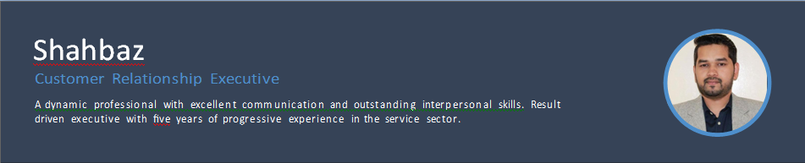
Email: shahbaz-393966@2freemail.com

WORK EXPERIENCE

Senior Customer Service Executive
2015 – Present
Ahalia Exchange is a UAE based company dealing primarily in

Dubai

SKILLS

Time Management
Adaptability and Flexibility
- Negotiation & Persuasion
- Strong Work Ethic

remittances and foreign exchange. The company is headquarteredVer in Abu Dhabi, UAE, and operates through 30 branches across the country.
Achievements/Tasks
Corresponding with customers for determining the queries and expediting corrective measures to ensure complete customer’s satisfaction.
Contributing signiﬁcantly in Digital Marketing and Marketing related activities and Promotions.
AML and Compliance analysis, ensuring that the company functions in a legal and ethical manner while meeting its business goals.

Team Handling
Verbal & Written Communication
Commercial Awareness

REWARDS AND RECOGNITION

Promoted as Senior Customer Service Executive after completion of one year
Al Ahalia Money Exchange Bureau

Quality Analyst
2011 – 2014

India

Awarded as the winner of the Risk and Fraud Prevention Campaign
Al Ahalia Money Exchange Bureau

A leading Australian based Business Process Outsourcing company in India.
Achievements/Tasks
Supporting IT Service Desk with all compliance activities like call audits, feedback, reporting on issues and repetitive issues identiﬁed etc.
Ensuring that the correct guidelines are being followed based on the principles of the Telecom Industry to cater customer’s needs.

Awarded Certiﬁcate of Appreciation (2012)
Choice Force InfoTech

Achieved the Best Quality Analyst of the year. (2013)
Choice Force InfoTech

LANGUAGES

EDUCATION

Bachelor of Arts (English)

Calcutta University
2007 – 2010
Courses
French Language certiﬁcate course for beginners

West Bengal, India
Date of Birth : 17 Nov 1987
Visa Status : Residence Visa
English
Full Professional Proﬁciency

Bengali
Full Professional Proﬁciency

BASIC INFO

Hindi
Full Professional Proﬁciency

Urdu
Full Professional Proﬁciency

Nationality : Indian

