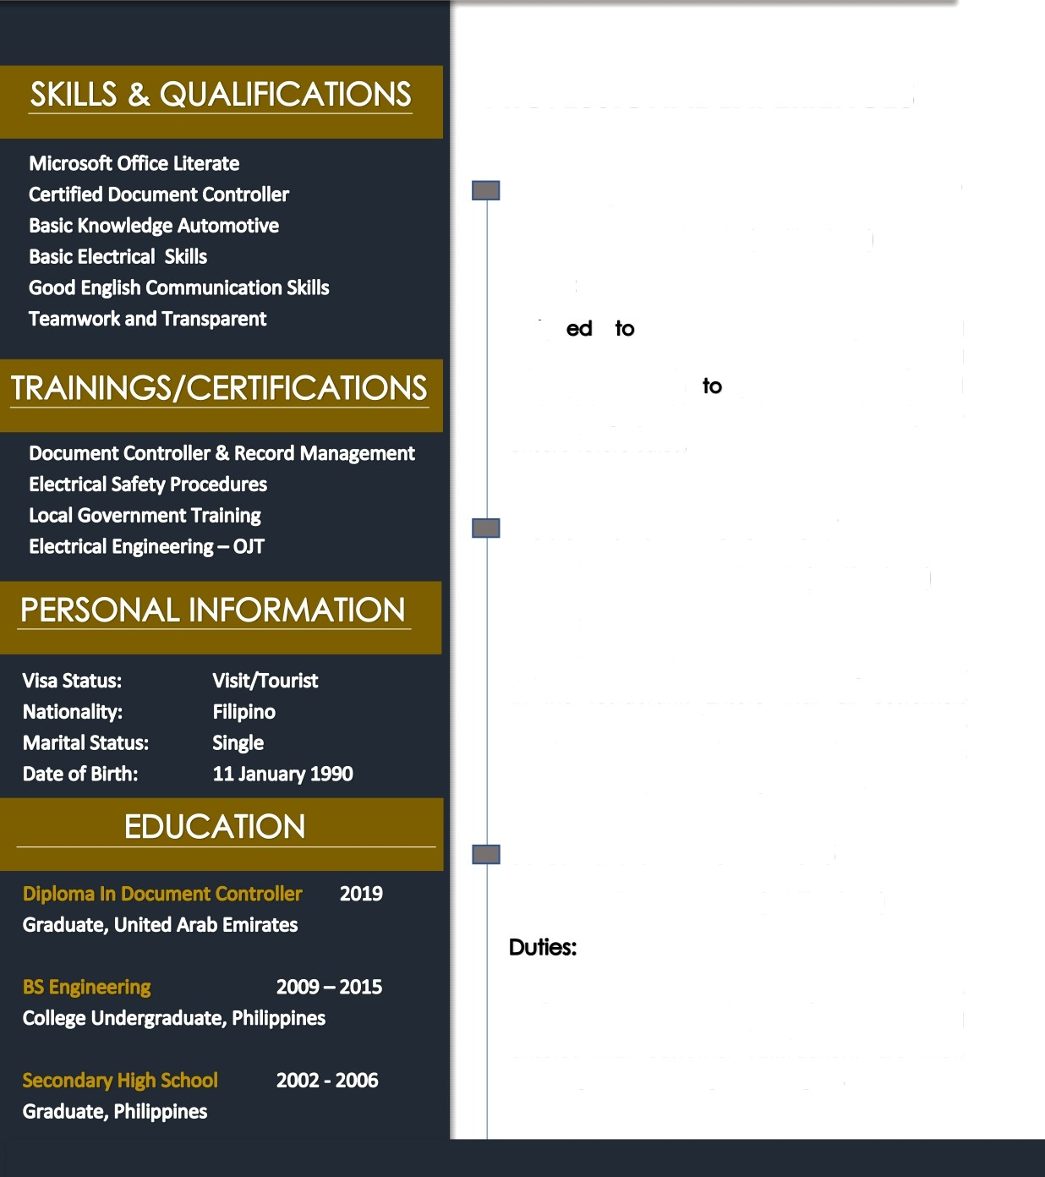

JOHNNY
As Document Controller/ Sales/ Restaurant

Email: Johnny-393969@2freemail.com

PROFESSIONAL EXPERIENCES
Sales Representative 2017-2019
( Philippines)

Duties:
Assign handle clients inquiries and represent soles product. Provide strong and solid presentofion potentials clients and maintaining positive business relationship to ensure future soles.

Head Waiter 2015 -2017
( Philippines)
Duties:
Supervise all service crews in assisting customers in the restaurant. Ensure thot all customers request and satisfactions ore met able to provide the best services. Immediately resolves issues thot may arise during workshifts.

Sales Assistant 2012-2015

( Philippines)

Assgined to assist and provide good services to customers inside the shop. Resolves issues and ensures thot customer satisfactions ore met. Meeting or exceeding soles targets.

