Resume: Salah



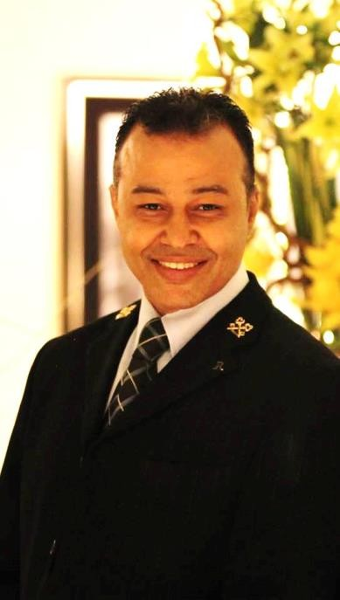

Salah
Member of Les clef Do'r international Nationality : Egyptian
Weight :177 Pounds
Length: 178 C M
E-mail: salah-393979@2freemail.com

Skills
- Advanced in Computer such as Internet , Microsoft Office, Opera.
- Good Team Player with Colleagues and the other department .
- Extremely Adaptable and flexible , Recognize different
- Excellent customer service skills
- Flexible and able to work at any time
- Planning and organizational talented
- Friendly & outgoing personality, well presented & groomed
- Guest focus & Problem solving skills
- Self-motivation, innovation and creativity
- Leadership and coaching skills
- Strong communication skills
- Attention to details and multitasking ability
Languages
- Arabic
- English

Previous Experience

Area Operations Manager
( 15 March 2019 – Present ) Dubai united Arab Emirates

- Manage and oversee all aspects of 34 different parking location operations and staff within the company’s portfolio
- meet organizational objectives, customer needs and contractual obligations
- Ensure compliance of company and client policies and procedures
- Review of client statements, and portfolio performance based on revenue analysis, profit & loss reports and various accounting based reports
- Responsible for annual budgeting and performance of location’s portfolio
- Builds relationships with existing clients while working on expanding location portfolio
- Assist in developing and facilitating the proposal process for existing and prospective clients for project development, proposal writing, contract negotiations, client presentation,
- Responsible to achieve the maximum level of Guest and clients satisfaction through the services that we offer
- Maintains effective communication with all clients and departments to ensure smooth service delivery,
- Responsible for interviewing, hiring, development and terminating of personnel as necessary
- Responsible to improve drivers performance
- Perform other duties as assigned

Previous Experience

Guest Service Manager

( May 2017 – 12 March 2019 )
446 Rooms( Dubai , United Arab Emirates )

- Provides leadership and support to all members of the Front Office and enforces of Excellence in all areas supervised ,
- ensuring that the highest levels of hospitality and service are provided,
- Manages the flow of questions and directs guests within the lobby,
- ensure each guests are welcomed in a professional and friendly manner,
- satisfying guest expectations from arrival through to departure,
- maintains effective communication with all related departments to ensure smooth service delivery,
- maintain a good working relationship with the Front Office team
- maintains an awareness of guest profiles through the Opera guest profile system,
- ensure that Front Office shifts are run efficiently,
- providing outstanding guest service,
- Assign duty roster for F/O attendant, Concierge, Bell Counter, Guest Relations and Business Centre.
- Checks cleanliness of lobby and public areas, lights and as well as front office staff in proper and orderly appearance and behavior,
- Checks on registration cards of arriving guests and ensures all information should be filled on each cards either by Guest Relation Officers or the guests,
- Gives the instructions to the Night Reception, during the high occupancy periods,
- Co-ordinates with all departments concerned in order to maintain Front Office functions properly ,
- Operates the front office computer system in order to assist front office attendants ,
- Fit and ensure switchboard makes appropriate wake up calls,
- Handles guest complaints and other related problems and reports on the Assistant Manager’s log book.

Previous Experience

Chief Concierge \ Duty Manager
( 17stNovember14 – April 2017 ) 396 Rooms( Dubai , United Arab Emirates )

- In charge of all Concierge operation,
- Insure each guests are welcomed in a professional and friendly manner,
- satisfying guest expectations from arrival through to departure, maintains effective communication with all related departments to ensure smooth service delivery,
- maintain a good working relationship with the Front Office team particularly Bell Boys.
- Ensures guests are greeted upon arrival and offered assistance at all times,
- maintains an up to date knowledge of the hotel services and communicates this to subordinates so they can supply information and respond to guest queries,
- maintains an awareness of guest profiles through the Opera guest profile system,
- Supervises the activity of the Bell Boys, ensuring that the guest luggage is carried from arrival point to room and from room to departure point on checkout. deals promptly,
- Efficiently and pleasantly with incoming calls,
- ensure that Front Office shifts are run efficiently,
- providing outstanding guest service,
- Assign duty roster for Concierge and front desk
- Handles all messages, mail and packages for guests and staff ensuring they are delivered at the appropriate time and stored if necessary in a systematic and efficient

Previous Experience

Chief Concierge
( October 12 – October 14 ) 333 Rooms(Cairo ,Egypt )

- Pre opining Team, assisting HR department in hiring new ambassadors ,
- Train and Supervises the work of Concierge, Navigators, Bellmen, Doormen and valet parking
- Maintains personalized service and Communicates with the Airport Representatives related to guest arrival details. Ensures that all guests are escorted and briefs about Hotel facility and room orientation to their assigned rooms .
- Coordinates with the Rent-A-Car service on transportation requirements .
- Organizes city tours for the guests. Keeps an eye on the cleanliness of the public areas.
- Handles any guest complaints professionally and reports them to the Front Office Manager accordingly
- Going out and discovering the unique places,Conducting micro-local research which provokes guest’s interests and peaks their curiosity about the locale in person visits
- Keeping an eye out for local/cultural events and new places to see, shop, or dine
- Working in conjunction with the management team to coordinate large ambassador training sessions ,Collecting feedback and suggestions from guests and ambassadors regarding the recommendations.

Training
- Excellence Service
- Basics Concierge and costumer care
- Essential skills for supervisors and managers
- Fight with fire
- Train the Trainer
- Foundation of leadership
- Business esthetics
- Night Manager crocus Training
- Housekeeping Manager Training

Achievements
- Founder of Egypt Concierge association 2012
- Ranked number one in trip advisor 2015 with Mövenpick Hotel
- Create ConSearch software
- being the general secretary & official speaker of Egypt Concierge association from 2012 till 2014

Hobbies
- Watching and play Foot ball
- Horse riding
- Reading
- Watching and play Chess
- Play saxophone

Awards
- General Manger thanks letters
- Guest thanks letters
- Employee of the month
- Concierge of the Month UAE 2010
- Trophy of 2nd Position for Maktom “Fujairah” Champion chip in CHESS 2010
- Certificate in basic concierge kills and customer care by DTCM

