GABER

Curriculum Vitae

PROFILE

I am a mature, positive and hardworking individual, who always strives to achieve the highest standard possible, at any given task. I possess excellent communication skills, and I have the ability and experience to relate to a wide range of people. I enjoy learning new things, I can work very well under pressure and I have the sales experience to handle customer complaints and solving problematic situations.

EDUCATION

Faculty of Arts Archaeology Department (Greek and Roman)

Alexandria University

Internship

Administrative Business (Greek &

Latin Archaeology)

Alexandria Library

SKILLS
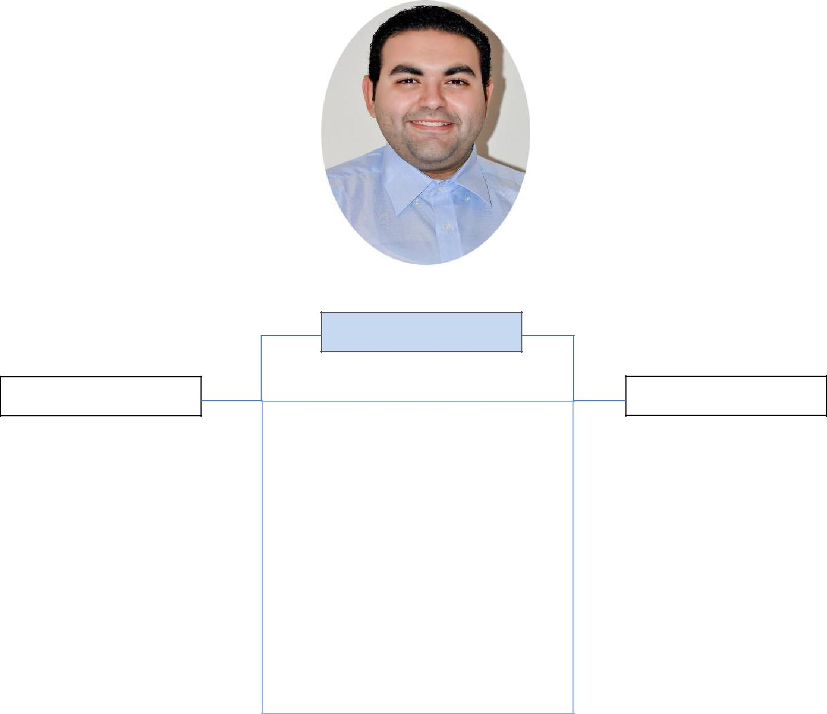

- Computer Proficiency

- Problem Resolution

- Deadline Oriented

- Staff Motivation

- Employee training and development

- Coordination

- Self – starter

- Customer Service Oriented

Deira, Dubai

Gaber-394026@2freemail.com 

PERSONAL INFO

Date of Birth: Oct. 28,

Language : Arabic/English

EXPERTISE

- Food Service
- Bill Generation

- POS Operation
- Inventory Keeping
- Order Synchronization
- Order Processing

EXPERIENCE

Supervisor

Jumeirah beach

Since January 2018 till now

Supervisor

Since November 2017

Team Leader/Baker, apparel group

Financial Centre, Dubai
October 2015 to October 2017

Egypt, Alexandria
April 2013- October 2015
Sales Promoter

Waiter

Alexandria, Egypt
2010-2012

REFERENCE

Available upon request.

