CONTACT

EMAIL: lisa-394029@2freemail.com

TECHNICAL SKILLS

Operating Systems:

Microsoft windows 7, 8, 10, Server 2012R2

Designing Tools/Software’s: MAT LAB, Proteus, HYPER-V, SQL (Beginner).

DETAILS

Date Of Birth: 27th September, 1995
Gender: Female

Marital Status: Single

Nationality: Indian

Languages: English, Malayalam, Hindi

Visa Status: Resident Visa

STRENGTHS

Comprehensive problem solving abilities

Good verbal and written communication skills
Ability to deal with people

diplomatically

Willingness to learn

LISA
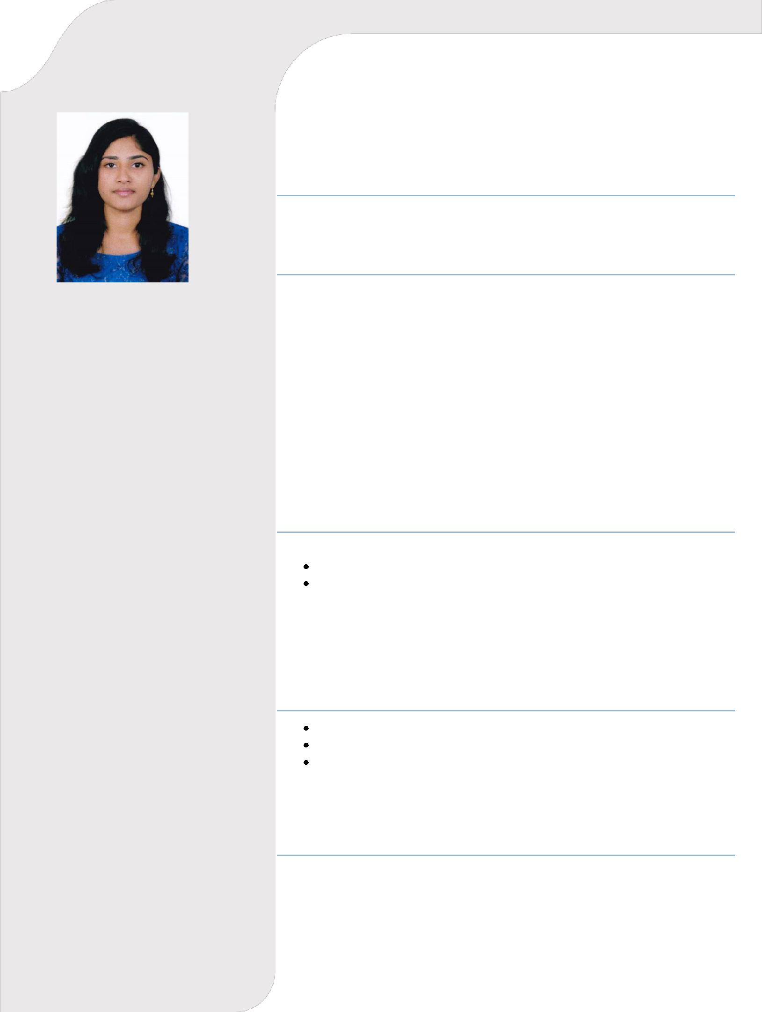
CAREER OBJECTIVE

To Work with a Rapidly Growing Organization with a dynamic and challenging environment to achieve goal of organization with my best efforts.

EDUCATIONAL DETAILS

B.Tech in Electronics and Communication Engineering- Aggregate of 6.85 CGPA Mar Baselios College of Engineering and Technology, Thiruvananthapuram, Kerala. University of Kerala

Year of passing: 2018

12th (CBSE) - 70%
Indian Excellent Pvt School, Sharjah, UAE

Year of passing: 2014

10th (CBSE) – 9.2 CGPA
Indian Excellent Pvt School, Sharjah, UAE

Year of passing: 2012

ACADEMIC PROFILE

PROJECT

Mini Project – Pulse oximeter

Main Project – SDH Intervendor Operability (BSNL Project)

INDUSTRIAL VISIT

Visited ISRO, Bangalore and got to learn about the satellite applications and saw various exhibits. Attended seminars based on the launching stages of a satellite.

TRAINING

Cisco Certified Network Associate (CCNA) for duration of four months. Microsoft Certified Solution Expert (MCSE) for duration of four months. One week Internship for Optic Fiber Communication at Regional Telecom Training Centre, BSNL, Thiruvananthapuram, Kerala during the month of December 2017.

DECLARATION

I hereby declare that the information furnished above is true and to the best of my knowledge.

Place: Sharjah Yours Sincerely

Date: Lisa

