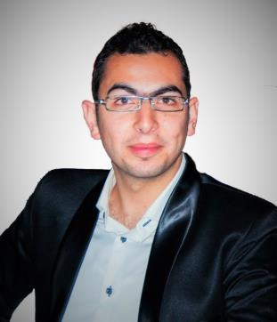
Sameh

E-mail: sameh-394049@2freemail.com
Address: Dubai – UAE

OBJECTVE

Seeking a Site Supervisor position as a Civil Engineer at your company That allowing me to utilize my education, internship and work experience while gaining valuable work experience in a team oriented environment.

EDUCATION

- I earned a Bachelor’s degree of Science (B.Sc.) in Civil Engineering

from Sinai University. | May 2015
    - CGPA: 3.52 “ Very Good ”

- Graduation project title:
  - “Analysis and Design tall buildings and compare between Structural systems to get the most economical and Safety".

    - CGPA: 4 “ Excellent ”

SKILLS & QUALIFICATIONS

- Knowledgeable in civil/structural design management and execution.
- Skilled in AutoCAD 2d, MS Office, Windows and Internet.
- Ability to produce technical specifications.
- Producing construction methodologies.

- Health and Safety awareness.
- Fast learner and independent with strong leadership and critical thinking skills.
- Very Good command of both written and spoken English.
- Excellent communication skills.

WORK EXPERIENCE

▪ I have attended a training as Site Engineer Summer 2014
- In a Construction Company, Cairo, Egypt.

( I have trained in Construction the building Of “ E-FINANCE COMPANY “) .

▪ Construction Engineer Oct 2015 – Apr 2016

- In a General Contracting Company, , Egypt.

( I worked as Site Engineer of “SPORTS ARENA PROJECT” in El-Arish Stadium With items :
Soil | preparation and compaction- Forming |  |  |  | and | pouring |  |  | different | R.C | elements | such
as | ( Isolated | Footing | ــ columns | – beams ــ |  | stands |  | )- Repairing of |  |  | damaged | R.C
elemnts - |  | Surface | preparation | for | Bitumen and |  |  |  | torch | membrane coating-

Backfilling-Masonry works-Steel Structure" Trusses Covering ").

▪ Road Engineer Apr 2016 – Oct 2016

- In a General Contracting, Egypt.

( I worked as Site Engineer of "Project of annual maintenance in Roads network in the city of El-Arish") .

▪ Road Engineer June 2017 – May 2018

- In a Trading & Contracting Company, Egypt. ( I worked as Site Engineer of "Project of the 30 june corridor" 5km) .

▪ Construction Engineer May 2018 – Till now

- In a Trading & Contracting Company, Egypt.

( I work as Site Engineer For "Construction of Head Regulator, Bridges and siphon(Tunneling machine) " with items :

- Soil preparation and compaction- Dewatering System - Forming and pouring different R.C elements such as ( shear walls –retaining walls - Piles)- Repairing of damaged R.C elemnts - Surface preparation for Bitumen and torch membrane coating- Backfilling )

Interests

- Computer
- Reading
- Swimming

- traveling.

- Learning

Personal Information

- Gender: Male

- Date of Birth: 1/03/1992

- Marital Status: Single

- Nationality: Egyptian

- Military Status: Exempted

