EDUCATION

2012 B Tech Mechanical Engineering

Adi Sankara Institute of Engineering & Technology, MG University, Kalady

2007 Higher Secondary

Govt. Rajah's Higher Secondary School,Kerala State Board, Kottakal

PERSONAL SKILLS

Good Communication

Leadership

Team Work

Judgment and Decision Making

Critical Thinking

Creativity

Time Management & Coordination

Active Listening

TECHNICAL SKILLS

Machining Operations – Lathe, Milling &

General Machining

ASNT Level II

Ultra sonic Testing ( UT ) Radiographic Testing ( RT ) Magnetic particle Testing ( MPT) Dye penetrant Testing ( DPT) System Analysis Fault Detection

Complex Problem Solving Operations Analysis Systems Evaluation Engineering Design Operation Monitoring Service Orientation

MS Excel, Word, Powerpoint

LANGUAGES KNOWN

English

Malayalam

Tamil

SALEEM
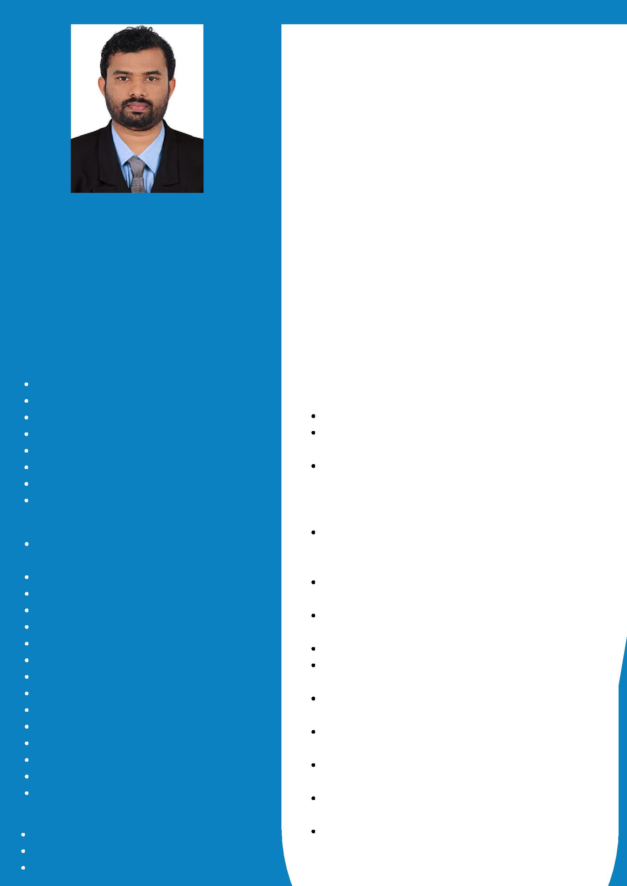

MECHANICAL ENGINEER

Email : saleem-394063@2freemail.com

CAREER OBJECTIVE

Detail-oriented Mechanical Engineer with more than 6+ years of experience in managing different phases of engineering operations. Looking for a better position in the field of Mechanical engineering in a reputable organization to expand my learnings, knowledge, and skills..

WORK EXPERIENCE

Assistant Engineer in Production Department

January 2017 - July 2019

Poduction planning.

Documentation of files as per AS9100 C standards.
Responsible for the manpower deployment for the various hammers in the drop Forging process & supervising the various processes in forge shop.

Supervising and coordinating activities of workers engaged in heating, forging, and inspecting metal work pieces and products.

Planning and coordinating sequence of operations within forge shop.
Maintain and provide consumables and tools to work stations.
Coordinating with other departments. Attending team meetings and sharing best practice with colleagues

Keeping Daily Production reports and other relevant documents
Protects organization's values and drawings by keeping information confidential. Undertaking other assignments, which may be assigned from time to time.

Entering and updating the data to the

production report.

Relationship building.

Assistant QA/QC Engineer

Trichy October 2013 - September 2016

Perform inspection of incoming products, materials or customer items according to job order.

Perform initial inspection and raise reports.

Perform in-process inspection according to procedures and customer’s specifications , raise report whenever necessary.
Perform final inspection of items NDT& Hardness to ensure that all quality requirements, analyze and decide the acceptance level of final product. Interact with customers and attend to their needs.

Prepare Data Book upon completion of jobs.

NDT Technician

Trichy

October 2012 - September 2013

Calibration of NDT Equipments & Maintaining calibration records.

Liquid Penetrant Testing &Magnetic Particle Testing in fabrication parts.

Carried out MT,PT for all boiler components.

Carried out PT on weld joints,water panels ,bow nuts and nuclear components.

AREA OF INTEREST

Quality Control

Oil and Gas Sector

HVAC

Mechanical Design

Manufacturing

Project management

M E P

INDUSTRIAL TRAININGS

Visited Telk, Kerala Automobiles as part of the Industrial visit.

Visited KAMCO Kerala Agro Machinery Corporation Ltd as part of the Industrial visit.

Trained as service advisor in Skyhigh Motors (Tata car Dealer).

PERSONAL DETAILS
Nationality. | : Indian
DOB | : 12 - 04 - 1989
Marital Status | : Single
Gender | : Male
Visa type | : Visit Visa
Visa Validity | : 10 - 11 - 2019

