ABDULLAH

Assistant Design Engineer

Abdullah-394067@2freemail.com

TECHNICAL SKILLS

AutoCAD

Basic of Solid Work

Microsoft Oﬃce

INTERESTS

Designing and Draughting

Research & Development

Production and Planning

Quality and Inspection

PERSONAL

CAREER OBJECTIVE
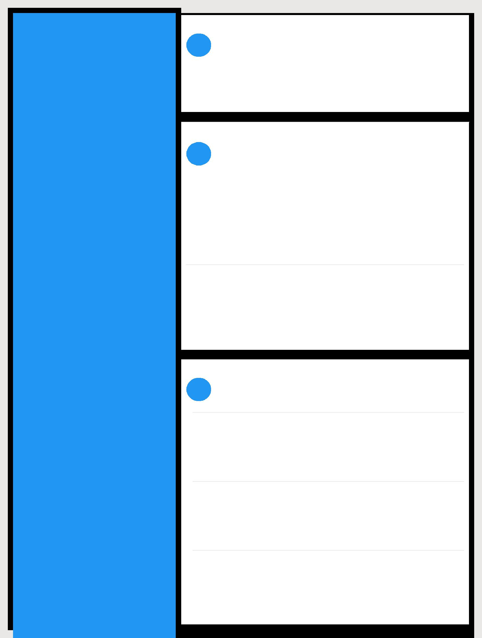

To work for an organization which provides me the opportunity to improve my skills and knowledge to grow accordingly with the organization's objectives and schedule.

 EXPERIENCE

Assistant Design Engineer

June 2018 - Present

Designing the various Mill Stands(Conventional and Housingless), Gear Boxes, Roll Changing Device, Sliding Car, Erection Drawings, Fabrication drawing, Foundation Drawing(Basic), BOM, BOQ etc.

GET (Production)

February 2018 - June 2018

Supervisor at Straightening and Peeling machines in order to achieve straight and finish Hydraulic Cylinder Rod.

EDUCATION

I.T.S Engg. College, Gr. Noida (A.K.T.U)

B. Tech (Mechanical)

81.23%

2018

Chokhraj T.S.V.M, Siswa Bazar

Intermediate

92.2%h

2013

P.I.C, Partawal Bazar

High School

71.33%

STRENGTHS 2011

Problem solving, Decision making, Eﬃcient, Diligent and Enthusiastic

SEMINARS

NPTEL video conference on Manufacturing science. Advanced Research in Mechanical by ARIMPIE 2016

 ACHIEVEMENTS & AWARDS
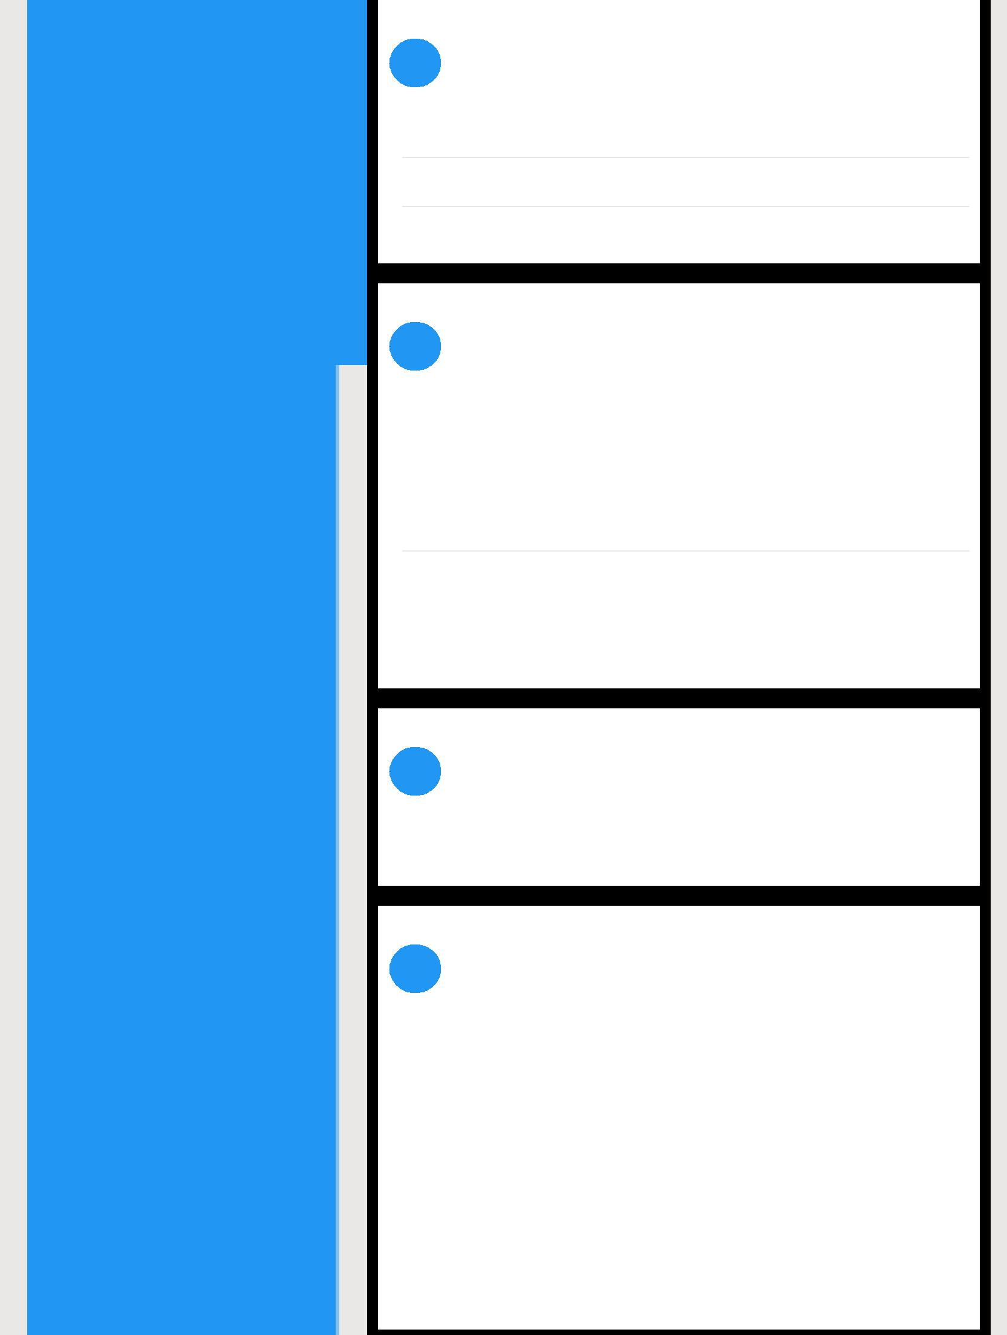

Employee of the Month (Nov 18 & Feb 19)

"Silver Medalist" in B.Tech

"Elite" certification in "Principle of Casting Technology" by NPTEL

PROJECTS

Project - Pneumatic cum Brick manufacturing machine

To develop the Bricks by using rotary extrusion operated by electric motor and final shape done by Pneumatic piston and Conyers Belt in order to get maximum output with less Manpower.

Internship - North East Railway, Gorakhpur

2 Months

Wagon assembly like Wheel, interior, brake drums etc.

ACTIVITIES

Volunteer Work

Exercises

PERSONAL PROFILE

 | Date of Birth | : 25/08/1996
 | Marital Status | : Single
 | Nationality | : Indian
 | Known | : English, Hindi, Urdu
 | Languages
 |  | Listening Music, watching Drama and
 | Hobby | : Gourmand

DECLARATION

I confirm that the information provided by me is true to the best of my knowledge and belief.

Date : 19.09.2019

Place : New Delhi

ABDULLAH

