CURRICULAM VITAE

MAHESH
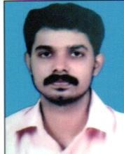
TRADING & CONTRACTING.LLC

EMAIL: Mahesh-394086@2freemail.com

 | PERSONAL PROFILE
 | Date of birth |  | : | 20.05.1983
 | Sex |  | : | Male
 | Marital Status |  | : | Married
 | Nationality |  | : | Indian
 | Languages Known |  | : | English,Hindi,Tamil,Malayalam
 | PASSPORT DETAILS
 | ➢ Date of Issue | : | 15-06-2011
 | ➢ Date of Expiry | : | 14-06-2021
 | ➢ Place of Issue | : | Trivandrum
EMPLOYMENT DETAILS

- 2008-2011 worked as a Heavy truck Driver in Dubai

- 2011-2013 worked in U K LONDON (private duties)

- 2013-2016 worked as a Heavy truck Driver in Dubai

- 2016-2018 working as a Heavy truck Driver in Oman

DECLARATION

I here by declare that the statement made above are true and correct to the best of my knowledge and belief

Place : Oman

Date :

MAHESH

