DANIAL
BS Civil Engineer

Danial-394090@2freemail.com

UAE driving License

Summary

Having total 4 years of professional experience in which almost 2 years as Site Engineer in UAE and 2 years at Site execution in Pakistan. In short period of time, I got chance to work in diverse Construction industry. During studies, I have done Internship in Oil & Gas development project, after Graduation I started my career as Site Engineer at Lahore orange line metro train project & Now I am working as a site engineer in Building construction in UAE.

Education

JULY 2015
BS Civil Engineering

Mirpur University of science & Technology (MUST) AJK.

Skills

• | Excel (frequently user); | • | Quantity Estimation
• Auto CAD 2D (Basic); |  | • | Micro Planning
• | Microsoft Project; | • | Negotiation & conciliation
• Microsoft Office (Word, PowerPoint); |  | • | Attention to detail

Experience (4 years overall)

SITE ENGINEER

Contracting Company in Dubai, UAE

JAN 2018 – CONTINUE

- Project Description:

“Midriff Hills, Mixed Use Development project (Multaqa phase)” Client: Dubai Investment Real Estate LLC.

Main Contractor: Engineering Contracting Company LLC (ECC Group)
Project worth: AED 454 Million

Project Overview: 2B + G + 4 + Roof in total 7 buildings. One Hotel Building, two Hotel Apartment Buildings and four Residential buildings. Ground Floor is fully utilized for commercial purpose.

- Project Description:

“BADR Phase 1, Mixed Residential & Commercial project” Client: Dubai Islamic Bank

Main Contractor: Engineering Contracting Company LLC (ECC Group)

1

Project worth: AED 688 Million
Project Overview: Common Basement + G (Retail & Residential) + 7 + Roof in total 11 buildings.

Responsibilities:

- Oversee the Execution of all phase of project.
- Implementation of work as per the Approved drawings.
- Experience in handling teams at site.
- Make sure that site meet legal guidelines, health & safety requirement

- Verify checklist of inspection request and testing as per planned schedule and approve (BBS);
- Compare the actual progress for the baseline program in Primavera p6 v8.3;

- Prepare weekly & monthly reports to the clients;
- Analysis of delays, mitigation and recovery;
- Monitor & compare weekly tasks for the site activities;
- Prepare weekly progress summary sheets for projects and compare with baseline program dates

- Prepare monthly presentations for the whole project status, activities payment received from the client, variations etc.

SITE ENGINEER

NOV 2015 – NOV 2017

Worked as Site Engineer at LAHORE ORANGE LINE METRO TRAIN PROJECT (LOLMTP)
Client: LDA
Project worth: 250 Million.

Responsibilities:
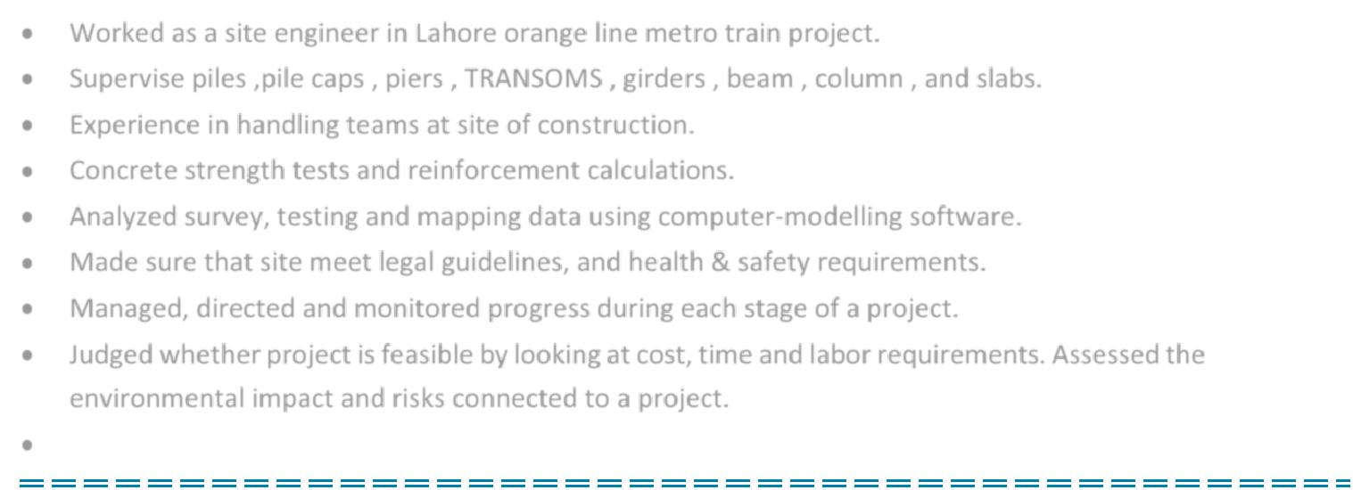
- Worked as a site engineer in Lahore orange line metro train project.

- Supervise piles ,pile caps , piers , TRANSOMS , girders , beam , column , and slabs.

- Experience in handling teams at site of construction.

- Concrete strength tests and reinforcement calculations.

- Analyzed survey, testing and mapping data using computer-modelling software.

- Made sure that site meet legal guidelines, and health & safety requirements.

- Managed, directed and monitored progress during each stage of a project.

- Judged whether project is feasible by looking at cost, time and labor requirements. Assessed the environmental impact and risks connected to a project.

- Attend progress meeting and co-ordination meeting on site with client and contractor.

HOBBIES

Sports enthusiast, Enjoy reading interesting books, Love watching documentaries and Socializing with friends.

LANGUAGES

English, Urdu & Hindi.

REFRENCE

Will be furnished upon request.

2

