PARVEZ
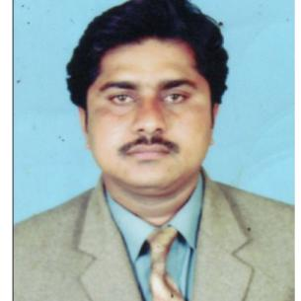

Parvez-394091@2freemail.com

OBJECTIVE

To obtain a responsible career, where I could optimally utilized my education, qualification as well as gained professional experience for making significant contribution in a progressive and dynamic organization.

EXPERIENCE

2016 - 2018 |  | GENERAL TRADING
 |  | SALESMAN
 |  | Greets people who walk in the store; respectfully asks if
 |  | they need assistance.
 |  | Provides educated recommendations based on customer’s
 |  | needs and objectives.
 |  | Assists customers in finalizing the purchase of the product;
 |  | processes type of payment and make sure customer is
 |  | given a receipt and exact change.
 |  | Immediately attends to customer complaints and works to
 |  | have it resolved in the fastest way possible,
 |  | Keeps the store clean and orderly.
2010 - 2014 |  | ELECTRIC STORE
 |  | WareHouse Supervisor
 |  | Plans, organizes, and supervises the operations of the
 |  | warehouse facility on a daily basis.
 |  | Receives documentation from equipment and material
 |  | suppliers.
 |  | Checks the quality of all materials received in the
 |  | warehouse and cross-references it with the order quantity
 |  | as detailed in the requisition form.
 |  | Organizes, loads, and delivers materials to the correct
 |  | location in the warehouse.
 |  | Supervises the processing of all requisitions and requests
 |  | for proper invoicing according to warehouse codes.
EDUCATION
2004-2006 |  | BISE SUKKUR SINDH PAKISTAN
 |  | 12th Intermediate (Commerce)
1999-2003 |  | BISE SUKKUR SINDH PAKISTAN
 |  | 10th Matriculation(General Science)

SKILLS

Computer and Internet Skills Written and Verbal Communication Organizational Skills Multi-tasking- Time Management

LANGUAGE

English-Urdu-Sindhi-(Arbic Normal)

ACADEMIC COURSES

IBA INSTITUTE COLLEGE SUKKUR

Sales & Marketing/Accounting 2008-2009

PERSONAL PROFILE

Date of Birth:15/02/1989
Gender: Male
Religion:Islam
Nationalty:Pakistani
Visa status:Own Visa(Transferable)

Visa Expiry:May 2020

