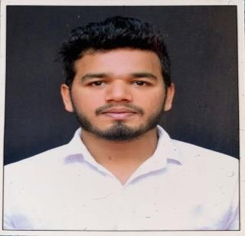
OBJECTIVE

Shafiq

DOB- 14.02.1996
shafiq-394111@2freemail.com

EXPERIENCE

Worked as a Part time Sales Coordinator
(July 2018-May 2019)

To secure a position which gives scope for learning and undertaking professional challenges, by displaying good interpersonal and team management skills.
- Maintaining high profile network with important clients in the area.
- Assisted as a single point of contact between the management and the customers.
- Maintaining accurate profile and history of all the clients in the database.
- Coordinated with the senior management in the pitch process- for the customer to buy suitable vehicle.
- Efficiently completed invoicing process and the registration of the vehicle.
- Assisted the sales team to provide consistency in customer satisfaction and to complete the showroom administrative works.
- Promoted sales within the showroom and outside of the sales area.
- Achieved the Sales target for July – Sept. 2018
- Train new administrative staffs in customer handling.

Worked as an Intern
(May 2018-July 2018)

SKILLS
WORK
MS-POWERPOINT
MS-WORD
MS-EXCEL
TALLY 9.0
PERSONAL
COMMUNICATION
TEAM PLAYER

INTERPERSONAL
TACTFUL, DECISION MAKING

- Conducted an organizational study on the behavior of the clients while buying a vehicle.
- Documentation and providing service packages to the clients.
- Weekly reports to the management and the mentor.
- Assisting the client in completing the registration process upon buying of the vehicle.

EDUCATION

Master of Business Administration (2017-2019) School of Management, Manipal
Manipal Academy of Higher Education Human Resource and Marketing

Bachelor of Business Management (2014-2017) Upendra Pai Memorial College, Udupi, Karnataka
Mangalore University

Pre University (2012-2014) Manipal Pre University College, Manipal, Karnataka
Department of Pre university Education

LANGUAGES  English, Hindi, Kannada, Malayalam, and Tamil.  INTERESTS  Anchoring Sports enthusiast  Playing individual and team sports  –Athletics, Volleyball, Cricket, Chess & other indoor- outdoor games. | SSLC (2011– 2012) Green Park Central School, Hiriadka, Karnataka  ICSE Board  PROJECTS  An organizational study on Client buying behavior for used cars - Udupi cars.  Minor thesis on Comparative Study of Work life stress in educational and corporate sector in Manipal.  ACCOMPLISHMENTS  Certified Brown belt holder in “Kobudo Budokan Karate“Since 2009.  Participated in the “Aloysius Inter-collegiate Volleyball tournament” held in St. Aloysius Autonomous College, Mangalore 2016  Won first place in the “Colloseum 2018” Volleyball tournament conducted by School of management, Manipal  Won second place in the “Colloseum 2018” Cricket tournament conducted by School of management, Manipal  Participated in the Inter-Mahe Volleyball tournament for two consecutive years 2018-2019  Participated in District Level Volleyball tournament in the year 2013-14  Participated in organizing the college fest in Upendra Pai Memorial College 2016-17  Employee of the month for consecutive three months July – Sept. 2018.
DECLARATION
I hereby declare that all the details furnished are true to the best of my knowledge.

Name: Shafiq
Place: ABU DHABI, UAE

