SHAMNAS
Email: shamnas-394121@2freemail.com  Holding valid UAE Driving License (Lightvehicle)  Academic Profile:  - BCOM, University of Calicut (from Uthaman College) 2006 -2009  - XII from Central Board of Secondary Education.  (KMM ENG school)2006  - S.S.L.C from Central Board of Secondary Education.  (KMM ENG school) 2004  BehavioralSkills:  - The ability to Empathize and Listen attentively has groomed me in to a compatible and level- headed team player and leader.  - A Pragmatic and Persistent approach has imbibed single- minded determination and focus towards every task that I undertake.  - An eye for Observation and a probing nature act as vital tools for keeping the ‘learning drive’ alive. | Mission Statement:
I believe in expanding my capacities to create results through new pattern soft thinking. Thus, I am in pursuit of an organization that is continually expanding its capacity to create its future through generative learning.
Profession:
CASHIER/SUPERVISOR /SALES /MERCHANDISER/OFFICE ADMINISTRATOR / DOCUMENTS CLERANCE / CLERK/
 | AcademicProfile:
 | - BCOM, Univeristy of Calicut (from Uthaman College) 2010 -2013
 | EMPLOYMENT EXPERIANCE:
- MUSCAT- OMAN
Worked as Sales Executive (Jan 2017- April 2019)

- STORE SECTION ABUDHABI, UAE (Dec 2014–Sep 2016) Worked as Supervisor
- ABUDHABI, UAE Worked as Salesman & Merchandiser From August 2009 to December 2012
 | SKILLS
- Handling and interacting with agencies and management.
- Perform other related duties as required.
- Keeping and control of company documents.
- Ensure the confidentially and security of all financial and employee files.
- Receive and verify invoices and requisitions for goods.
- Processes payments by totaling purchases; processing checks, cash ,and store or other credit cards.
- 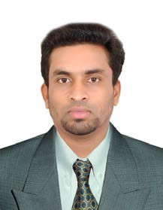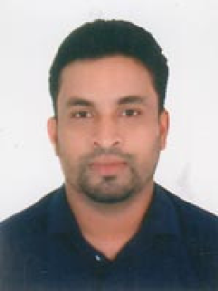Contributes to team effort by accomplishing related results as needed.

- Expert in driving.

ComputerSkills
KeySkillsandAchievements:

- Leadership skills

- Logical and Analytical approach to solving problems

- Ability to grasp and learn new things quickly

- Good communication skills in English and Hindi & Arabic.

- Highly organized with the ability to manage multiple tasks to meet the deadlines.
PASSPORT DETAIL

Place of Issue: Muscat
Date of Issue : 11/05/2018
Date of Expiry :10/05/2028
- Windows
- MicrosoftOffice
- Tally
- PeachtreeAccounting
- InternetBrowsing
- BasicKnowledgeinComputerHardware&Networking

PersonalParticulars:

Name :Shamnas
Date ofBirth :16/11/1987

Gender :Male

Place of Domicile :Eramangalam, Kerala.

Languages Known :English ,Hindi, Arabic & Malayalam

Hobbies :Sports, Music, Driving.

Achievements : Playing Cricket and Football in District level Tournaments.

Declaration

I hereby declare that the above written particulars are true to the best of my knowledge and belief.

Shamnas

