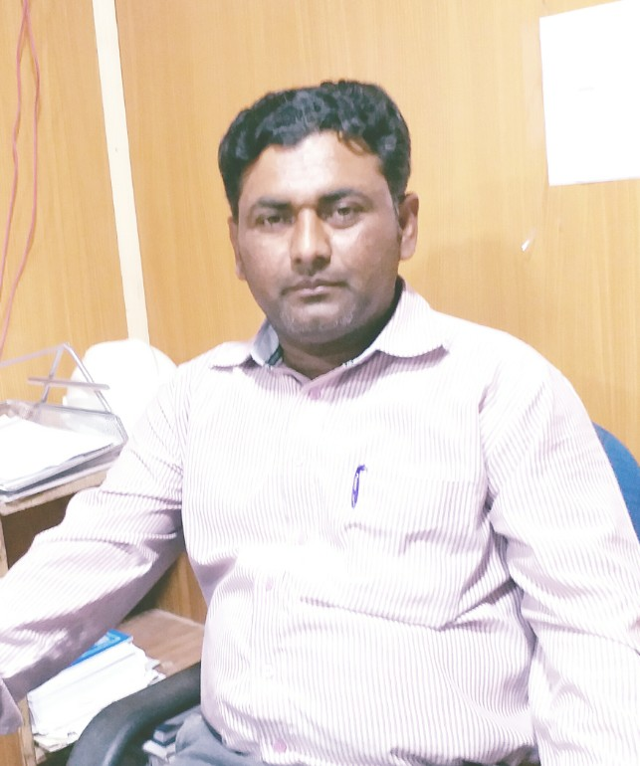
IRSHAD
Irshad-394127@2freemail.com

CAREER OBJECTIVE:
To obtain a position in an organization which may provide opportunity to work in a fast paced, professional and competitive environment and allow me to be a part of its vision for enhancing my skills and growing my career along with it.

QUALIFICATION:
- B.E Civil Engineering - 2006 to 2009
Mehran University of Engineering & Technology, Jamshoro

RESEARCH WORK: (Final Year Thesis/Project)
A knowledge based on the maintenance and planning of highway concrete bridges

PROFESSIONAL EXPERIENCE:

01 Feb 2018 To till date.
  - working as QC Engineer civil as a Third party Inspection Job description:
- Carry out a Provides necessary assistance to construction supervision team with respect to material inspection.
- Performs civil quality assurance inspections and prepares daily reports.
- inspections and checking for all quality related procedures in the site.
- carry out all inspections to follow the specifications, codes and drawing.
- if any violation occured then delivered Field Quality Alert and Non conformance report NCR.
- Meetings with main client and contractors about quality of all activities.
- Reviewing project documents and drawings
- Ensuring quality of project as per standards of quality e.g quality inspection plan and project specifications
- All types of site inspections of civil work to ensure quality of work
- Ensuring quality of construction Materials concrete, rebar etc as per International codes and Standards (ASTM, AASHTO).
- Review all type of project Documents related to quality assurance including project quality plans (PQP), Quality inspection plan (QiPs), Punch Lists, Quality Dossiers, Material Approval requests (MARs), Method statements, Bar bending schedules (BBS).

- 15 April 2015 To 30 december 2017
  - Working as QC Engineer ( Coal Power Plant Project)

Job Description:
- Setting out the works in accordance with the issued for construction drawing, specification and related method statement.
- Liaising with the project planning engineer regarding construction programmes
- Checking materials and work in progress for compliance with the specified requirements
- Observance of safety requirements
- Resolving technical issues with employer’s representatives, suppliers, subcontractors and statutory authorities
- Supervising and counselling junior or trainee engineers
- Measurement and valuation (in collaboration with the project quantity surveyor where appropriate)
- Providing data in respect of variation orders and site instructions
- Preparing record drawings, technical reports, site diary

- 10 May 2014 To 16 Mar 2015
  - Working as Senior Engineer

Job Description:
- Ensures that Contractor's works are being carried out according to plans, standards, and specifications prior to approving work.
- Provides necessary assistance to construction supervision team with respect to material inspection.
- Performs civil quality assurance inspections and prepares daily reports.
- Reports includes but not limited to; maintenance problems, calculates dimensions and component specifications and discusses project requirements with superiors

- 22 Apr 2013 To 30 Apr 2014
  - Working as QC civil Engineer

Job Description:
- Conduct the laboratory tests of all kind of material; Fine aggregates, coarse aggregates, water and admixture used for concrete
- Prepare the mix designs of concrete and trials mix of cubes and cylinders to check the strength after 7 days and 28 days
- Monitoring the batching plant and to give guidance to the plant operators about different mix designs
- Execution and monitoring of work at different sites
- Submission of daily report of concrete at different sites to the higher management
- Conduct the slump test, temperature test and compressive strength test of concrete
- Prepare the compressive strength test reports after crushing cubes or cylinders of concrete
- Responsible for quality of material and strength of concrete
- Provide feedback to the higher management on the client needs and problems
- 11 Oct 2010 To 30 Mar 2013
  - Working as FIELD ENGINEER (SCCDP PROJECT)

Job Description:
- Survey and Design of Community Physical Infrastructures Schemes (CPIs)

- Preparation of cost estimates Community Physical Infrastructures Schemes
- Submission of monthly progress report of CPIs programme activities in the respective areas
- Preparation of Scheme Installment Requests
- Assist Community Physical Infrastructures Schemes (CPIs) section in preparation of proposal, data collection, monitoring and evaluation of the sectoral programme
- Any other task assigned by PM/RGM/RP PITD/DPO
- Provide feedback to seniors and higher management on client problems and needs on daily basis

- 02 Mar 2010 To 30 Sep 2010
- Worked as SITE ENGINEER (Benazir Housing Society Project)

Job Description:

  - Survey of the houses in assigned areas

  - Estimation of the houses along with their components

  - Execution of the work according to the estimated design and drawing

  - Monitoring of the work in preparation of Houses and assist the material

  - To provide technical support to the masons and labors

  - Submission of weekly progress report to the management

PROFESSIONAL ASSOCIATIONS:
- Member of Pakistan Engineering Council (PEC) since June 2010;

INTERNSHIPS:
  - Three weeks internship at Nagar Parker at Gabion Dams from associated consulting engineers ACE(pvt) Limited
  - Three weeks internship at construction of jail Fly over Karachi from Loya Associates

INDUSTRIAL VISITS:
- Pakistan Steel Mills, Karachi
- Layari Express Way, Karachi
- Thatta Cement Factory, Thatta
- Izhar Construction Company, Karachi

COMPUTER SKILLS:
- Windows, MS Office (Word, Excel, PowerPoint)
- Internet interfacing

INTERPERSONAL SKILLS & EXTRA ACTIVITIES:
- Better Leadership Traits
- Good Communication, Presentation and Interpersonal Skills
- Good in written & spoken English, Urdu, Sindhi languages
- Reading Books (Religious, Engineering related, Literature etc) and Newspapers. Playing Cricket

PERSONAL INFORMATION:
- D.O.B: 3rd Feb, 1988
- Nationality: Pakistani
- Religion: Islam

