Raj Kumar  rajkumar-394145@2freemail.com  DOB: 02 July 1975  ACHIEVEMENTS  Awarded best performer of the month multiple times in recognition of being the best performer of the team.  Extra mile award for going beyond the call of duty to meet the business requirements.  Long service awards for completion of 5 years and 10 years.  Successfully implemented/completed HBE- Rendezvous program by covering 353 home- based employees.  SKILLS & STRENGTHS  Functional Attributes  Able to develop excellent working relationships with people from all levels of professional and social backgrounds.  Worked under pressure situations and met all expectations set by the management and client SLA’s.  Excellent communication, presentation & interpersonal skills, with the ability to relate well to people from a wide range of cultures. Able to perform effectively in high pressure environments.  Personal Attributes  Self-motivated. Reliable.  Consistent. | CAREER OBJECTIVE  To be a part of a highly competitive company wherein my knowledge, talents, skills, and experience can be effectively utilized that will result for continuous personal and professional growth and development.  SUMMARY  Talent recruitment and acquisition professional with experience developing and executing recruiting plans within in-house settings. Manage all phases of full-cycle recruiting, from initial sourcing and screening through offer negotiations, placement and onboarding. Creatively source high-caliber candidates by leveraging recruiting software, social media, cold calling, and employee referrals.  RECRUITMENT/HUMAN RESOURCES/ADMINISTRATION SKILLS  Talent assessment and acquisition.  Sourcing and screening (Naukri.com, Monster, LinkedIn, and Times Jobs, etc.)  Advanced Boolean searches.  Social media recruiting (Advertisements, etc.)  ATS and Recruitment Software (HRMS, VirtualEdge, iCIMS, HireCraft).  High-volume staffing (Skilled, Technical, IT, Executive, Management, Directors, Finance/Accounting and Office/Admin Support Staff).  Interviewing (Telephonic, face-to-face, Skype, etc.). Offer negotiations/finalization.  Onboarding and induction. Vendor management.  PROFESSIONAL EXPERIENCE  Assistant Manager-HR/Senior Talent Acquisition Lead/Recruitment Manager, Senior/Recruitment Manager/IQC/Production Trainer/SWAT Executive (June 2007 - June 2018)  Hyderabad, Telangana, India  JOB DESCRIPTION  Recruitments utilizing various sourcing methods like Web portals, i.e., Naukri.com, Monster, Times Jobs, etc. as well as external agencies/consultants.  Referring/Managing/Updating internal database, employee referrals, etc.  Screening and shortlisting profiles as per the SLA’s of clients. Coordinating with candidates for initial screening, understand their competencies & skill sets, making them understand job role by providing complete, accurate, and inspiring information to candidates about the company and position before shortlisting candidates.
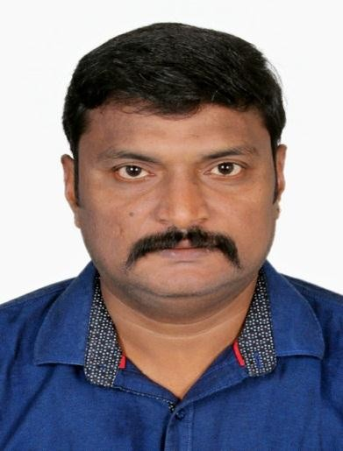

Computing Skills  MS Office. Microsoft Word. Excel.  PowerPoint.  Internet Applications.  Language Skills  English. Hindi. Telugu. Malayalam. Kannada. Tamil.  Urdu.  Interests/Hobbies  Reading. Music.  Travelling. Photography. Cooking. | Arranging for personal interview on shortlisting, coordinate with client in arranging the final interview.  Performing detailed reference checking and/or reference analysis on selected candidates and review results with clients.  Maintaining daily/weekly/monthly reports such as interview status reports, closure reports and feedback reports.  Complete pre-employment formalities until onboarding as per company's policy.  Meeting 100% TAT deadlines.  Actively supported all HRBP activities in the absence of full-time HRBP.  Conducted inductions for all new employees.  Production Manager  (November 2006 - March 2007)  Andhra Pradesh, India  JOB DESCRIPTION  Handling end-to-end operations/delivery of projects by being a bridge between the production unit and clients.  Senior Proof Reader  (September 2005 - September 2006)  Vasavi Prosoft Transcriptions Limited  Hyderabad, Telangana, India  JOB DESCRIPTION  Audit/Proof Read/Edit reports/files/documents from junior level and deliver error-free reports to the client.  Senior Proof Reader  (July 2004 - August 2005)  Metasolutions Inc.  Hyderabad, Telangana, India  JOB DESCRIPTION  Audit/Proof Read/Edit reports/files/documents from junior level and deliver error-free reports to the client.  Senior Medical Transcriptionist  (January 2003 - June 2004)  Telangana, India  JOB DESCRIPTION  Edit/Transcribe reports/files/documents, audit reports/files/documents from junior MTs/OJTs/Trainees, and deliver error-free reports to the client.

Senior Medical Transcriptionist
(December 2002 - December 2003)

Telangana, India

JOB DESCRIPTION
Edit/Transcribe reports/files/documents, audit reports/files/documents from junior MTs/OJTs/Trainees, and deliver error-free reports to the client.

Senior Medical Transcriptionist/OJT/Trainee
(November 2000 - November 2002)

Hyderabad, Telangana, India

JOB DESCRIPTION
Edit/Transcribe reports/files/documents, audit reports/files/documents from junior MTs/OJTs/Trainees, On-the-job Training/Training, and deliver error-free reports to the client.

EDUCATION
Graduation: Bachelor of Arts
Institution: Dr. B R Ambedkar Open University
City: Hyderabad, Telangana, India

Pre- University: Vidyapeet Junior College Institution: Board of Intermediate Education City: Hyderabad, Telangana, India

Secondary School: Kendriya Vidyalaya Golconda No.1
Institution: Central Board of Secondary Education
City: Hyderabad, Telangana, India

TRAININGS AND PROJECTS
Completed Six Sigma training. Active team player in CIP projects.

MISC. INFORMATION
Notice Period: Immediate
Reason for Change: Career Development

REFERENCES
Available upon request.

g

