Curriculum Vitae

SUMON
Email : summon-394157@2freemail.com
Dubai, UAE

Post a lied for: Hea Vehicle Driver

A Challenging attractive position commensurate with my qualificatlon and experience. To work in accordonce with my Lnow/edge, skills ond work effectively by providing high quollty & standard service are on my way to the entire satisfaction and success of the company as well as to build up my career and quality.

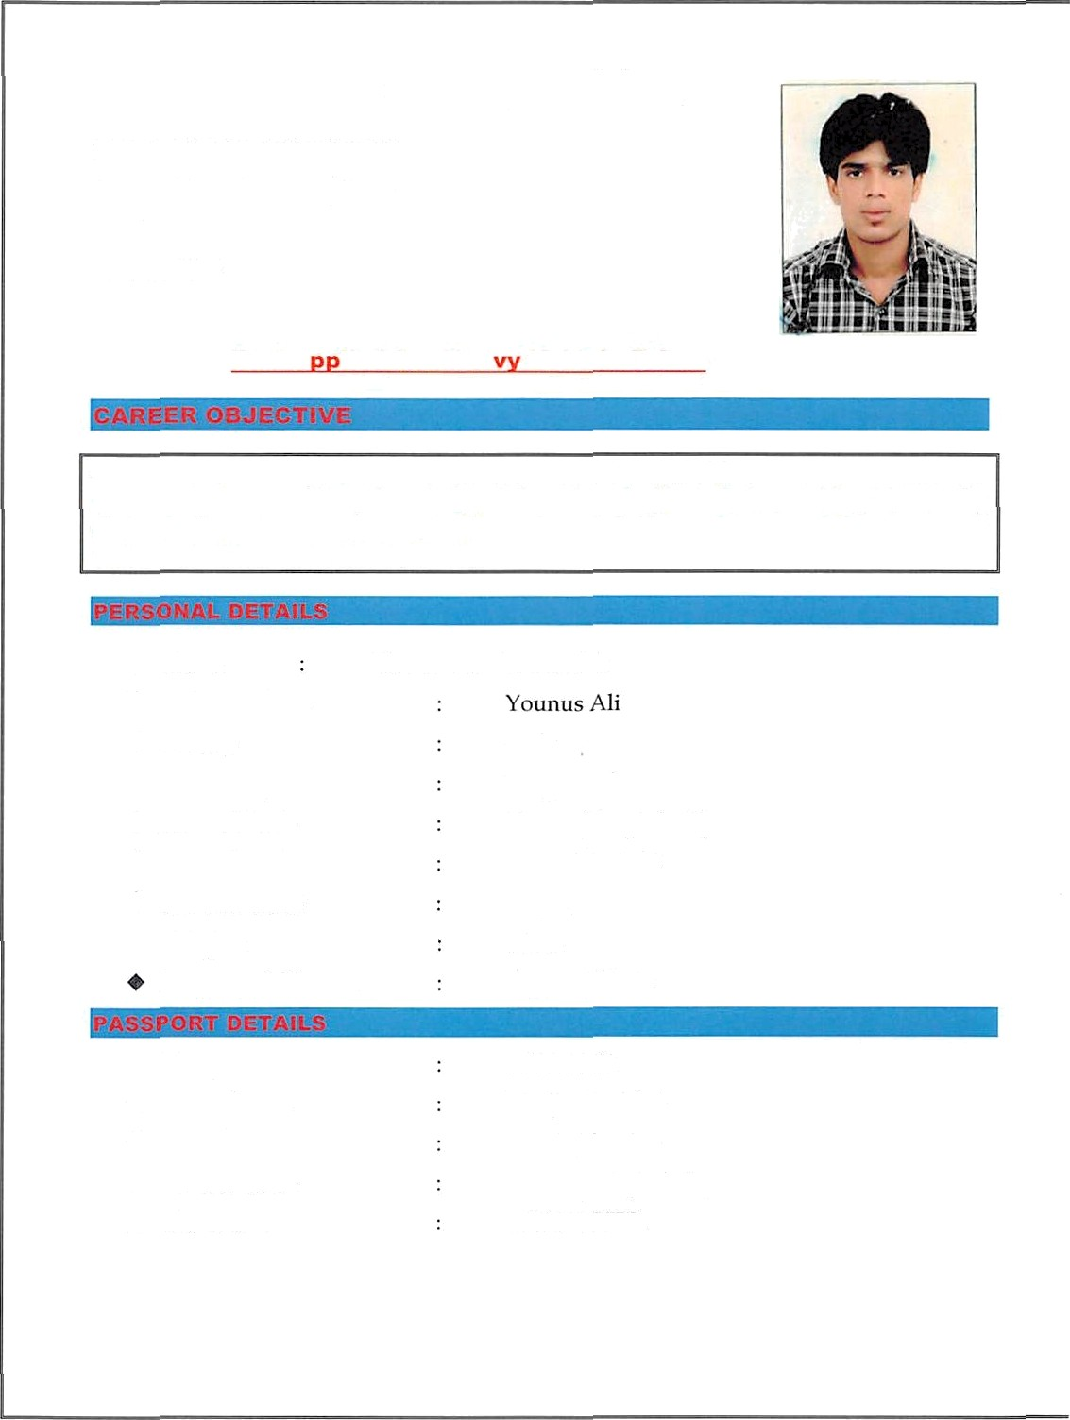
Gender

Nationality

+ Place of Birth Date of Birth
Marital Status Religion Language’s Known

Date of Issue Date of Expiry Place of Issue Visa Status

Male Bangladeshi
Dhaka (Bangladesh) 03 - JUN - 1992
Single

Islam
English, Hindi

28 - JAN - 2016
27 - JAN - 2021
Dhaka (Bangladesh) BUS DRIVER.

Issue Date Expiry Date Place of Issue
Pei mitteci \*ehiclcs

13 — 02 - 2014
13 — 02 - 2024

DUBAI (UAE)
3,6

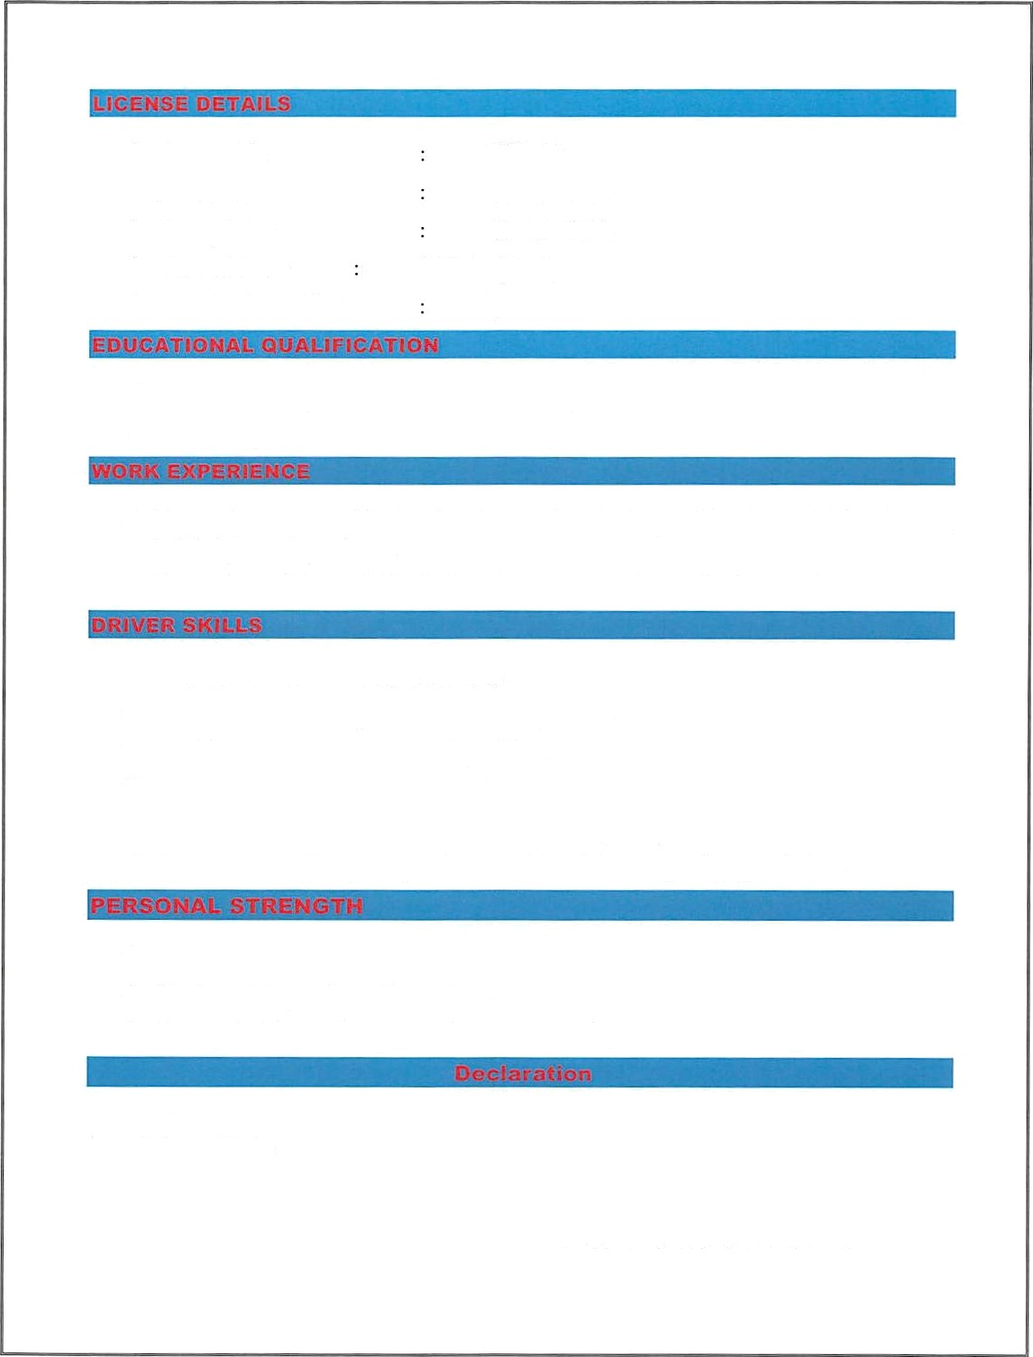

S.S.C Sccc›ndar)• School Certificate iii Bangladesh.
H.S.C Hibher School Certificate in Bangladesh.

Presently work as a “Driver in Dubai, UAE. 5years Experience.
Worked as Driver in BangIadesh,4 year Experience.

Good verbal communications skills.
Pei’forrn vehicle safer checks before dcpartui c. Excellent customer service and t)ualities.
Report any safer' concerns immediately to coiiipany iiianagcinent. Assist customers in a pi tifcssional, polite, anal prompt manner.
Demonstrated ability to operate the vehicle follow ing safer' guidelines.

Respectful and cooperation with colleagiies.

Hard w orking anii result orientetl.
Yotlll@ H0altliy alice enei'gctic. Sti ong Team Player.

I do hei’cl›y ‹declare that all the alcove rnentioi1e‹l ‹retails ai e true anc4 correct to the best of my knou•le‹ige and belie

SUMON

