Personnel Information

E-mail: safvan-394189@2freemail.com

Date of Birth | :
11-2-1996
Cast and religion | :
Islam, mappila
Gender | :
Male
Nationality | :
Indian
Marital Status | :
Single

Languages known:

English, Malayalam

SAFVAN
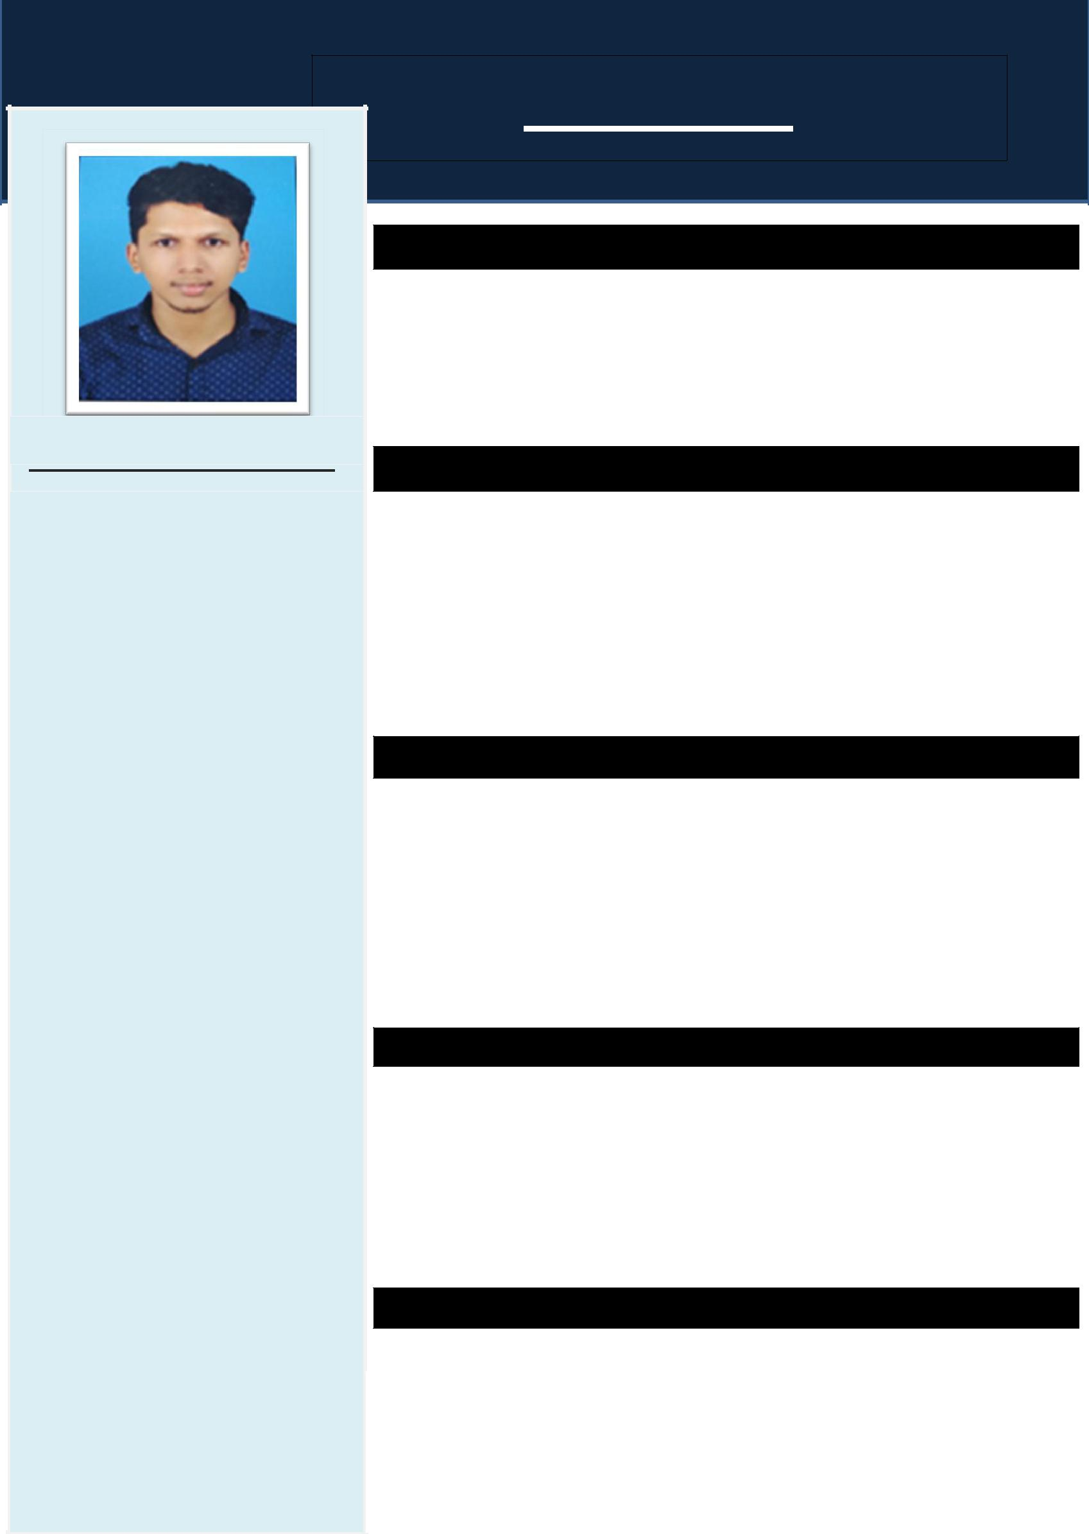

CAREER OBJECTIVE

Ambitious to build a career in accounting and finance with an organization where team work is required and hardworking is appreciated and to be in a position which is best suited to my knowledge and skill.

KEY SKILL

- Sincere and hard working.

- Computerized accounting with tally.

- Internet and commerce management.

- Knowledge of accounting and auditing.

- Can work efficiently in tally

IT SKILL

- TALLY EP 9(GST)

- MICROSOFT OFFICE

- QUICK BOOK

- PEACH TREE

EXPERIENCE

- 3 Month experience cement as an accountant.

- 1 year and 10 months experience as an accountant. ( still working))

ABILITIES AND AREA OF STRENGTH

- Ability to work efficiently and in a confident work environment.

- Ability to carry on responsibility level.

- Also possess good interactive skills.

EDUCATIONAL QUALIFICATION

 |  |  |  |  | 2011 |  |  |  |  |  | SSLC
 |  | 2011 - 2013 |  |  |  |  |  |  |  |  | VHSE (Accountancy And Auditing)
 |  |  | 2014 - 2017 |  |  |  |  |  |  |  | DEGREE (B.Com Computer Application,
 |  |  |  |  |  |  |  |  |  |  | Calicut University)
 |  |  |  | 2018 |  |  |  |  |  |  | PGDCAM (Tally, peach tree, quick book, excel)

DECLARATION

I do hereby declare that the particulars given above are true to the best of my knowledge and belief.

DATE : 5 -9 -2019 | SAFVAN

