Curriculum Vitae

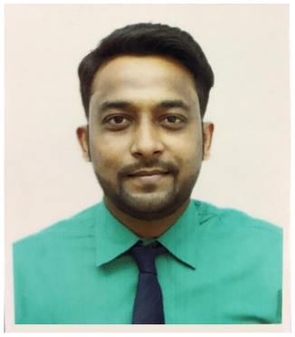
Latifkhan
E-Mail: latifkhan-394195@2freemail.com

Objectives:
To Work in an organization where I am able to contribute the organization’s growth and profitability with, my skills and in turn get an opportunity to gain exposure and expertise that would help me to build a promising and successful career.

Experience:

- Worked in Accounts Department from
09/02/2017 to 31/03/2019

Responsibilities:
- Working in Tally ERP9, Excel & Word
- Handling and verifying quotations, preparing purchase order for the same.
- Handling day-to-day cash transaction, preparing salary, cheque, payment, receipt, purchase order & Bank reconciliation
- Export documentation
- Sound Knowledge in Import & Export

- Worked for one year (2012) in Accounts Department

Responsibilities:
- Working in Tally ERP9, Excel & Word
- Handling and verifying quotations, preparing purchase order for the same.
- Handling day-to-day cash transaction, preparing salary, cheque, payment, receipt, purchase order & Bank reconciliation
- Export documentation

- Worked for 2 years as Accountant.

Responsibilities:
- Detail-oriented, efficient and organized professional with extensive experience in accounting system.
- Receive, Register, Verify & process all invoices & transactions in the record.
- Managed vendor accounts, generating weekly on demand cheque
- Process monthly payroll & maintain approved payroll records
- Bank reconciliation

- Worked at SOFTAGE INFORMATION TECHNOLOGY LIMITED (Vodafone India) for 2 years as Data Entry Operator.

Responsibilities:

- Maintaining an MIS data of complete sim sales details along with customer details.
- Enters information into the computer system through typing and scanning.
- Verifies accuracy of work by comparing it to source documents.
- Compiles data from various sources.
- Maintains confidentiality of information.

Educational Qualification:

Degree | Board/University | Year of passing
B. Com | Gujarat University | 2010
H.S.C. | G.S.H.C.E. Board | 2007
S.S.E. | G.S.H.C.E. Board | 2005

Other Skills:

Computer Knowledge: MS Office, Tally 9.

Strengths: Hardworking, Self-Confident, Honest and Good
Communication Skills & Punctual.

Personal Information:

Date of Birth : 03rd June 1990
Marital Status : Married
Religion : Muslim
Languages Known : English, Hindi and Gujarati
Gender : Male
Nationality : Indian
Interest Areas : Reading, Listening Songs & Travelling
Visa Status : Visit Visa

Date: Signature

Place: Dubai (Latif Khan)

