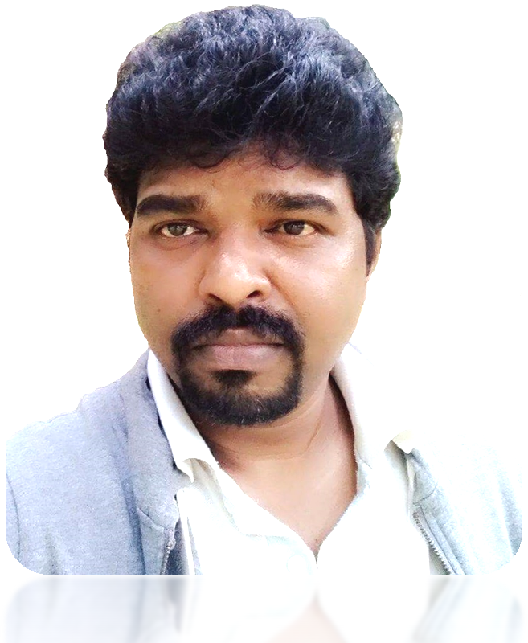
organization
ven professional, targeting assignments in Finance & Accounts, with a reputed
: senthamarai.kannan@hotmail.co
+971 52 517 8217
www.linkedin.com/in/senthamarai-kannan-41484744

Achievement-dri
Senthamarai Kannan
P R O F I L E S U MM A R Y

- An achievement-driven professional, offering over 19 years of rich experience in administering the entire gamut of Accounts & Finance functions.
C O R E C O M P E T E N C I E S

Finance and Accounting Operations Regulatory Compliance
MIS Reporting and Documentation GAAP/IFRS
Accounts Payable & Accounts Receivable

Finalization of Accounts / Statements Budgeting & Forecasting
Cash Flow management Auditing and compliance Accounting standards
- Skilled in Supervising Finance and Accounts activities encompassing

consolidation & finalization of accounts, intercompany reconciliation and settle stakeholders.
m
scrutiny of general ledger, ent of payments with all

- Experienced in administering the reconciliation process and monthly accounts closing process while reviewing & finalizing financial statements.
m
- Capable of providing leadership across establishing and implementing internal controls disciplines throughout the organization, monitoring all facets of cost accounting including budgeting, forecasting, cash flow, financial analysis, variance analysis reporting and cost control.
- Proficient in ensuring smooth running of the accounts payable &
accounts receivable and ensuring efficient processing and collections of company payables and receivables.
- Team-based management style coupled with the zeal to drive visions into reality.

P R O F E S S IO N A L E X P E R I E N C E

Available on UAE Visit Visa till 15th December 2019
Sep’17 – Sep’19
Sgs Mechcrafts India Private Limited, Coimbatore as Manager Accounting and Finance
Scope: P&L Management 3 directs reports Manage Accounting and Finance operations Inventory Management

Summary of Contributions:
- Provide timely & accurate submissions of monthly MIS & budgeting including analysis and preparing annual budgeting.
- Consolidate forecast business plan results & estimates and communicate updates to the business plan, providing insights into the underlying drivers of the results
- Accounts receivable management including receivable reconciliation and ageing, accurate recording of collections and accrued revenue, accounts payable including payroll, liquidations of advanced payments, approval of accounts payable journals, reconciliation and aging and cash management.
- To drive the highest degree of Financial Planning, P&L and balance sheet and cash flow management
- Review and filing of statutory-compliance.
- Inventory recording and monitoring of received and issued items
- General accounting and general ledger entries including fixed assets depreciation and disposal, fixed assets reconciliation, pre-payments, accruals, bank reconciliation, provisions and write-off
- Lead and manage all key financial planning and reporting system implementations policies and internal controls.
- Ensures completeness, accuracy and timeliness of all financial reporting including variance analysis. Completeness of annual audit reviews and ensuring compliance with IFRS and with all legal requirements.
- Responsible for a key point of contact for internal audit and statutory audit
- Ensuring local business plan has a sound financial plan. Understanding and awareness of actions taken as acting finance controller for group Companies.

Highlights:
Implemented and designed the structure of the financial software for the company.

May’15 – Aug’17
Nasdaq Corporate Solutions (India) Pvt Ltd., Bangalore as Manager – Accounting
Scope: Finance Head 5 directs reports Reported to VP and Board of Directors Audit liaison Accounting, Finance Management

Summary of Contributions:
- Accomplishing all the day–to-day finance and accounting operations and ensuring accurate recording and books close in accordance with global business plan and internal calendars and perform a wide variety of general accounting functions including accounts receivable, accounts payable management including payroll preparation, outstanding review, and approval of payments and month-end closing processes with compliance report. Scrutiny of general ledger, intercompany reconciliation.
- Recording reporting activities for two branches in India, managing cash flow, monthly and quarterly MIS with analysis and co-coordinating with stakeholders across different entities.
- Ensuring that the accounting transactions adhere GAAP, IFRS requirements and budgeting & forecasting.
- Evangelizing the internal controls as per Companies Act and enable audit certification for the India legal entities
- Monitoring the health & hygiene of the account balances vide timely and quality account reconciliation collections and payment.
- Preparing project profitability report for making decisions.
- Implementing the changes required in accounting as per latest accounting policies update
- Preparing financial statements and driving the tax and statutory audit for closure in time and without audit qualifications
- Conducting in transfer pricing audit
- Managing the accounting operations and cash management as an Indian Finance head for Bangalore and Nagercoil units and acting as a finance controller for Indian entity

Highlights:
Implemented a PeopleSoft, oracle based ERP environment and Concur, employee reimbursement tool. Conducted GST compliance workshop for implementing GST

Jan’12 – May’15
Velan Valves India Private Limited, Coimbatore, as Assistant Manager – Accounts/Finance
Scope: 4 directs reports Cash Management Audit liaison Accounting, Finance Management Internal Controls Reported to CFO

Summary of Contributions:
- Provided and interpreted financial information on general accounting by monthly/quarterly/year end reporting (Flash, P&L, Balance Sheet, cash flow and financial statements)
- Ensured statutory compliance, track and monitor compliance of filing requirements for Service Tax, VAT, TDS and any other applicable indirect taxes.
- Review and processing of approved Projects, capital, trade and non-trade vendors payments and receivable management
- Safeguarded integrity, completeness and accuracy in accounts reconciliation process including capital budgets, general Ledger, accounts payable and accounts receivable.
- Ensured that appropriate internal controls in place, in line with local statutory laws and GAAP, and critically examine potential issues where financial risks & opportunities may be drawn out for tax line items including external commercial borrowings
- Supported tax leader and consultants on driving favorable closure on litigations. Preparing financial statements conducted in statutory, tax and transfer pricing audit.
- Coordinated with banks and financial institutions for all finance related matters including sanction and renewal of cash credit, bank guarantee, letter of credit and foreign exchange. And authorized signatory for cash management along with the directors.

Highlights:
- Successfully setup at the green filed venture, all initial finance department controls to form up a finance team as a first finance employee of the company.
- Implemented a Baan ERP environment.

Feb’08 – Dec’11
Ultra Tech Cement Limited (RMC Division), Coimbatore as City Head- Commercial Scope: Cash Management All Commercial functions 2 directs reports Internal Controls Summary of Contributions:
- Monitored & controlled accounting operations and maintained books of accounts & policies, statutory & internal audit controls.
- Generated monthly MIS & work closely with the corporate planning and accounts payable & accounts receivable.
- Administrated cash management, statutory compliances, MIS, documentation for vendor agreements. Knowledge of accounting standards and guidelines with latest tax regulations and evaluations for cost reduction opportunities.

Highlights:
- Managed all vendor price negotiations with the best rates to raise the unit profit maximization and proven as a paymasters an individual Unit Commercial Head
- Successfully implemented a SAP for accounting and commercial functions.

E A R L Y C A R E E R
Apr’04 – Feb’08
Kala AutoTex, (Manufactures of Machined Components for Automobiles, Textile Machinery), Coimbatore as Accounts Officer

Sep’02 – Mar’04
The Residency (5 Star Hotel in India), Coimbatore as Accounts Executive

Aug’99 - Jul’02
Kirthilal Kalidas & Company, Coimbatore (Manufacturer and retailer of diamond and gold Jewelers), as Marketing Executive

P R O J E C T S

Title: “A study on the accounting and reporting procedures”
Organization:M/s Best Techno Management private Limited, Coimbatore Period: May’96

Title:“Consumers attitude towards hire purchase with respect to LMV’s”
Organization: 20th Century Finance Corporation Ltd., Coimbatore Period: May’98

Title: “A Study on investor’s attitude towards non-banking finance companies”
Organization: PSG College of Arts and Science, Coimbatore Period: Jan – Apr’99

E D U C A T I O N & O T H E R C R E D E N T I A L S

1999 M.Com., (Specialization in Finance) from PSG College of Arts & Science, Coimbatore
1997 B.Com., (Commerce) from PSG College of Arts & Science, Coimbatore

Other Courses:
- Diploma in Office Automation @ PSG College of Arts & Science, Coimbatore
- Strong aptitude with PeopleSoft, Baan Finance, SAP Modules: Financial Accounting (FI), Material Management (MM), Sales & distribution (SD) and Tally ERP 9.3.1 and MS office packages

P O S I T I O N S H EL D

- Department representative of Department of Commerce at PSG College of Arts and Science, Coimbatore (1997-1999)
- City Head at UltraTech Cements Limited, second in command and responsible for all Finance and Commercial activities

(2008-2011)
- Section Head - Finance at Velan Valves India PVT Limited (2012- 2015)
- Indian Finance Head at Nasdaq Corporation India Private Limited for Indian operation (2015 – 2017)
- Acting Finance Controller for Sgs group Companies (2017 – Sep 2019)

P E R S O N A L D E T A I L S

Date of Birth : 4th January 1976
Languages Known : Tamil & English
Marital Status : Married
Nationality : Indian
Passport Number and Validity : Z 5068849 and Validity till 26/07/2028
Permanent Address : 161, Thulla Arumugam Street, Puliakulam, Coimbatore – 641045. Tamil Nadu, India
Current Address : Flat No: 204 , Al Sheikh building , Near Desi Deira Rrestaurant, Rolla Street, Burdubai, UAE

======

