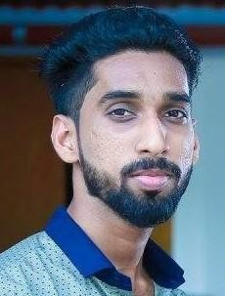

E-Mail:
Jauhar-394265@2freemail.com

Personal Data:

Computer Skills
Programming Language: C, Verilog Web Technologies: HTML,PHP,IIS Operating System: Windows, Linux, Windows Server 2008
Application Package: Microsoft Office

Languages Known
English Hindi Tamil Malayalam

Hobbies Listening Music, Travelling,
Playing Football And Cricket

JAUHAR

Career Objective
To have a growth oriented career where I can prove my credentials on the grounds of Performance and Commitment and to help the Organization to reach its objective. Realize my potential, and to become a successful professional.
Specialization /Interesting Sectors
- Electronics engineering, Material handling, electrical, Production planning, Hardware, Networking (MCITP and CCNA) and Ticketing Agency.

Work Experience

- Worked as Office Manager from 15/December/2015 to 10/August/2016.
- Worked as Ticketing Executive from 10/February/2017 to 12/July/2019.
Date of Birth | : 09-06-1992
Religion | : Muslim
Nationality | : Indian
Marital Status | : Single

Academic Qualification
- Diploma in Electronics and communication Engineering - Board of Technical Education, Government of Kerala.
- Higher Secondary - Board Higher Secondary Education Kerala Government
- SSLC - Public Education Department Of Kerala Government

Professional Traits
- Smart worker, Effective communication
- Problem Solving and Right Decision Making at Right Moment
- Willing to work-hard in any kind of situation, Interpersonal skills
- Disciplined and good etiquette
Projects

Project 1

Title :Intelligent Accident Presentation For Two Wheelers
Tools : 89c51 Micro Controller, Liquid Crystal Display, Alcohol Sensor, Helmet Sensor, License Reader, LEDS, GSM Modem Interface, Sim, Power Supply, Switch.

Project 2

Title :Sunlight Alarm
Tools :Resistors, Capacitors, 555ic, Switch, Speaker, LDR, Battery, Transistor
Declaration

I hereby declare that the above-mentioned information is correct up to my knowledge and I bear the responsibility for the correctness of the above- mentioned particulars.

Jauhar

