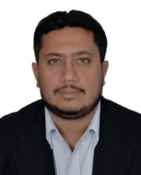
NABEEL
BACHELOR OF ARCHITECTURE
S.O.E Membership
DM Registered

E-Mail: nabeel-394268@2freemail.com
Nationality:Pakistani D.O.B:5th Nov. 1984 P.O.B: KSA

Objective: To join a vibrant and lively organization, where I’ve the opportunities to learn, contribute and
groom my professional skills.

Professional Career Summary:
Area of Interest: Office, Commercial, Residential, Educational, Religious, High-rise Buildings & Corporate Interior.

Professional Expertise:
Pre-construction:Concept Designing, Architecture Planning, Presentation, Detailed Drawings, Project Coordination with other discipline, Meeting with clients, Authority Submission/Discussion& Approval, Overall Project Handling.
Post Contract:On & Off site coordination Construction, Reviewing Tender Documents, Pre Tender Meetings, Post Tender Meetings, Project Follow up & Progress Monitoring, Responding RFIs, Review/approve Submittals, Review/approve Shop drawings, Selection of Material & approval , Inspections, Attending progress meeting etc.

Experience: 6 Year(s) of Professional Experience
Duration | Country of Exp. | Designation | Experience
May-16 – Present | United Arab Emirates | Project Architect | Currently Working
Dec-14 – April-16 | Pakistan | Architect Engineer | 01 year 04 month(s)
Apr-13 – Nov-14 | Pakistan | Project Architect | 01 year 07 month(s)
Mar-13 – Apr-13 | Pakistan | Post Grad. Internship Program | 01 month(s)

Education:
Sr. | Degree/Certification | University/ Institution | Specialization | Year
01. | B-Arch | Dawood College of Engineering & Technology | Architecture & Planning | 2013
02. | Intermediate | Cadet College Sanghar | Pre-Engineering | 2004
03. | Matriculation | Usman Public School | Science | 2001
04. | LEED GA (Certification) | Course lectures complete – Preparation for test in progress | Green Building | In Progress

SoftwareSkills:
Sr. | Short Courses& Skills | Working Levels
01. | Auto CAD (2D-Architecture) | V. Good
02. | Photoshop (Plan Render) | Good
03. | Google Sketch Up (3D Modeling + Basic V-ray Render) | Good
04. | MS Office | V. Good
05. | Revit Architecture | Average
Reference : Reference & Portfolio can be furnished on demand.

PORTFOLIOGLIMPSE
Some of Live/completed Projects in Dubai, UAE:
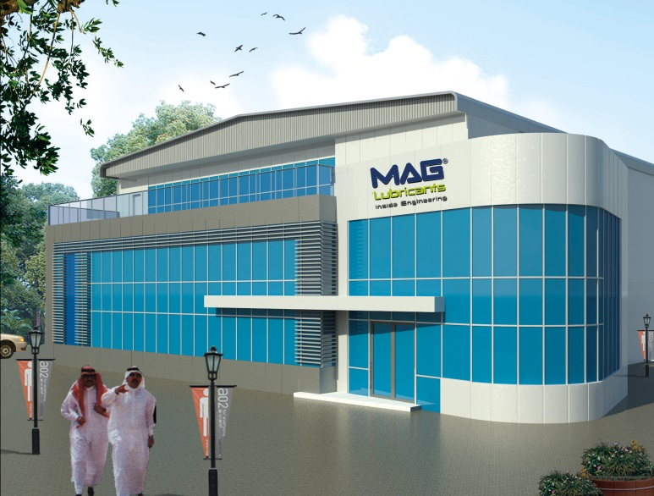

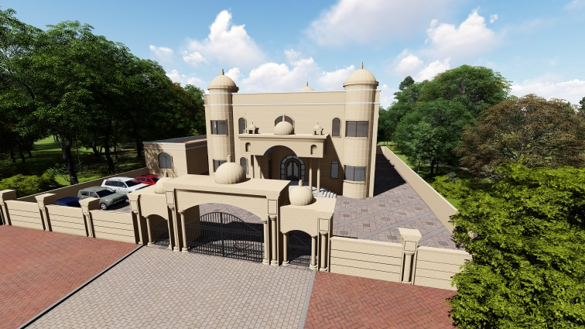

G+M Office Block at Existing Factory in JAFZA-(Dubai) for
M/S Mag Lube L.L.C
As Project Architect/Coordinator
G+1 Villa at Dubai Hills (Dubai) for
Ms. MarimIshaq Abdullah
As Project Architect

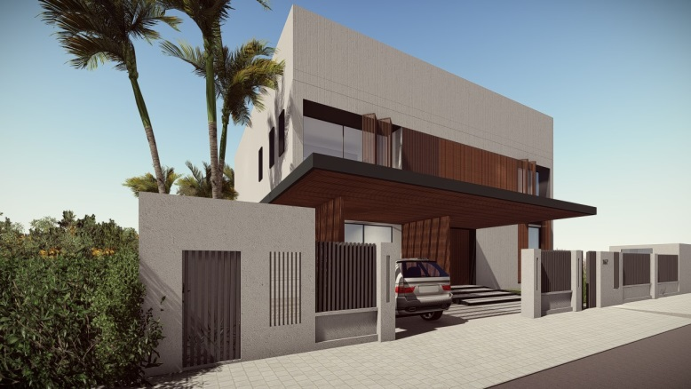
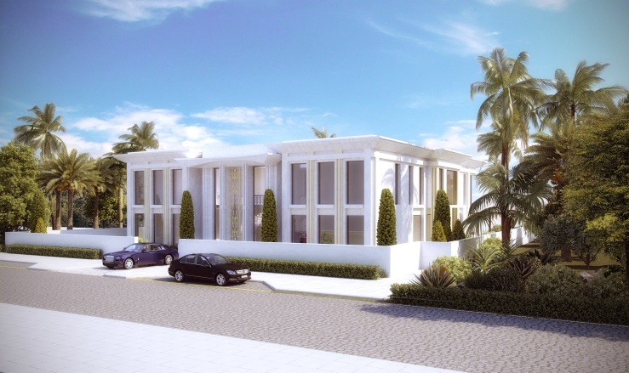

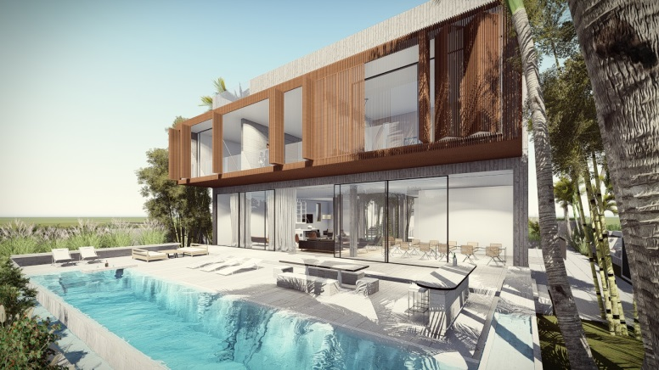
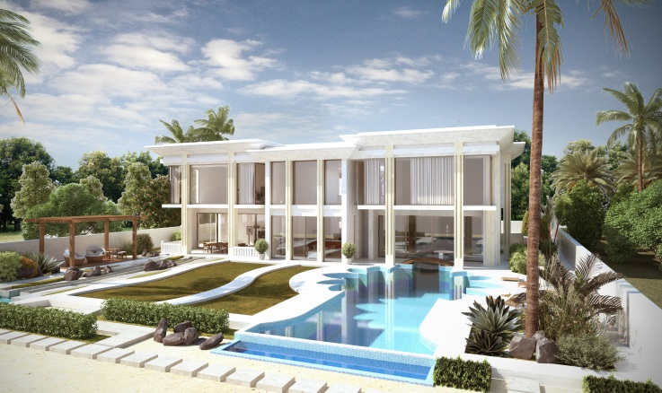

B+G+1 Villa at Dubai Hills(Dubai) for
Mr. HammadAtassi
As Project Architect
B+G+1 Villa at Jumeira Bay(Dubai) for
Mr. BakhtiyorIrgashiev
As Asst. Project Architect

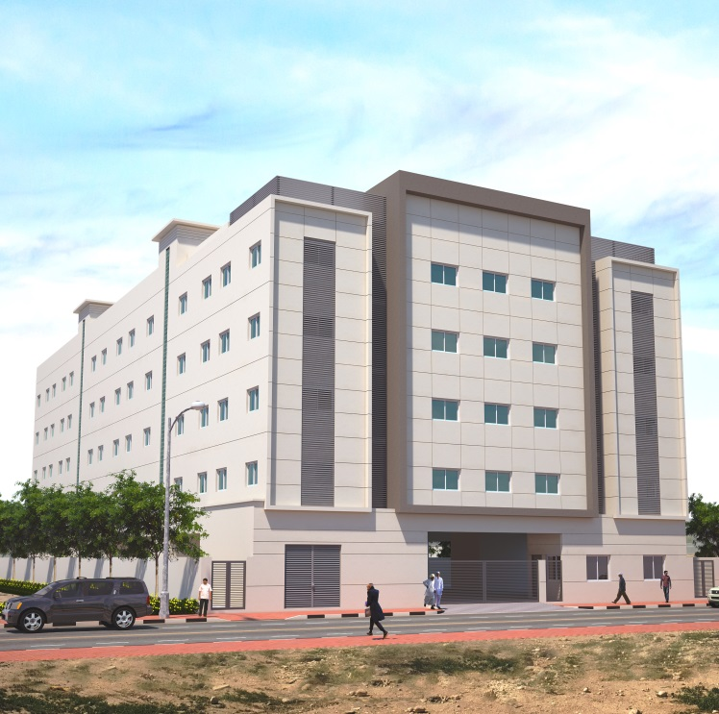
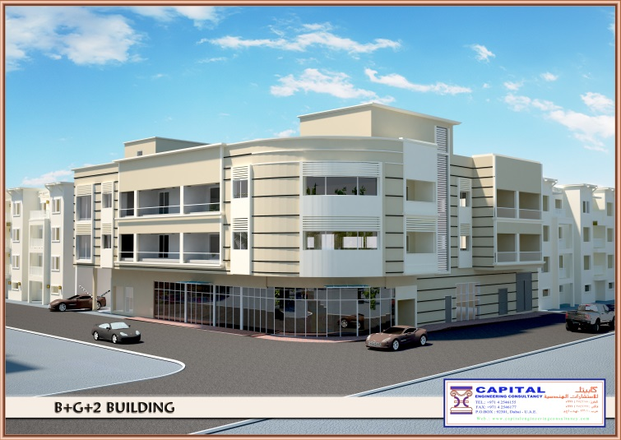

B+G+2 Residential Commercial
Building At Hor Al Anz (Dubai) for
Mr. Ahmad Ali Essa
As Asst. Project Architect

G+4Labor Accommodation at JabelALi Industrial (Dubai) For
M/S White Horse Properties L.L.C
As Project Architect
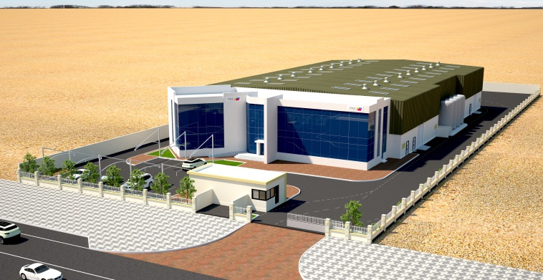

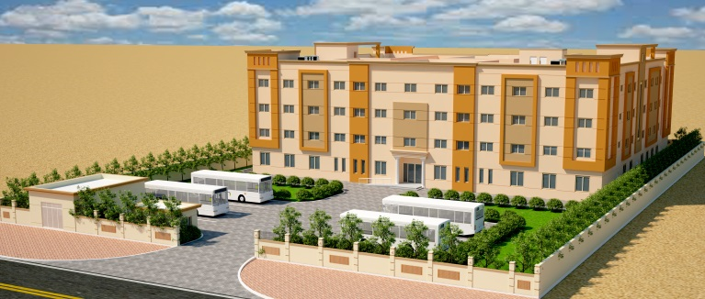

Ground Only Factory Shed & G+M Office Block at JAFZA (Dubai) for
M/S. PAC Technologies L.L.C
As Asst. Project Architect

G+3Labor Accommodation at DIP (Dubai) For
M/S GBMT Steel Services L.L.C
As Project Architect

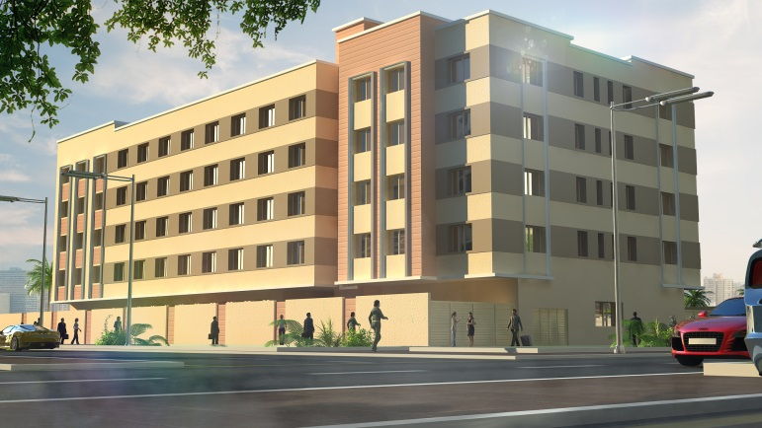
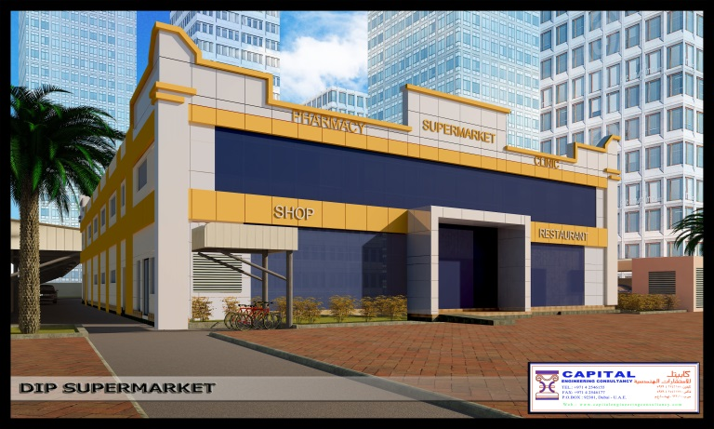

G+3Labor Accommodation at
Jabel Ali Industrial (Dubai) For
M/S Elements GAG Real Estate Development L.L.C
As Project Architect

G+M Hypermarket at D.I.P (Dubai) for
Mr. Walid Ali Ibrahim Al Mannaei Al Tamimi
As Asst. Project Architect

Some of Completed Projects in Pakistan:
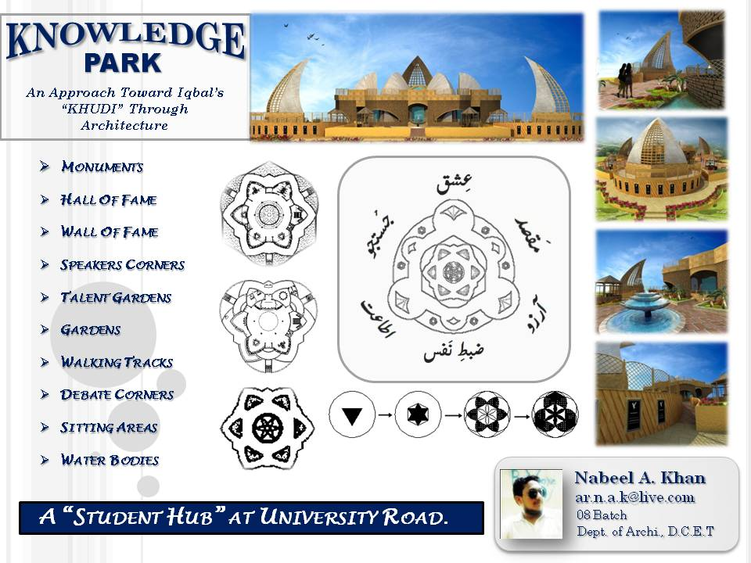
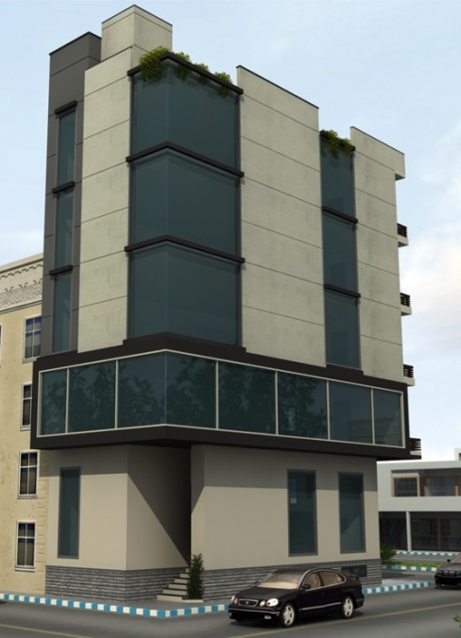

Final Year Thesis Design Project
Knowledge Park
An Approach toward AlamaIqbal’s Philosophyof “Khudi” (Self)
100 sqydOffice Building For
Abbaseen Construction Co.
Design, Detail & Site Inspection

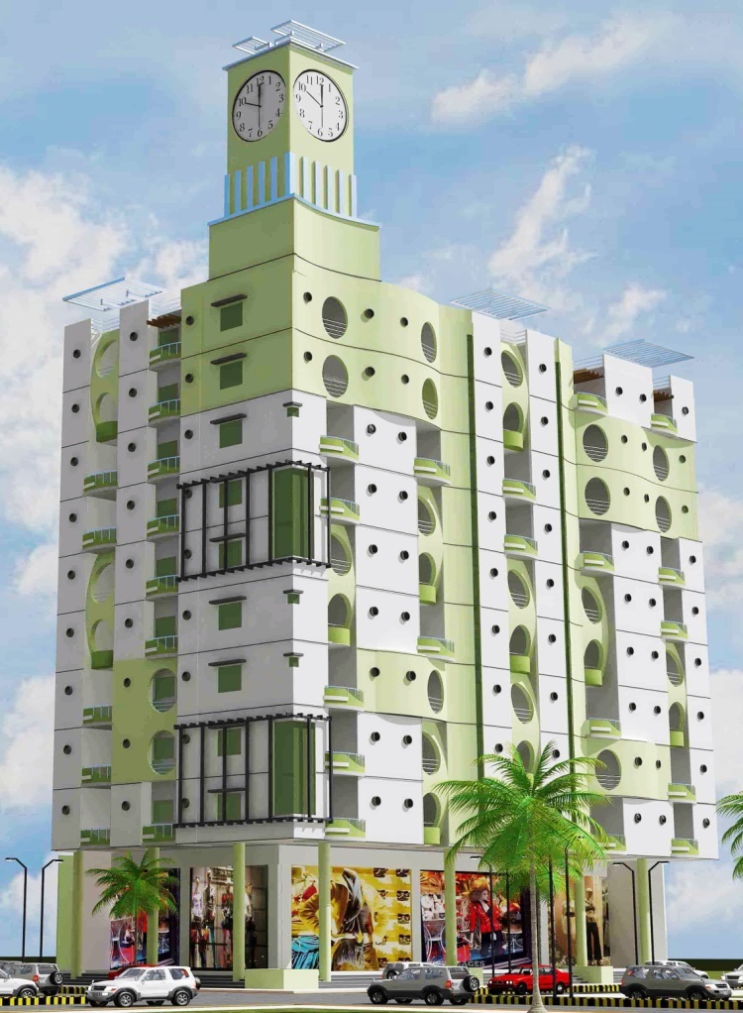
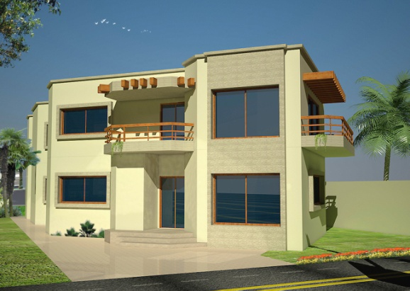

400 sqyd.B+G+1 Residence for
Mr.Amir Kamal Jafri
Design, Detail & Site Inspection

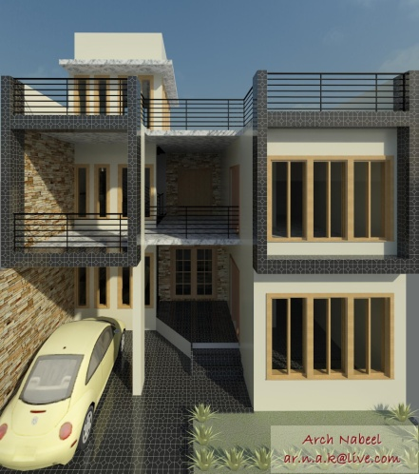

Residential Commercial Building
Euro Clock Tower
Basement Parking, Ground & Loft Showrooms + 10 Typical Floors
Detail, Site Inspections, Co-ordination
200 sqydResidence For
Mr. MaazFarooqi
Design, Detail & Site Inspection

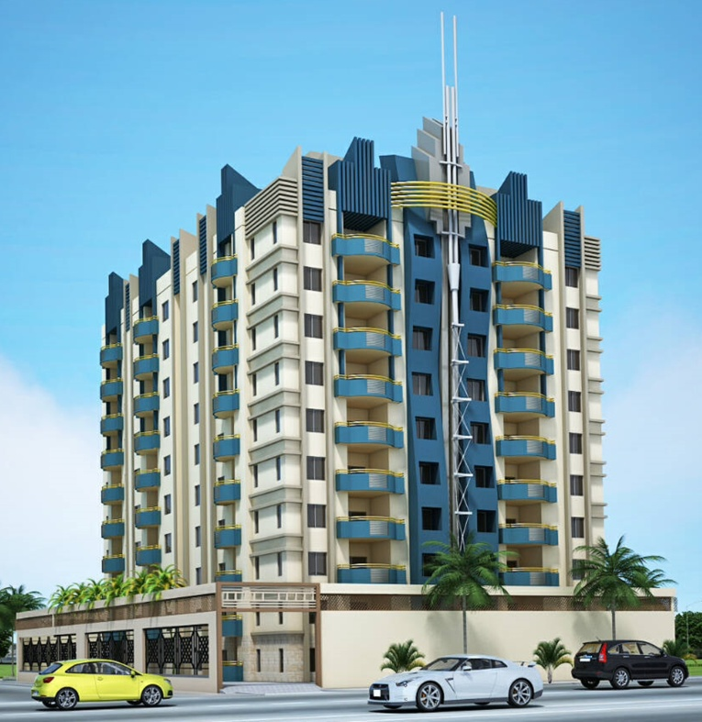
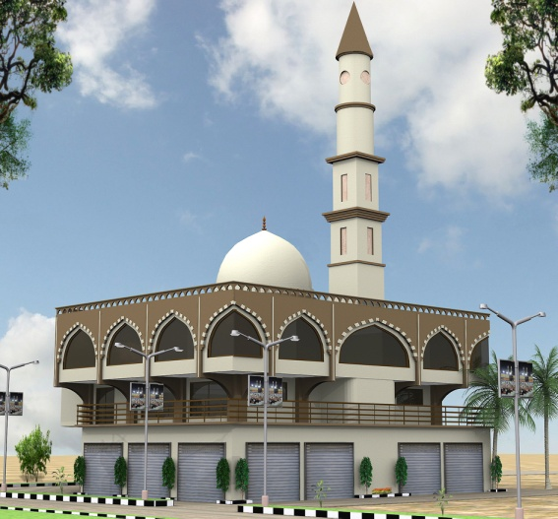

500 sqyd Masjid Project
Jama Masjid Memon Nagar Karachi
Design, Detail, Site Inspections

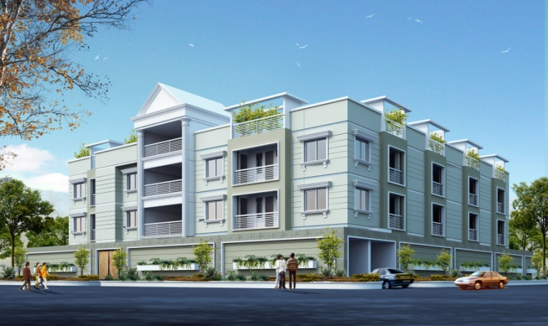

Residential Commercial Building
Euro Hi-Tech Tower
2 levBasement Parking + Ground
+ 9 Typical Fl
Detail, Site Inspections, Co-ordination

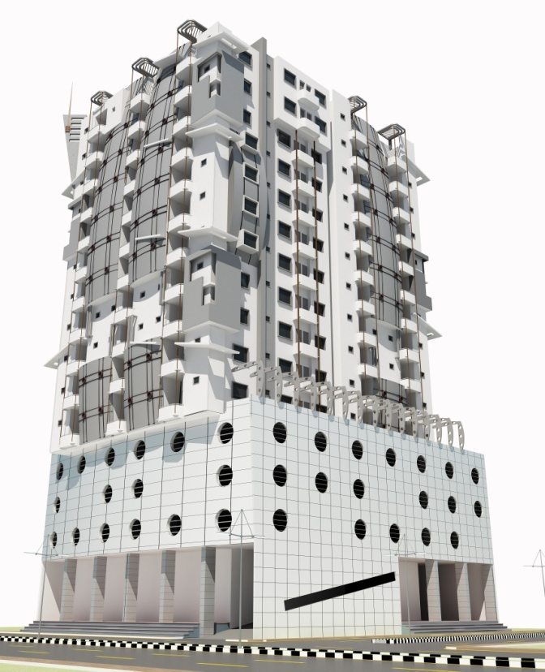
Residential Commercial Building
White House Residency
Detail, Site Inspections, Co-ordination

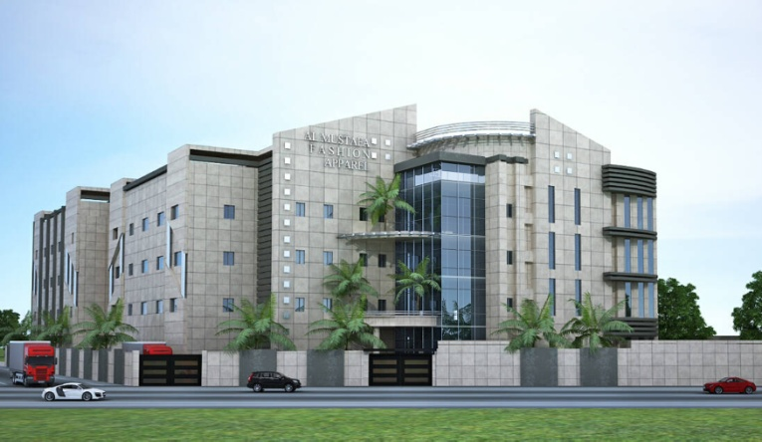

Textile Factory
Al-Mustafa Fashion Apparel
Detail, Site Inspections, Co-ordination

Nabeel
Residential Commercial Building
Euro Hi-Tech Tower
Basement, Ground& LoftShowrooms + 3 Level Parking Fl.+ 11 Typical Fl
Detail, Site Inspections, Co-ordination
Bachelor Of Architecture

