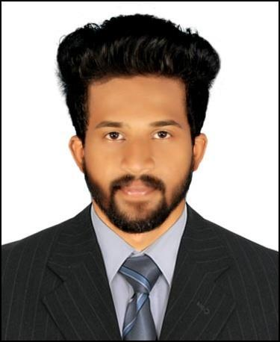
SENIN

MECHANICAL ENGINEER

Gmail: senin-394279@2freemail.com

PROFILE

Versatile Mechanical Engineer having one and half years of experience like to work in a firm with a professional work driven environment where I can utilize and apply my knowledge, skills which would enable me as a fresh graduate to grow while fulfilling organizational goals. Recognized for a keen ability to improve design components, increase products and manufacturing efficiency.

SKILLS

Team leadership

Design

Technical

Confident and
Active Learning

Interpersonal and
Communication

Self motivating

Hard working

Programming
Languages

Languages

Academics

- Nehru Institution of Technology, Coimbatore , Anna University

Degree: B.E Mechanical Engineering (2017)

- Little Flower Higher Secondary School, Nilambur, Malappuram

12th Govt State Board: Science (2012)

- Little Flower Higher Secondary School, Nilambur, Malappuram

10th Govt State Board: Science (2010)

Experience

- Project Coordinator (1&half year)

[Ernakulam (Sept 17 to Mar19)]

- CNC Opertor (6 months)

[Coimbatore (Mar 16 to Sept 16)]

Personal Skill

- Ability to rapidly build relationship and set up trust.

- Confident and Determined

- Ability to cope up with different situations.

- Excellent communication, leadership skills, organizational skills and making reliability

- Confidence in facing the challenges in the work assigned.
- Ability to work under stress.

- Languages : English , Hindi , Malayalam

CERTIFICATIONS

- AutoCAD 2D & 3D
- HVAC Engineering

- MEP Engineering

HOBBIES

- Volunteer work

- Travelling

- Badminton

- Chess

- Painting

ADDITIONAL INFORMATION

Visa Status : Visiting Visa

D.O.B : 18/May/1994

Marital Status : Single

Nationality : India

Religion : Christian

IT Proficiency
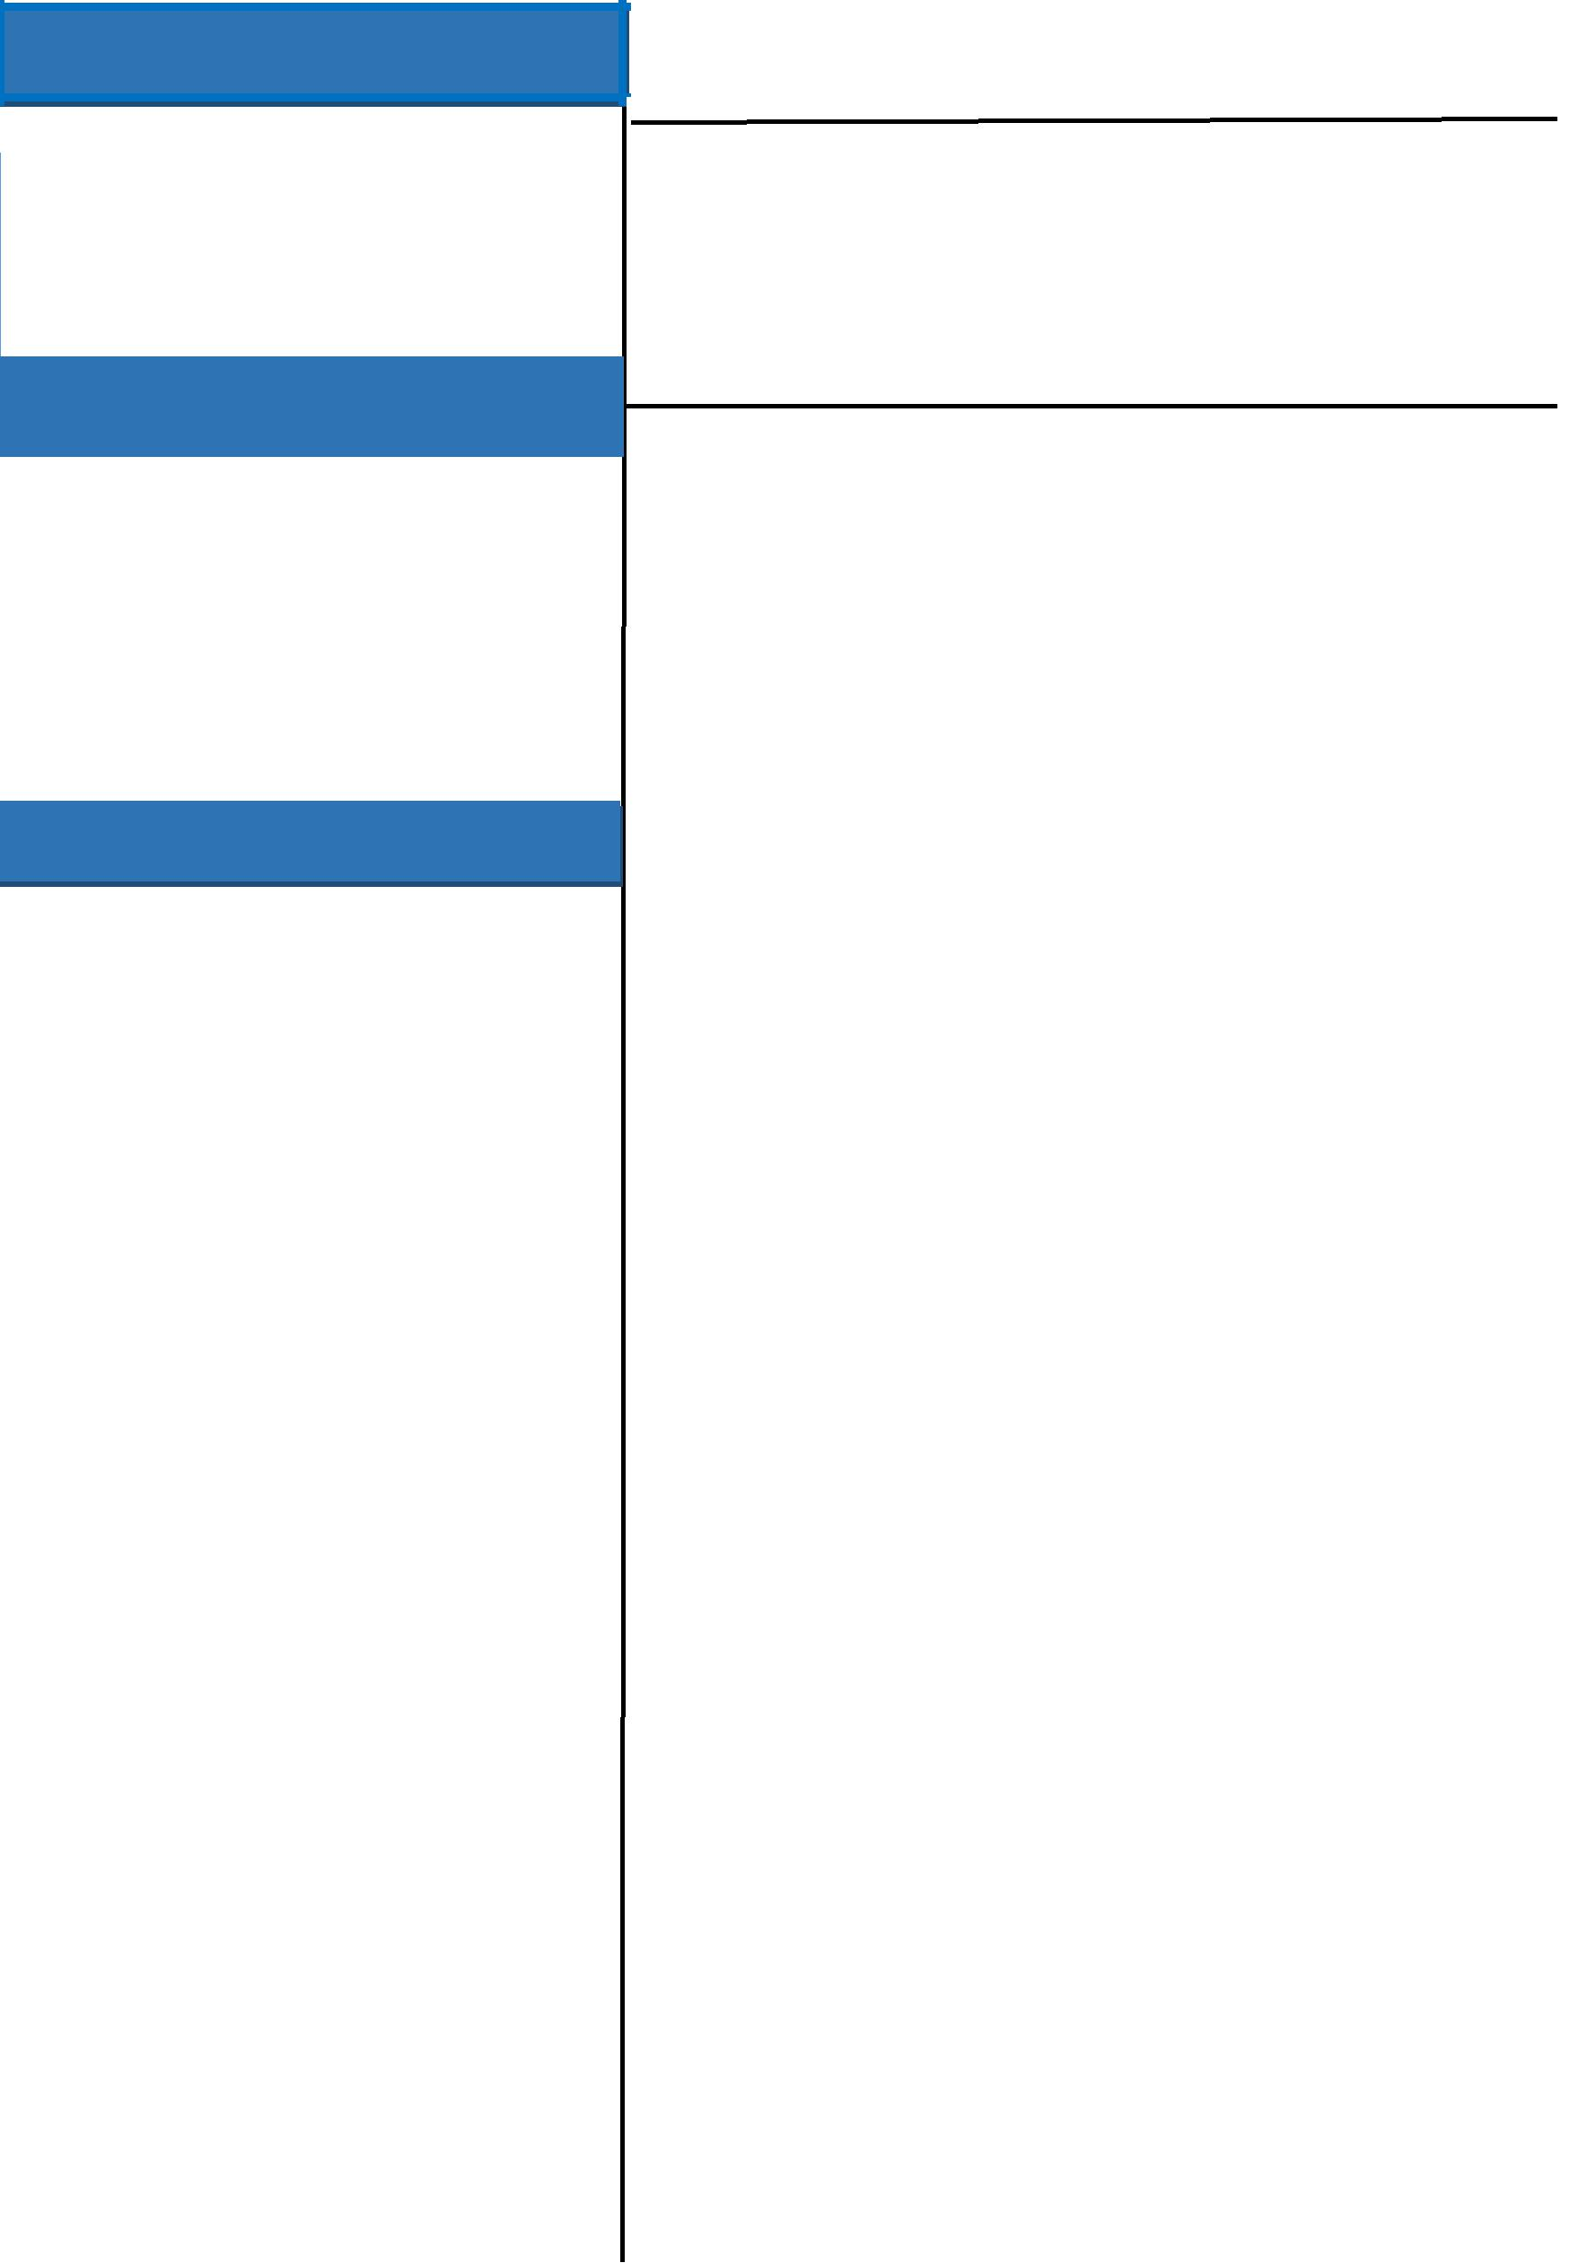

- Auto CAD

- Microsoft Office Word, Microsoft Office Excel, Microsoft Office Power Point.

Responsibilities

- Planning and project abilities include scheduling in project management and resource.

- Highly confident site coordination and supervising.

- Familiar with environments regulatory Compliance, Research and design proficiencies include Finite Element Analysis, Project/Quantification Planning, ISO & Safety Compliance, Statistical/Process Analysis, On-and Off-line Test Development, Manufacturing specifications, and Design & Validation.

- Active listening and critical thinking skills for determining clients’ needs and implementing plans to make them a reality.

- Excels in teamwork environments where engineers come together to gather information, problem solve, and implement a strategy.

- Affinity for identifying the underlying principles affecting situations, which leads to less time brainstorming and more time actively building workable solutions.

- Excelled in identifying stress points during stress analysis of piping systems and worked with designs to choose appropriate support locations and supports.

- Completion and distribution of documents records with status reports, material requirement calculations, punch lists and hydraulic calculations. All information shared with appropriate team members and supervisors

- Ability to understand and sort out the technical problems that may occur during work.

- Thorough working knowledge in structural construction field.

- Operating CNC machines of automotive parts.

- Understanding the depth of cutting and adjusting the values according to the given measure.

- Locking and unlocking of mold pieces into CNC machines under safety precautions.

- Testing and checking the error of product in vernier calipers(digital), Go/ No Go gage, Air gage, Micrometer.

- Checking the product in Coordinate measure machine for further error calculations.

Co-/Extra –Curricular Activities

- Coordinator for symposium conducted by Mechanical department. ( Mechanium 2k15)

- Actively participated in various cultural activities for inter college.

Declaration

I do hereby declare that the above information is true to the best of my knowledge.

