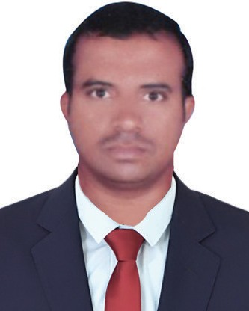
Name : Thirupathi
Nationality : Indian
E-Mail : thirupathi-394285@gulfjobseeker.com
Qualification : MBA (Finance & Marketing)
MCOM (Finance)
Experience : 7 Years

PROFESSIONAL OBJECTIVE:

Seeking a position as an Accountant & Administration Staff where extensive experience will be further developed and utilized. To work in an organization as an efficient and highly motivated team associate. Given an opportunity I will prove my knowledge and experience to benefit the Organization. To achieve challenging where my knowledge and problem-solving skills can be utilized to benefit the organization.

WORK EXPERIENCE:

- Worked in India.
Designation : Senior Accountant
Duration : 2012 June to Aug 2019
The main duties handling as follows:
- Maintaining cash book, journal and ledger accounts.
- Preparing Financial Statements (Profit & Loss Account and Balance sheet)
- Sound knowledge on Liabilities and Assets.
- Income & Expenses.
- Prepared weekly confidential Receipts and Payment reports for Presentation to Management
- Assist to senior accountant for finalization of accounts
- Preparation of cheques for day to day transaction.
- In charge in Bank Transaction (Cheques / Cash) and Bank reconciliation.
- Cash/Cheque deposits & withdrawals and Other Banking Operations.
- Make sure all the utility bills are paid on time.
- Have a good experience in accounting Software’s extensively for accounting tasks.
- Preparing Daily Time Sheets & Monthly Time Sheets.
- Prepare Monthly Salary for the Employees.

2.Working in India
Designation : Accounts Assistant &Administration Staff
Duration : 2009 Dec to Nov 2011
The main duties handling as follows:
- Maintaining the petty cash.
- Handling accounts payables and accounts receivables.
- Preparing the Journal Voucher, Bank & Cash Payments, Bank & Cash Receipts, Credit Note & Debit Note.
- Manage cashier remittance notebook with equivalent cash collection and deposit to the bank.
- Posting the Sales & other Transitions Daily & Weekly.
- Manage accounts receivables and follow up the outstanding payments.
- Integrate accounting and administrative functions smoothly.
- Entry the Bank Transactions in Accounting Software Daily & Weekly for the Bank reconciliation. Maintain bank deposits and check payment records.
- Prepared weekly confidential sales report for Presentation to Senior Accountant.
- Execute journal entries and posting in accounting software in a timely and accurate manner.
- Prepares / issued cheques for the supplier and transmittal of payments for the Forwarder & daily cheques reports.
- Count the Inventory every year and submit the senior accountant.
- Check the bank Balance every day & Assist to senior accountant for Bank reconciliation.
- Maintaining accounts, databases and daily billings in order and up to date.
- Provide day-to-day Admin and accounting support to the branch manager.
- Prepare Monthly Salary for the Employees.
- Assist senior accountants in the preparation of monthly/yearly closings.
- Prepare and submit weekly/monthly reports to senior Accountant.
EDUCATION QUALIFICATION:

Name of the Examination | University/Board | Year of Passing | Percentage
M.COM (Finance) | Osmania University | 2014 | 55%
M.B.A  (fINANCE & mARKETING) | Osmania University | 2009 | 63%
B.COM (Computers) | kakatiya university | 2007 | 71%
intermediate | Board of intermediate | 2004 | 81%
ssc | Secondary School Education | 2002 | 71%

TECHNICAL Skills:

- Applications : MS Office (Word, Excel, Power Point).
- Operating Systems : Window-XP, Vista, Window 7 and Windows 10.
- Typing Skills : 25 WPM.
- Accounting Packages : TallyERP9, Zoho Books.
- Proficiency in computer literacy

PERSONAL INFORMATION:

Gender : Male
Date of Birth : 18/04/1986
Marital Status : Married
Visa Status : Visit Visa till 13th December 2019
Place of issue : Hyderabad
Languages Known : English, Hindi and Telugu.

DECLARATION:

I hereby declare that the above statements are true, complete & correct to the best of my knowledge & belief.

Date:
Place: [Thirupathi]

