Curriculum Vitae
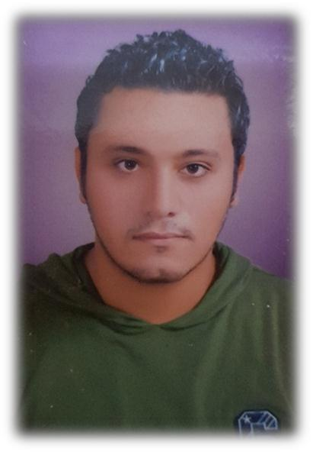

Personal Information

Name

:

Mamdouh

Nationality

: Egyptian

Birth Date

: 25 July 1991

Gender

: Male

Mail

Marital Status

: mamdouh-394292@gulfjobseeker.com

: Married

Education

: 2013 Bachelor of civil engineering, Zagazig University

Graduation Degree Graduation project Graduation project degree

: Very Good

: Reinforced concrete design

: excellent

1

Work Experience

JOB Title: site engineer (Contractor)

Employer Country: Qatar

From: july 2016

To: may 2017
Project: two accommodation buildings inside army camp (total

Project Cost 1 billion Q.R )

Location: Almazroua – umm Slal Ali
Contractor: Al Bandary Engineering

Consultant: Diwan Al Emara Engineering Consultant

Owner: Qatari army

JOB Title: site engineer (Contractor)

Employer Country: Qatar

From: May 2017

To: November 2018
Project: One villa for Company’s Owner (Project Cost 20 Million Q.R)

Location: Bahari Villas South, the Pearl Qatar - Doha

Contractor: Al Bandary Engineering

Consultant: MZ and partners (MZP Consultant)
Owner: Eng. Ahmed Al Rayyan (Owner of Al Bandary Group).

JOB Title: site engineer (Contractor )

Employer Country: Qatar

From: November 2018
To: February 2019

Project: two mosques

Location: AL kheesa – umm Slal Mohammed
Contractor: Al Bandary engineering

Consultant : Al Awqaf

Owner: Al Awaqaf

JOB Title: site engineer (contractor )

Employer Country: Egypt

From: March 2015

To: March April 2016
Project: Tanta police station (project cost 48 million l.£ with an

area of 2000 m2 )

2

Location: Tanta

Contractor: Al Dawlia for trading &contracting (IESC)
Consultant: The Egyptian army

Owner: ministry of interior

JOB Title: site engineer (contractor)

Country: Egypt
From: August 2013

To: October 2014

Project: two residential building (area 600 m2 each ,6 typical

stories )
Location: Al mustaqbal city ,Cairo

Contractor: Al Dawlia for trading & contracting (IESC )

consultant : The Egyptian army
Owner: The Egyptian army

Nature of the Job:

The Civil engineers create, improve and protect the environment in which we live. They plan, design and oversee construction and maintenance of building structures and infrastructure, such as roads, railways, airports, bridges, harbours, dams, irrigation projects, power plants, and water and sewerage systems

Job description

- Arranging construction activities to achieve the target on the required time up to time schedule.

- Following the construction and make hand over to the consultant.

- Making daily or weekly report to my manager .

- Making maintenance after the handing over .

- Making payments for the subcontractors

- Making client payments

- Saving material and not making so much losses

- Assuring safety in the site is one of my missions

3

Computer Skills

- AutoCAD ,sap2000,etabs, safe ,CSI column, Microsoft Office

Language Skills

- Arabic: Mother tongue

- English: very Good

Other skills

- Have a driving license

Personal skill

- Excellent communication skills

- Ambitious

- Hard worker, ability to work under stress

- Ability to learn any & everything in short time

- Ability to work individually & as an effective team member

- Self-motivated, dependable & goal-oriented

- Like to be in challenge

Interests and Hobbies

- Internet, computer, sports

4

