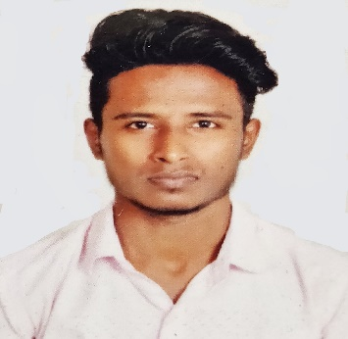
CANDIDATEPROFILE

ABIN
MECHANICAL ENGINEER

Email: abin-394307@2freemail.com

CAREER OBJECTIVE:

To pursue a challenging and growth oriented career and to develop my practical knowledge in my work area so as to develop my career and the company.

PROFILE SUMMARY:

- Good communication and interpersonal skills with a learning order for new skills andtechnologies.
- Able administration of confidential projects with dispatch and discretion. Possess positive attitude, responsible, and high degree of self-motivation. Excellent problem solving and analyticalskills.
- Strong personal initiative, energy and enthusiasm. Confidence in interaction and communication at all levels &cross-culturally.
- Smart, fast learner, customer focused and stable underpressure.
- A quick learner with an inquisitive mind, committed to pursuingpersonal development.
- Proficient in AutoCAD and MS-Office.

EDUCATIONAL QUALIFICATIONS:

2019 Bachelor’s Degree in Mechanical Engineering
Anna University - Chennai, India
7.2 CGPA
2015 Higher Secondary Certificate
Major: Computer science
Pius XI Higher Secondary School
76%

ACADEMIC PROJECTS:

- Design and Analysis of Composite Leaf Spring.
- Design and Fabrication of Self-Acting Hydraulic Jackfor light weight vehicles.

TECHNICAL SKILLS:

- AutoCAD 2D Design Software Proficiency
- Revitand Microsoft Office Proficiency
- CATIA V5 3D CAD Modelling Software Proficiency
- Project Management and Leadership Skills

EXTRACURRICULAR ACTIVITIES:

- Attended International Conference on Information, Robotics, Construction & Communication held at PERI Institute of Technology for “Design and Analysis ofComposite Leaf Spring“.
- Attended Workshop on “Robotics” conducted by “Trios Technology”.
- Secured “First Place” in “Light Music Competition” conducted by “Voice of India Music Academy Trivandrum”.

FIELD OF INTEREST:

- Computer Aided Design (CAD)
- Interior Design
- Engineering
- Maintenance Engineer
- Supervisor

SPECIALITY:

Handling the job independently

Quick learner

More familiar with Engineering Drawings

Highly adaptable and able to learn new technologies faster
PERSONAL DETAILS:

Highest Qualification : Bachelor of Engineering
Date of Birth : 24-05-1997
Gender : Male
Marital : Single
Nationality : Indian
Visa Status : Visit Visa - Till Oct 6th 2019
Languages : English, Tamil, Malayalam, Hindi

DECLARATION:

I hereby declare that the information furnished above is correct and true to the best of my knowledge and belief.

(ABIN)

