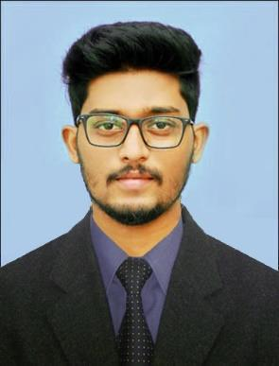

SUJIL

Desktop Support Engineer/Sales/Designing

International City,Dubai, UAE

Email: sujil-394309@2freemail.com

OBJECTIVE

To secure a promising position in a well-established company and utilize my potential to the fullest, put my technical skills to best use, contributing to the success of the organization, proving my passion for work and excellence to grow with it.

EXPERIENCE (1 year and 7 months)

Thrissur, Kerala (6 months) Designation: Junior Web Developer

- Developing Web Applications using ASP.NET MVC.
- Designing Web Sites.
- Dealing with Database (SQL SERVER).
- Solving clients problems using remote desktop applications.

Thrissur, Kerala (1 year and one month) Designation: Desktop support Engineer

- Addressing client’s problems regarding software and networking.
- Guiding users with simple step by step instructions.

- Remote troubleshooting.
- Customize desktop application to meet user needs.
- Follow up with clients ensure their systems are functional.

ACADEMIC PROFILE

B.E in Computer Science & Engineering (2013-17)
- Royal College of Engineering & Technology, Akkikavu, Thrissur.
- CGPA 6.2

- SN GHSS School, Kanimangalam, Thrissur.
- Passed with 62%

SSLC, Kerala state board (2010-2011)
- SN BOYS High School, Kanimangalam, Thrissur.
- Passed with 75%

CAPABILITIES

- Hard working.
- Ability to adapt to changes.

- Good in verbal and written communication skills.

- Punctuality and loyalty towards my work.

- Good in customer handling.

- Good in handling projects.

PERSONAL SKILLS

- Programming Languages known: Asp.net MVC,HTML,CSS3, BOOTSTRAP

- Database known: SQL SERVER , SQl, MSACESS
- Graphic Designing (Adobe Photoshop, Illustrator, Light Room)

- Blog and Content Management
- Sales Skills

- Ability to learn new technologies quickly.

PERSONAL DETAILS

Date of Birth

Sex

Nationality

Marital Status

: 21.02.1996

: Male

: Indian

: Unmarried

Languages known VISA Status

: Malayalam, English, Tamil

: VISIT VISA

I hereby declare that the above particulars are true to my knowledge and belief.

Place: Dubai, UAE

Date: 13/09/2019 SUJIL

