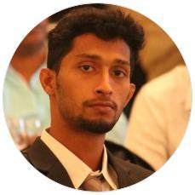

Sijo-394310@2freemail.com

SKILLS

Good communication skills

Good leading capacity

Ms oﬃce Tally

LANGUAGES

English

Full Professional Proficiency

Hindi

Full Professional Proficiency

Malayalam

Full Professional Proficiency

Tamil

Full Professional Proficiency

INTERESTS

Playing basketball

Travelling reading

SIJO

Master of International Business (MIB)

National level basketball player

EDUCATION

- Master of international business (MIB-finance) DR.G R Damodaran college of science coimbatore (2017-2019)
- Bcom( finance)
Sree keralavarma college thrissur(2013-2017)
- Manual +tally &VAT

Sree sankaracharaya computer center sreekandapuram(2019)
OBJECTIVE

To work and maintain a learning attitude and seeking employment with a company where I can use my talents and skills to grow and expand the company I want to succeed in a stimulating and challenging environment building success of the company
Courses.

Manual+tally including VAT

EXPERIENCE

Six months of experience in accounting come financial analyst (March2019 –september 2019)

ORGANIZATIONS

(Vytila kochin)
CERTIFICATES

- Management and banking allied training(SAMBAT)
- Six months of working experience cirtificate as an accountant

come financial analyst in abe service pvt. ltd

- Mib course completion certificate o Bcom course completion certificate o Hse completion certificate
- Sslc course completion
PERSONAL PROJECTS

- A STUDY ON EFFECTIVENESS OF HR POLICIES IN MRCMPU
.LTD KANNUR (12/2018 – 01/2019)
- 2 Months of internship project in abe service pvt
.ltd
ACHIEVEMENTS

Represented kerala basketball team in( 2009 -2019)
Represented Calicut university basketball team(2013-2017)
Represented bharathiyar university team

