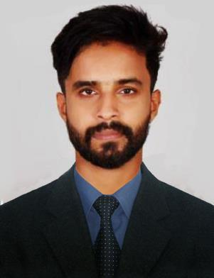

OSCAR
International City, UAE
Email: Oscar-394316@2freemail.com

OBJECTIVE

To enhance my professional skills in a dynamic and stable workspace which contributes to the productivity and profitability of the organization details oriented with an analytical bend of mind and possess positive attitude. Proficiency at grasping new technical concepts quickly & utilizing in a productive manner.

EXPERIENCE

Thrissur, Kerala ( 2018 OCT )

Designation : Software Engineer

- Developing of Web Apps using ASP.NET MVC.
- Designing of Web Sites.
- Dealing with DataBase(MYSQL)

Thrissur, Kerala ( 2017 OCT- 2018 OCT ) Designation: Software Engineer / Customer Service / Data Entry

- Developing of ERP Softwares using VB6.
- Dealing with DataBase( MSACCESS)
- Support (Online &OnCall) of existing softwares of company.

- Direct communication and customer handling.
- Entering service data’s on daily basis

ACADEMIC PROFILE

B.E in Computer Science & Engineering (2013-17)
- Royal College Of Engineering & Technology, Akkikavu, Thrissur.

Higher Secondary, Kerala State Board (2012-2013)
- St.Antonys HSS School, Pudukad, Thrissur.
- Passed with 86%

SSLC, Kerala state board (2010-2011)
- Holy Angels Higher Secondary School, Kuriachira, Thrissur.
- Passed with 94%

CAPABILITIES

- Hard working.

- Ability to adapt to changes.

- Good in verbal and written communication skills.

- Punctuality and loyalty towards my work.

- Good in customer handling.

- Good in handling projects.

- Advanced in Spoken English

PERSONAL SKILLS

- Creative

- Good in coding languages (ASP.NET,MVC,HTML,JAVASCRIPT)

- Good in Data Base ( MYSQL,MSACCESS)

- Blog and Content Management

- Graphic Designing ( Adobe Photoshop, Illustrator, LightRoom)

- Ability to learn new technologies quickly.

PERSONAL DETAILS

Date of Birth

: 26.10.1994

Sex

Nationality

Marital Status

: Male

: Indian

: Unmarried

Languages known VISA Status

: Malayalam, English, Tamil, Hindi, Telugu

: VISIT VISA

I hereby declare that the above particulars are true to my knowledge and belief.

Place : UAE

(Oscar)

