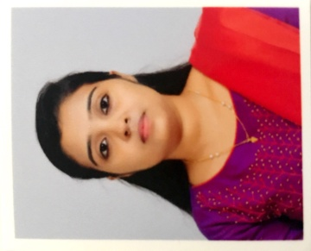 |  | Silpa  Resume  Objective  To start my management career by joining a well settled and highly professional organization and grab good career advancement through large efforts and innovative work techniques  Academic Education  .  - Completed MBA in Finance and Human Resource from Calicut University, 2018.  - Graduated in Bachelor Of Commerce with Finance from Calicut University, 2016  - Higher secondary education from board of HSE, Kerala in 2013  - High school education from board of SSLC, Kerala in 2011  Professional qualification  - Extremely bright academic records with absolute performance consistency.  - Thorough understanding of the fundamental principles of business administration and their practical usage.  - Highly organized thought process and well structured problem dealing attitude with an edge of innovativeness.  - Profound managerial qualities and skills to handle multiple teams simultaneously.  - Ability to handle both, the internal activities of an organization as well as the external dealings with customers, vendors, government bodies, etc.  - Uncommon command over spoken and written English.  - Very strong in handling the MS office tools and web search tools  Key Skills  - Possess strong analytical skills with the ability to make well decision.  - Good communication and writing skill.  - Honest, reliable and punctual.  - Effective and Multi tasking.  - Flexible, adaptive and keen to take initiative.  Academic project undertaken  - A study on customer loyalty of Penco marbles and granites Ltd.  - A study on the analysis of financial performance of Kajah tea company Pvt. Ltd.  Personal Information  Gender : Female  Date of Birth : 07/12/1995  Nationality : Indian  Marital Status : Married  Language Known : English, Malayalam  E mail : silpa-394325@2freemail.com  Visa status : Residence
Silpa-394325@2freemail.com

Declaration

I hereby declare that the above written particulars are true to best of my knowledge and belief.
Place: Dubai Silpa
Date: 17/04/2019

