Majed
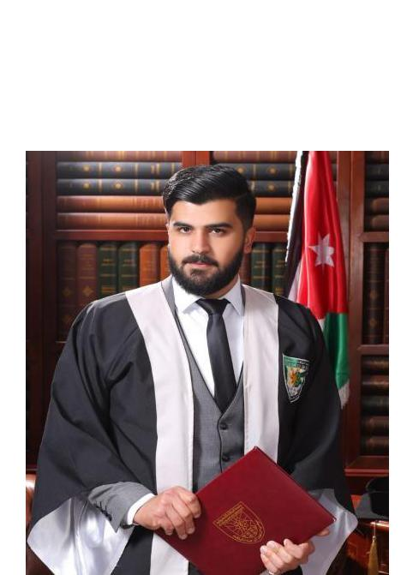

Thermal and Hydraulic Machines Engineering

Personal information

Nationality : Jordanian

Email: majed-394326@2freemail.com

Birth : September,6,1996

Languages

Arabic Native Language

English Good

Objective

A Thermal and Hydraulic Machines Engineering looking for working in a challenging environment demanding my skill and efforts to contribute in achieving organizational objectives.

Education

Bachelor's degree (B.Sc.) in Machines Engineering | 2014 - 2019

- Major : Thermal and Hydraulic Machines Engineering

- Institute : Al-Balqa Applied University

- Grade : (Good)

Secondary Education | 2012 - 2014

- Industrial Stream
Institute: Abu Bakr Al-Razi Amman, Jordan

- Grade: 87.3%

- Trade:Electricity

Professional Skills

Proficiency in:

- AutoCAD

- C++

  - Microsoft Office

Personal Skills

- Team Work: Very Good

  - Leadership: Excellent

Creativity: Very Good

- Problem solving skills: Excellent

Projects

Graduation Project: Repair of composite material with application to air craft components.

University Training

In Al-Masar Engineering company.

References

References are Available upon request.

