CURRICULUMVITAE
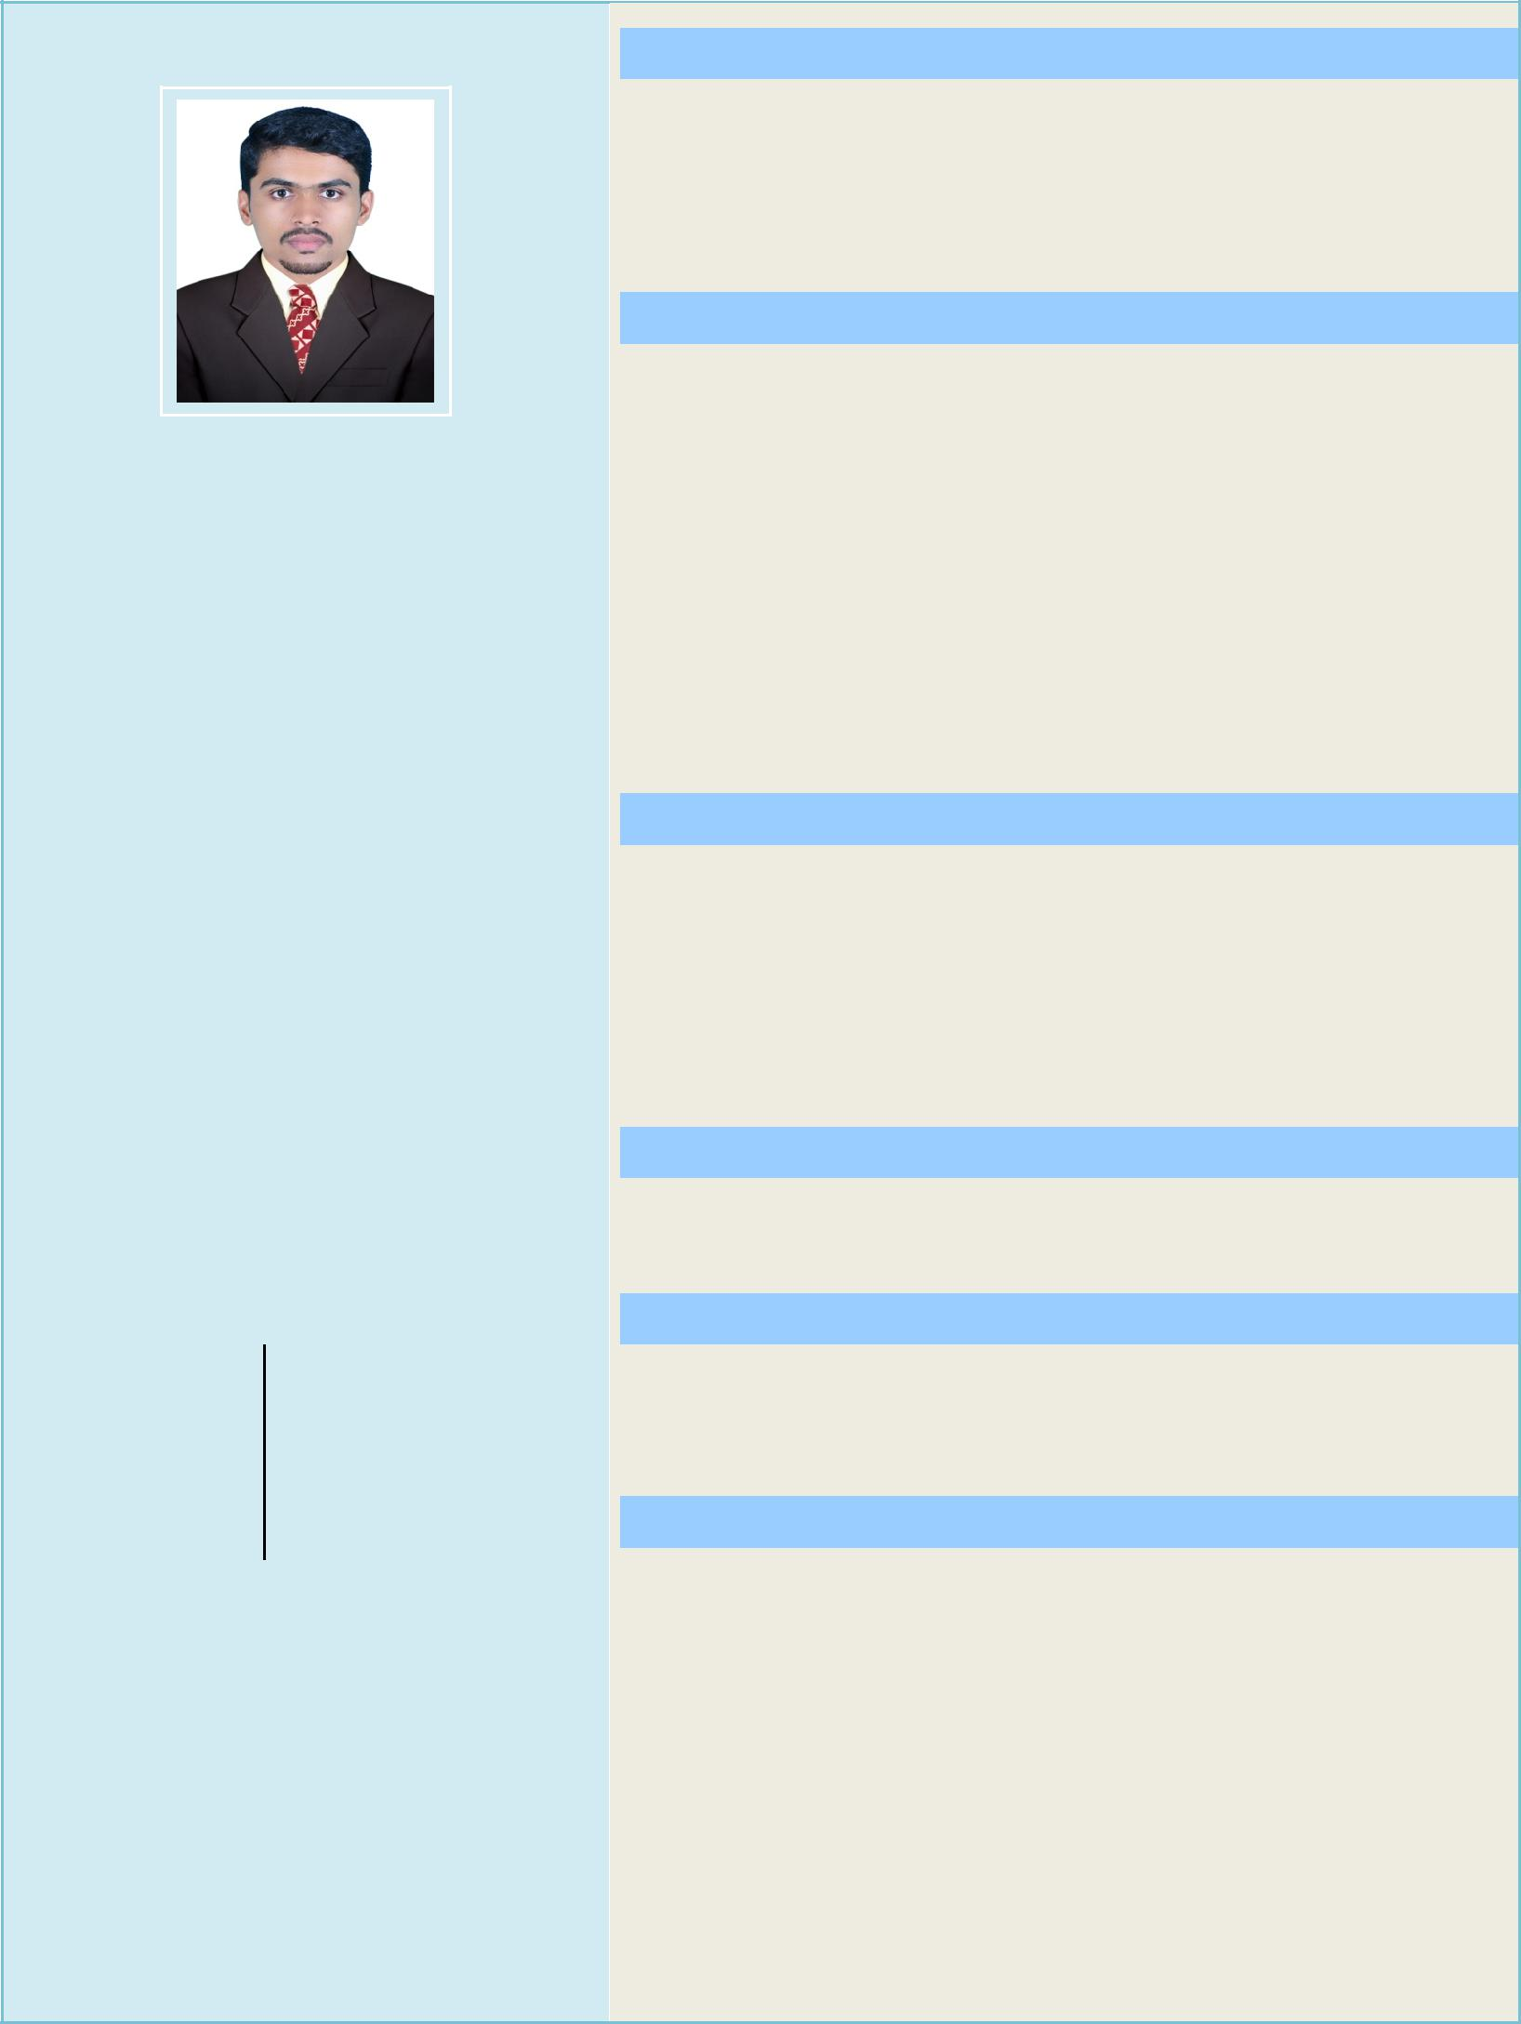

PERSONALDATA

SHAFIN

e-mail:

shafin-394342@2freemail.com

PersonalData

DateofBirth 30.03.1995

Sex Male

Nationality Indian

Religion Muslim

MaritalStatus Single

LanguageKnown

ToSpeak:

English,Arabic,TamilandMalayalam

ToRead&Write:

Objective

Toworkinanesteemedorganizationwithaldedications andsincerity,whereIcanprovemymanagerialability towardsthegrowthoftheorganizationatanyworking environment

EducationalQualification

BID

BachelorofInteriorDesigning

HimalayanUniversity

PlusTwo

Humanities

BoardofHigherSecondaryExamination,Kerala

SSLC

SecondarySchoolLeavingCertificate BoardofPublicExamination,Kerala

AdditionalQualifications

- AutoCAD(Draftsman)

- 3d’sMax(3dVisualizer)

- VRay

- Corona

- Photoshop

- M.S.Office

WorkExperience

- 3yearexperienceasInteriorDesigner

Strengths

- Self-confidence

- Honest

- Sincere&Hardworking

Declaration

Iherebydeclarethattheinformationprovidedabove isfactualytrueandcorrecttothebestofmyknowledge andbeliefandifgivenanopportunitywilexhibitmybest andmostcreativeeffortsataltimes.

Place:

English,Arabic,HindiandMalayalam | Date: | SHAFIN

