Objective
Senior customer care advisor. . Hold an experience of 4yrs, 6months in a BPO industry. I am optimistic by person, very flexible, yet focused and set realistic goals. Honest, punctual and self-motivated, I am able to learn quickly Excellent at verbal and writing communication and time management skills. Can work in challenging and innovative environment and team. Put my best to complete any task with in time with full efficiency to achieve greater heights of success.

Skill Highlights
- MS-office  - Strong decision maker  - Complex problem solver | - Strong Communication  - Innovative  - Service-focused

Experience
(Karnataka, India) Jun 2018-Jul 2019

A contact center solutions, which ensures client needs are taken care, Aegis is been awarded with many awards for the customer care support in past years and Aegis received NASSCOM customer service excellence award2017 for process improvement and efficiencies.

One of the leading and fastest growing travelling Industry. The process is mainly emphasis in book Airline tickets, Hotel reservations, cars rentals, cruises and vacation packages
Worked as a” customer care advisor” for the process Expedia (USA).
- Assist customer to book a bundle,(flight, car,& hotel )
- Assist customer to make changes on the reservation (flight, hotel and car with the policy)
- Assist customer to cancel the reservation.(towards flight, hotel and car with the fowling policy )
- Assist customer resolving their issues towards car rental and hotel booking by contacting the concern Authority.

(Karntaka, India) Jan 2016-Apr 2018

One of the leading Telecommunications services in Emirates. It is a Largest career service provider in international voice tariff in mid-east and Africa and the 12th Largest voice carrier in the world , Etisalat is one of the of the internet hubs in the middle East providing connectivity to other telecommunications operators in the region.

Contact
Visa validity:28-10-2019
Nationality: India
Email: anjum-394351@2freemail.com

Languages
Speak: English, Hindi, Tamil, Kannada & Urdu.

Read: English & Hindi.

Write: English.
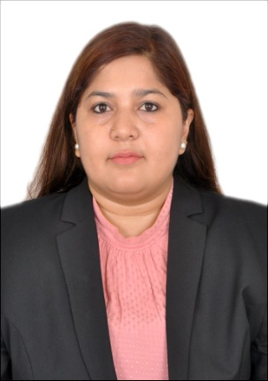
ANJUM

Achievements / Extra Curricular Activities
Cultural
Participated in several cultural programs conducted in college.

Personality Traits:
An efficient team player in a group and highly self-motivated individual.
Possess excellent verbal and written communication skills.
An excellent reasoning abilities and flexible to learn new process.
A flair for creative work such as painting, designing and craft work .
Ability to troubleshoot problems and construct solutions.
Possess the ability to plan, Organize and schedule events.
Easily adaptable to situations.

Area of Interest:
Music
Photography
Dance

Languages
Speak: English, Hindi, Tamil, Kannada & Urdu.

Read: English & Hindi.

Write: English.

Worked as a ” customer care advisor” (UAE).
- Assist customer Resolving the billing query
- Understand customer requirement and offer them a suitable package.
- Assist customer to buy add on in the mid of the month
- Assist customer with their complaint try to resolve on the call or raising a complaint

Worked in the “complaints department” in the same Organization.
- Assist customer with their complaint, by investigating
- following the rules of the organization while resolving the issue.

(Karnataka,India) Jan 2010-Dec 2015
Worked as a Reception cum admin for an Ayurvedic clinic.

- Schedule Appointments for the patients
- Help with medicine
- Prepare a salary sheet for the employees and attendance
- Take care of the entire center (from housekeeping to ordering the medicine)

Education
- Higher Secondary
Karnataka state Open University (P.U.C) February 2015.
- Nursery Teachers Training (NTT) course from Hymamshu Jyothi Kala Peetha Pre-Primary Teachers Training Institute, Malleshwaram, Bangalore, September-2009.
- I-Maths Training, July 2009.
- Principles of Teaching course from Regional Vocational Training Institute, Bangalore July 2007 – October 2007.
- Dress Making from Regional Vocational Training Institute, Bangalore, August 2005 -May 2007 (Basic and Advance course).

Declaration
I hereby declare that the above-mentioned information is correct to the best of my knowledge and I bear the responsibility for the correctness of the above-mentioned particulars.

Date: Signature

Anjum

