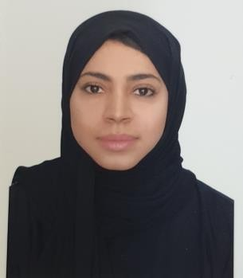

FATIMA
Email ID: Fatima-394353@2freemail.com
Abu Dhabi- UAE

OBJECTIVE
To work in a medical setting organization that provides to excel my career in highly competitive and professional environment.
To build a long-term career in non-medical position and stay connected to the hospital environment due to the current circumstances of not being able to work as a GP.

PERSONAL INFORMATION
Marital status: Single Nationality: Pakistani
Religion: Muslim Date of Birth: 05/09/1990
Place of Birth: Abu Dhabi, U.A.E Visa Status: Father’s Sponsorship

EDUCATION
2008 - 2014 MD Grodno State Medical University- BELARUS 2006 - 2008 High School Sheikh Khalifa Bin Zayed Arab Pakistani School- U.A.E.

PROFESSIONAL EXPERIENCE
SEPT 2015–AUG 2016 Medical Intern
Abu-Dhabi, U.A.E:

Obtain histories and perform medical examination for in & outpatients, write patient’s notes, attend daily ward rounds all under the supervision of the professional superior.

04,DEC 2017 – 25, MAR 2018 Clinical Attachment Pediatrics
Abu –Dhabi, U.A.E

01, April – 26, April 2018 Clinical Attachment Internal Medicine
Abu Dhabi, U.A.E

CERTIFICATION:
SEPT, 2016 American Heart Association (AHA) - Basic Life Support
(Provider)

FEB, 2018 Contribution towards the Pediatrics Residency Clinical Exam (OSCE) held on 8th and 22nd 2018

CONTINUOUS MEDICAL EDUCATION (40 + CME HOURS )
2014 -2019 Attended CME seminars in various hospitals

RESEARCH
- Nov 2015 Research in IgG4-Related Disease with Sclerosing Bone Disease, a diagnostic dilemma

POSTER PRESENTATION

- Dec 2015 - Speaker at ESR Conference, Abu Dhabi
- Dec 2015 - Poster Presentator at SEHA Congress Conference, Abu Dhabi
- Mar 2016 - Poster Presentator at ARLAR Conference, Morocco

CORE ABILITIES
- An efficient team player with excellent problem solving and trouble shooting skills
- Able to learn quickly and clearly communicate regulatory guidelines
- Good communication skills and practical skills in General Medicine and in Basic Life Saving Procedures
- Computer Skills: MS Word, Excel, and PowerPoint.

LANGUAGES
English | Arabic | Russian | Balochi | Urdu
Fluent | Fluent | Good | Fluent | Fluent

EXTRA CURICULLAR ACTIVITIES

  - Participated in Science Seminars and Workshops in School
  - Participated in many Quiz and Cultural Competitions
  - Participated in Russian Poem Competition in University

REFERENCES

References are available upon request

