CURRICULAM VITEA

Hayatullah
Email – hayathullah-394394@2freemail.com

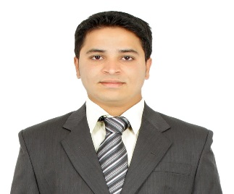
CAREER OBJECTIVE: -To pursue a career and to be associated with a growing company to work in an environment that rewards achievements and opportunities for growth and achieve success in career and experience. By optimistic, enthusiastic and co-operative, willing to take-up responsibilities adapts me to the job.

EDUCATIONAL QUALIFICATION:-

- Certificate - Bachelors in Hotel management Green Fields College.
- Certificate - Intermediate from Anwar ul loom college
- Certificate - SSC from Vikas high school.

GULF & INDIA EXPERIENCE:-

- Saudi Arabia : 2 years in Tony Romas as shift manager.
- Qatar (Doha) : 1 year in sport’s corner as Storekeeper.
- Park Hyatt Hyderabad : 1 Year as a G.S.O.
- Fusion 9 and Pragathi Resorts : 2 year as a senior receptionist.

JOB RESPONSIBLITES:-

- Greeting and thanking guests in a sincere, friendly manner.
- Register and process guests and their assigned rooms.
- Accommodate guest requests.
- Collaborating and communicating with other internal departments to ensure guest satisfaction.
- Up selling guest room and promoting hotel services.
- Handling cash payments or card mode access.
- Maintain a clean and neat front desk area.
- Complying with company procedures and safety policies.

PERSONAL SKILLS:-

- Administration and customer service skills.
- IT skills to work with computerized booking and payment systems.
- Excellent written and spoken communication skills.
- A friendly and professional telephone manner.
- The Ability to stay calm under pressure and look after several things at once.

STRENGTH:-

- Positive attitude
- Self-motivated, energetic and time management
- Analytical thinker and very fast learner
- Highly disciplined, hardworking and well organized individual.
- Physically agile, and able to stand extended periods.

PERSONAL PROFILE:-

Date of birth : 02/06/1986
Gender : Male
Nationality : Indian
Native place : Hyderabad
Marital Status : Married
Language Known : English, Arabic, Hindi, Telugu & Urdu
Visa Status : Visit Visa 3 months (19.09.2019 Arrival date)

DECLARATION:-

I hereby affirm that the information above given by me is true and correct to the best of my knowledge and looking forward for a chance to work in your esteemed organization.

Date: Place – Fujairah – United Arab Emirates. (Hayatullah)

