Curriculum Vitae

NITIN

Personal info -

Email- nitin-394412@2freemail.com

Date of Birth-
14-07-1998

Certificates-
- PGDCA Certificate
- Graduation Certificate
- HS (+2stage)pass certificate
- Madhyamik pass certificate
- Certificate of completion Master Diploma

CARRIER OBJECTIVE

As a Goal Oriented,Diligent and Disciplined.I wish to take all challenges to prove myself.
I desire to work in an Environment that promotes Teamwork and opportunity.To take up new Challenges and work with Loyalty and Sincerity and to obtain a meaningful and challenging
Position that enable me to build a successful carrer in the Hospitality Industry and allows scope for Advancement.

EDUCATION

- B.Sc. from Siddharth University Siddharthnagar.
- Master Diploma in Architectural Design.
- PGDCA

EXPERIENCE

- Data collector & Data entry operator ( 2 years)
- CADD Centre Training Service Lucknow

LANGUAGE

- HINDI
- ENGLISH
- BHOJPURI

STRENGTH

- Appreciative
- Flexible

OTHERS

- Very Good Time Management skill
- Good Bussiness skill
- Good Communication skill

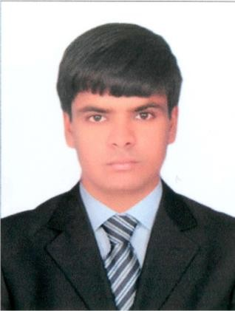

SKILL

  - M S OFFICE
  - Networking
  - Master Diploma in Architectural Design(Driving Digital Designs!)

PASSPORT DETAILS-

Place of Issue : Lucknow
Date of Issue : 24/01/2017
Date of Expiry : 23/01/2027

